Fused filament fabrication and recycling of bio-based polyamide 11 reinforced with recycled short carbon fibers
Mirko Coser, Daniele Rigotti, Alessandro Pegoretti

Department of Industrial Engineering, University of Trento, Via Sommarive 9, 38123 Trento, Italy

Abstract
This research investigates the fused filament fabrication (FFF) and recycling of bio-based polyamide 11 (PA11) reinforced with recycled short carbon fibers (rCFs), aiming at enhancing the sustainability of polymer additive manufacturing. The study evaluates the rheological, thermal and mechanical properties of PA11 reinforced with 10% and 20% rCFs, analysing both hot-pressed (HP) and 3D-printed samples across multiple recycling cycles. The results reveal that while the addition of rCFs improves tensile stiffness and strength, it reduces ductility and impact strength. Mechanical properties degrade progressively after each recycling step, more noticeably in 3D-printed specimens due to fiber breakage and matrix degradation. Despite this, PA11/rCF composites retain up to 95% of their elastic modulus and 80% of their ultimate tensile strength thus, highlighting a strong potential for circular manufacturing. These findings highlight the potentiality of bio-based PA11 composites for a more sustainable additive manufacturing, while also emphasizing the need for further optimization to mitigate the adverse effects of recycling on mechanical performances.

Highlights
- PA11 reinforced with recycled carbon fibers was 3D printed.
- The production process degrades the polymer matrix and breaks the fibers.
- Recycling reduces viscosity mostly at low shear rates due to chain scission.
- Stiffness is not much affected by recycling
- PA11/rCF composites retained performance over three recycling cycles.

Keywords: PA11, short carbon fibers, FFF, 3D printing, recycling.
- Introduction

Additive Manufacturing (AM), commonly known as 3D printing, has witnessed a rapid growth, particularly in the field of thermoplastic polymers and its market size is expected to grow up to $37.2 billion by 2026¹. This revolutionary technology involves the layer-by-layer deposition of molten materials to build a three-dimensional (3D) object. The process begins with a 3D model, based on computer-aided design (CAD), sliced into layers by a software, generating a deposition path for each layer. AM is renowned for its flexibility and offers the capability to produce complex net shapes quickly without auxiliary tools or moulds, minimizing material waste therefore, making it an appealing choice for rapid prototyping, design, and relatively low-volume production²⁻⁶. AM techniques can be categorized into seven categories, including materials extrusion, powder bed fusion, vat photo-polymerization (VP), binder jetting, materials jetting, sheet lamination, and directed energy deposition^{3,6,7}. Fused filament fabrication (FFF, also known under the trademark name of fused deposition modelling, FDM), a subtype of materials extrusion, is a leading 3D-printing method, recognized as one of the most popular and well-known Additive Manufacturing (AM) techniques, employing thermoplastics in filament form for the creation of prototypes and functional components. This process consists in extruding a thermoplastic-based filament through a nozzle at a temperature above its glass transition or melting temperatures. The melted material is then deposited layer by layer on a moving platform to systematically build a 3D object^{2-4,8}. The quality of the final product can be optimized by changing different processing parameters like build direction, printing and bed temperature, flow rate, layer thickness, line width, printing speed, infill density and pattern⁵. FFF offers easy accessibility with straightforward operations and relatively low costs. Typical domestic 3D printers are available at a range of approximately $200 - $300 while the price can go up to $2000 - $8000 for professional applications. However, despite being recognized as a cost-effective approach within the domain of additive manufacturing processes, the application of FFF in worldwide manufacturing initiatives is limited by several factors: the build size is constrained by the dimensions of the printing plate and chamber which usually do not exceed 200 x 200 x 200 mm for domestic FFF printers. The resolution is lower compared to other AM techniques (like VP) due to the size of the nozzle, which diameter is typically around 0.4 mm, and the production rate is quite low. Additionally, the printed products have an anisotropic nature and demonstrate diminished strength and toughness in the printing direction (z-axis) owing to weak interlayer bonding and void formation. This limitation significantly influences the overall mechanical properties of the manufactured components^{4,7}. Up to now, the most utilized FFF filaments are petroleum-based, such as acrylonitrile–butadiene–styrene (ABS), polypropylene (PP), polyamide (PA), polycarbonate (PC), thermoplastic polyurethane (TPU), polyether ether ketone (PEEK), polyethyleneimine (PEI) and high impact polystyrene (HIPS)^{3,5,7-9}. The only environmentally friendly options are mainly restricted to polylactic acid (PLA), polycaprolactone (PCL) and polyhydroxyalkanoates (PHAs) like polyhydroxybutyrate (PHB). Although PLA is a commonly used bioplastic for FFF, being easily printable with no production of toxic fumes, it suffers from several other disadvantages such as low thermal stability, high degradation rate during processing, brittleness and low toughness⁵. PHAs, have good mechanical properties, are biodegradable and biocompatible however, they are limited by their brittleness, stiffness, and narrow gap between thermal decomposition and melting temperature¹⁰. PCL have been extensively used in the biomedical field thanks to its biocompatibility but, having low melting temperature and poor mechanical properties have prevented it to being effectively exploited as 3D printing material for producing consumer products^{11,12}. Another possible eco-friendly candidate to be used in AM processes is polyamide-11 (PA11). PA11 is a semicrystalline polymer (glass transition temperature $T_{g}$ ≈ 45 °C, melting point $T_{m}$ ≈ 190 °C, crystallinity up to 40%), synthesized from castor oil which finds application in a range of high-performance engineering scenarios such as fluid transfer lines, hydraulic and pneumatic hoses, cable sheathing, medical equipment, electronic device components, and sporting goods^{13,14}, thanks to its particularly good mechanical properties such as high elongation at break and impact strength¹⁵. However, 3D printing highly crystalline materials poses challenges, since the crystallization can introduce structural deformation, warpages and can cause detachment from the build plate¹⁶. Additive manufacturing (AM) is not limited to conventional unreinforced thermoplastics. In fact, while traditional manufacturing methods have excelled and have been exploited extensively during the last decades with fiber-reinforced composites, the realm of 3D printing with short-fiber composites is gaining ground for its economic feasibility. Though the mechanical properties may not match continuous-fiber reinforced composites, the cost-effectiveness and practicality of direct printing using commercially available 3D printers make short-fiber composites a viable option. Consequently, there has been extensive research in recent years on the utilization of fiber-reinforced composites for fused filament fabrication^{2,6,17,18}. Another important aspect to consider related to the environmental impact of plastic components produced by FFF, is their recyclability. As said before PLA is one of the most used polymers in AM, but researchers have noted several technical problems with the use of recycled PLA filaments for 3D printing. These problems include uncontrolled crystallinity, poor mechanical properties due to thermal degradation, higher shrinkage and decreased durability¹⁹. Given the 2030 goals that Europe set as part of their Circular Economy Package on the 2nd of December 2015, such as recycling of municipal and packaging wastes at the level of 65% and 75% respectively and the reduction of landfilling to a maximum of 10%²⁰ and the continuous growth of FFF in all kinds of manufacturing sectors²¹, favouring the use of 3D printing materials that are more suitable for being recycled into filament should be of paramount importance. In this study, commercially available polyamide 11 and recycled short carbon fibers (rCFs) were used to produce filaments for FFF. Rheological, thermal and mechanical tests were conducted on 3D-printed samples and, for comparison, also on compression moulded ones. The materials were then recycled and re-printed two times to assess the ability of PA11 and PA11/rCF composites to withstand the thermal processes involved in the recycling processes and evaluate their capability to be used to enhance the sustainability of AM.
- Materials and methods
  - Materials
The thermoplastic matrix used in this study is a Rilsan® BESNO TL. polyamide 11, produced by ARKEMA s.a. (Colombes, France) in form of polymer granules. Its main properties are reported in Table 1. The reinforcement is constituted of recycled short carbon fibers (rCF) Type-65 Produced by Zoltek subsidiary (St. Luois, Missouri, USA) in form of chopped fibers of 6 mm cut length. Its characteristics are reported in Table 2.
Table 1: Rilsan® BESNO TL. PA11 main properties.
Property | Value | Standard
MFI (230°C, 2.16 kg) [g/10’] | 1 | ISO 1133
Elastic modulus [MPa] | 1280 | ISO 527-1/-2
Yield stress [MPa] | 38 | ISO 527-1/-3
Yield strain [%] | 5 | ISO 527-1/-4
Melting temperature [°C] | 186 | ISO 11357-1/-3
Density (ù[g/cm3] | 1.02 | ISO 1183
Vicat grade (50 N) [°C] | 160 | ISO 306

Table 2: Zoltek Type-65 rCF main properties.
Property | Value
Sizing content [wt%] | 2.75 ± 10
Humidity content [%] | max 0.20
Bulk density (minimum) [g/L] | 350
Relative density [g/cm3] | 1.81
Nominal fiber length [mm] | 6

  - Sample preparation
A rCF content of 10 wt% and 20 wt% was selected (Table 3). The typical amount of short carbon fibers in carbon fiber-reinforced plastics or thermoplastic composites ranges from 10% to 40% by weight²², but a 20% CF reinforcement is a typical amount found in industrial reinforced 3D printing filaments, as it provides a significant improvement in mechanical properties²³ while avoiding excessive brittleness that could lead to filament breakage during printing.
Table 3: Produced materials.
Sample | PA11 [wt%] | rCF [wt%]
PA11 | 100 | 0
PA11_CF10 | 90 | 10
PA11_CF20 | 80 | 20

To prepare the two reinforced composites, firstly both rCF and PA11 were dried at 80 °C under vacuum for 12 h. The PA11 was then weighted and introduced into the compounder (Thermo Haake Rheomix equipped with Roller Rotors R600) for 1 minute at 60 rpm with a processing temperature of 200 °C. Then the fibers were added and the process continued for other 5 minutes before extracting the product. After cooling down, the materials were machined to produce small chips using a RN 166/1 granulator (Piovan SPA, S. Maria Di Sala, VE, Italy) equipped with a 3 mm sieve. Part of the samples were processed through hot pressing (HP) by inserting the chips into a 120x120x2 mm plate steel mould positioned between two steel plates covered by Teflon films to avoid the material to stick to the surface. The mould was placed into a hot press, heated up to 200 °C while applying a pressure of 3.4 MPa for 5 minutes. Then the press was water cooled to ambient temperature. 1BA specimens were then machined from the produced plates with a CNC milling cutter. The production process is schematically depicted in Figure . The remaining chips were instead fed into a Thermo Haake Rheomex twin screw extruder ((screw diameter D = 16 mm; L/D ratio = 25, where L is the screw length) to produce the filament for fused filament fabrication. The machine settings are indicated in Table 4 . The extruder was equipped with a flat die having a hole of 1.8 mm in diameter. The Thermo Haake Rheomex twin screw extruder was combined with a modified 3Devo Next 1.0 Advance Filament Extruder that was used to automatically measure the filament diameter, drew it to the desired width of 1.75 mm and collect it on a spool. The material was cooled during the drawing process by means of a system of four fans. The hot-pressing and filament production processes are schematized in Figure S1 and Figure S2. The filament was then employed to print the specimens for the mechanical tests using a Creality Ender 3 V2 3D printer. The slicing of the 3D printed specimens was obtained through the software Ultimaker Cura. The main printing parameters are listed in Table 5.

Table 4: Processing parameters of the Thermo Haake Rheomex twin screw extruder. T1 to T4 are the temperatures of the screw, TD is the temperature of the die.
Material | Screw speed [rpm] | T₁ [°C] | T₂ [°C] | T₃ [°C] | T₄ [°C] | T_{D} [°C]
PA11 | 10 | 150 | 200 | 200 | 200 | 200
PA11 + rCF | 10 | 150 | 215 | 235 | 230 | 220

Table 5: Printing parameters
Parameter | Value
Layer height [mm] | 0.2
Line width [mm] | 0.4
Wall line count | 2
Infil pattern | Lines [-45, 45]
Printing temperature [°C] | 250 (PA11), 255 (PA11_CF)
Build plate temperature [°C] | 100
Flow [%] | 95 – 100
Print speed [mm/s] | 50
Retraction distance [mm] | 0.5
Cooling | No

When printing directly on the heated bed, the polyamide 11 shrinks extensively due to its high propensity to crystallize. This causes the material to warp and detach from the printing surface. The most common method to reduce thermal stresses and thus warpages, is the use of a heated chamber, containing the printer, set at a temperature of around 100 °C¹³. However, this system despite working effectively, is quite expensive and not very practical. In fact, the high price of the heated chamber, the energy demand that this system requires to heat up the atmosphere and the need of a 3D printer able to sustain such high temperatures, could make it a disadvantageous solution for domestic but also industrial applications. Another approach to avoid the detachment of PA11 from the printing plate would be to increase the adhesion between the heated bed and the polymer when deposited. To do so, a 2 mm thick aluminium plate was coated with a thin film of PA11 (around 150 μm) by hot pressing granules to its surface using a Carver hot press at a pressure of 1.5 MPa and a temperature of 200 °C. The press was then water cooled keeping the pressure constant. After cooling, the polyamide strongly adheres to the aluminium forming a homogeneous, smooth and flat layer. This PA11 coated plate, (Figure S3), was then used to replace the typical glass hot bed of the Ender 3 V2.
The recycling step was carried out by machining the produced specimens with a RN 166/1 granulator and using the obtained flakes for the same production processes described in this section.
- Experimental techniques
  - Dynamic rheological measurements
The rheological measurements were carried out to explore the trends of the storage modulus (G'), loss modulus (G''), loss factor (tan Δ) and complex viscosity (η*) as a function of frequency (ω), to gain insights into the processability of the investigated blends and evaluate the effects of thermal treatments. The test was performed with a TA Instruments HR-2 Discovery Hybrid Rheometer in parallel plate configuration. Frequency sweep experiments were carried out at 250 °C in air with a gap of 1.0 mm between the plates. The frequency range was set from 0.05 to 600 rad/s at the strain amplitude of 1%.
  - Optical microscopy
An Olympus DSX1000 optical microscope was used to observe the produced filaments and specimens for the mechanical tests. This technique was employed to evaluate the orientation of the fibers by using both mixed and polarized light.
  - Dynamic mechanical thermal analysis (DMTA)
Dynamic mechanical thermal analysis tests were performed using a TA Instruments DMA Q800 device (TA Instruments-Waters LLC, New Castle, DE, USA) in order to investigate the shrinkage of the material during cooling in solid state from 140 °C to 40 °C. 3D printed samples, obtained by cutting out the middle section of some ISO 527 1BA tensile specimens, were tested at a cooling rate of 10 °C/min in controlled force applying a load of 0.001 N.
  - Optical dilatometry
A Hesse Instrument D-37520 optical dilatometer was used to investigate the thermal expansion/contraction of the prepared materials during the printing process. The specimens were heated from 50 °C to 250 °C and then cooled back to 50 °C at a rate of 10 °C/min with 8 minutes isotherm in between the two steps. The specimens were produced starting from 1 mm hot-pressed plates that were cut into 4 mm discs with a die cutter.
  - Differential scanning calorimetry (DSC)
The thermal behaviour of the material was evaluated through DSC analysis which was performed using a Mettler Toledo DSC 30 calorimeter with the following thermal cycle: -20/250 °C, 250/-20 °C, -20/250 °C at 10 °C/min with a 10 ml/min nitrogen flux. This technique allowed to obtain the values of the glass transition temperature ($T_{g}$), the melting temperature ($T_{m}$), melting enthalpy (${ΔH}_{m}$) and degree of crystallinity ($χ_{c}$) of the PA11. This latter was calculated through Equation (1).
 | $$χ_{c}=\frac{ΔH_{m}-ΔH_{cc}}{w_{PA11}⋅ΔH_{m}^{0}}$$ | (1)
Where ${ΔH}_{m}$ and ${ΔH}_{cc}$ are respectively the melting and cold crystallization enthalpy of the material, w_{PA11} is the weight fraction of PA11 in the sample and ${ΔH}_{m}^{0}$ is the melting enthalpy of a 100% crystalline PA11 which, according to literature is ${ΔH}_{m}^{0}$ = 206 J/g²⁴.
  - Thermogravimetric analysis (TGA)
The TGA was used to assess the thermal degradation properties of the samples by measuring the temperature corresponding to 1%, 2% and 5% mass loss ($T_{1\%}{, T}_{2\%}$, $T_{5\%}$), the decomposition temperature ($T_{D}$) and the residual mass ($m_{fin}$). $T_{D}$ was defined as the temperature relative to the peak of the derivative thermogravimetry (DTG), which was obtained by deriving the TGA curve. The analysis was performed with a TA Instrument TGA Q5000 applying a thermal scan from 30 °C to 700 °C at 10 °C/min, both in nitrogen and air atmospheres. The carbon fibers, initially 6 mm long, after being compounded in the polymer matrix were broken into smaller pieces by the mechanical shear stresses applied inside the mixer. Therefore, the actual length of the fibers after the production process was assessed by TGA scan from 30 °C to 500 °C at 10 °C/min in a nitrogen atmosphere. The residual mass was positioned in a sample holder; acetone was added and gently hand mixed to help the dispersion of the fibers. The goal was to obtain a homogeneous dispersion without clusters with fibers well separated between each other. The fibers were then observed with an optical microscope and the resulting images analysed with ImageJ® software to obtain their length distribution.
  - Quasi-static tensile test
The tensile tests were used to investigate the strength and stiffness of the materials and were performed with an Instron® 5989 tensile testing machine equipped with a 1 kN load cell and, for the elastic modulus evaluation, an extensometer (Instron 2620-61 having a gauge length of 12.5 mm). The elastic modulus (E) was evaluated on 6 specimens for each sample in the deformation range from 0% to 0.3% using an extensometer and estimating a "chord modulus" at 0.05 and 0.25% deformation values. The test was performed at a strain rate of 0.025 min⁻¹. The tests at break, used to evaluate the ultimate tensile strength (UTS) and strain at break ($ε_{b}$), were performed at a speed of 5 mm/min.
  - Evaluation of the impact strength
The evaluation of the impact strength was carried out under Charpy conditions performed following the standards UNI EN ISO 179-1 and 179-2. Test bars (80x10x4 mm) were 3D printed and then notched (notch radius of 0.25 mm, aperture angle of 45° and a depth of 2 mm). The test was performed using a Ceast 6549/000 Charpy pendulum equipped with a hammer ISO 15J M544 at an impact speed of 1 m/s. Some plasticine was placed between the specimen and the sample holder to reduce vibrations during the impact. After completing the tests, the samples were analysed under the optical microscope to measure the resisting cross section.
- Results and discussion
  - Dynamic rheological measurements
The complex viscosity (η*) curves, plotted against the angular frequency, obtained from the dynamic rheological measurements are reported in Figure 1. All the three materials follow a similar trend and the neat PA11 presents the highest η* values in the entire frequency interval. The composite reinforced with 10 wt% of rCF has the lowest values due to the degradation of the matrix upon melt compounding. PA11_20CF has slightly higher viscosity due to the larger amount of carbon fibers that help counterbalance the degradation during the production process. Figure 2 and Figure 3 shows the complex viscosity curves of the produced materials during the different stages of the recycling process carried out through 3D printing and hot pressing. The values of the complex viscosities (η*) in Pa·s obtained at an angular frequency of 0.05 rad/s and 10² rad/s (shear rate, $\dot{γ}$, of 1.25 and 2500 s⁻¹ respectively) are reported in Figure 4 (and Table S1 to Table S4). From these data it can be seen that, at the lowest frequencies (Figure 4a and Figure 4b), the neat PA11 granule shows the highest viscosity. The compounding process used to produce the composites reinforced with rCF affects the material lowering the viscosity of about 20-25·10³ Pa·s. The production of the filament further degrades the material. Doubling the rCF content from 10 wt% to 20 wt% favours an η* increase of about 1000 Pa·s for the 3D printed specimens. The overall production and recycling process through extrusion and 3D printing seems to follow a linear decreasing trend in viscosity. The recycling process through hot pressing has one less thermal treatment, therefore its impact on the rheological properties of the materials is lower. After two recycling steps the η* values of HP components are similar to the η* related to the first recycling stage of 3D printing. Furthermore, the thermal processes affect η* by progressively flattening the curves (Figure 2 and Figure 3) meaning that, the variation in complex viscosity in much higher at lower frequency than at the higher once. Studies have shown that during thermal oxidation, PA11 undergoes embrittlement due to oxidative degradation. This process involves the formation of radicals along the polymer chain (hydroperoxides and peroxy radicals), leading to chain scission and a reduction in molecular weight^{25,26}. Due to this flattening, at 10² rad/s (Figure 4c and Figure 4d), for the reinforced materials, η* is slightly higher after being extruded and printed. After this first small increase, the viscosity follows a decreasing trend similarly to the 0.05 rad/s plot. Typical shear rates for extrusion and 3D printing are between 10² - 10³ s⁻¹ (4 - 40 rad/s)^{27,28}, and from these results it can be noticed that the viscosity reduction in this shear rate range is much lower than that generated at lower frequencies. Therefore the 3D printing process is less affected by the degradation of the material compared to processes that apply lower shear rates such as compression moulding (1-10 s⁻¹)²⁹.

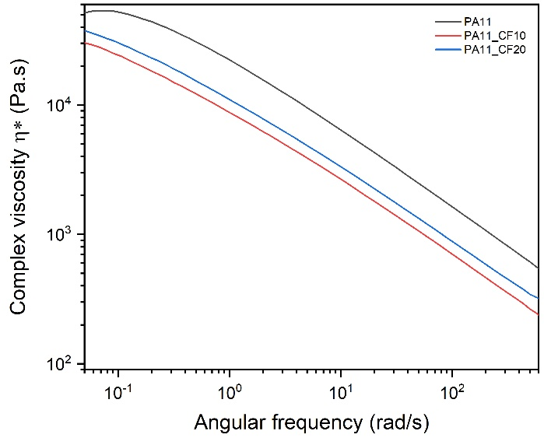
Figure 1: Complex viscosity (η*) curves obtained from the dynamic rheological tests at 250 °C on the produced materials (virgin PA11 and reinforced blends after compounding).

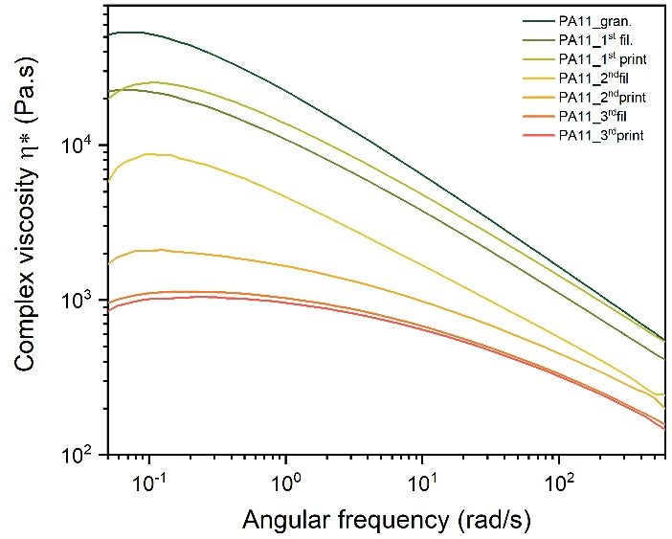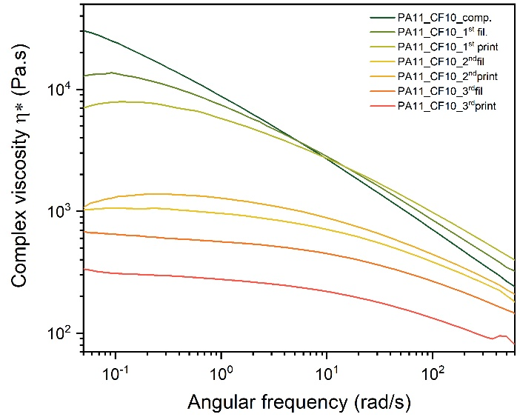
(a) | (b)

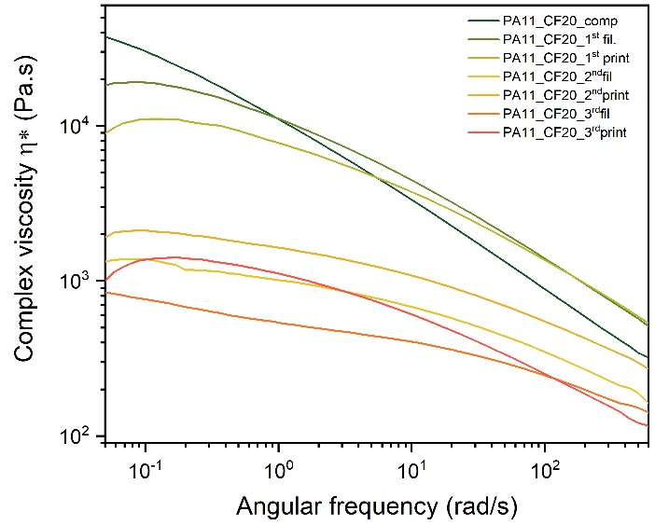
(c)
Figure 2: Complex viscosity (η*) curves obtained from the dynamic rheological tests at 250 °C on the prepared samples after each step of the recycling process through fused filament fabrication.

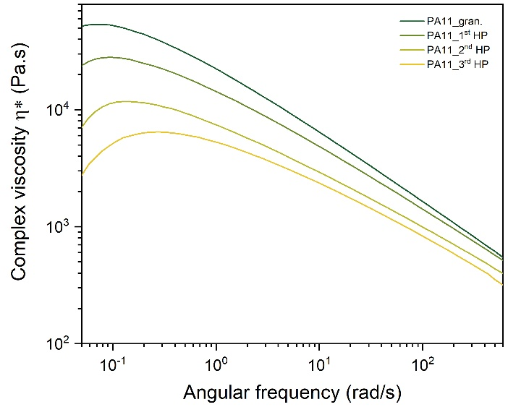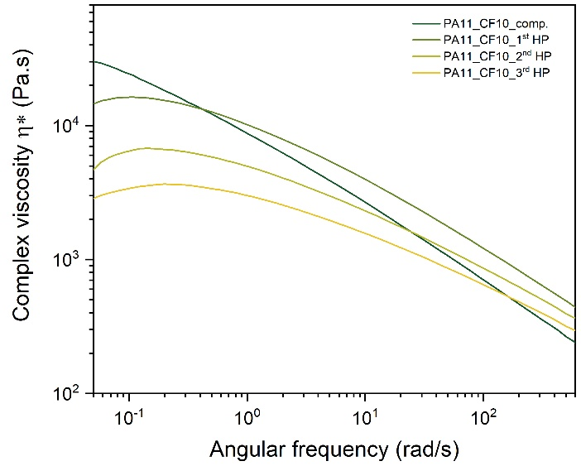
(a) | (b)

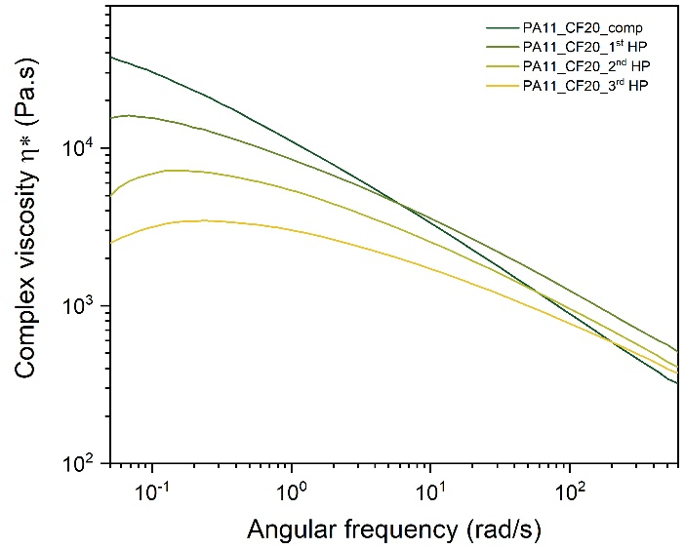
(c)
Figure 3: Complex viscosity (η*) curves obtained from the dynamic rheological tests at 250 °C on the prepared samples after each step of the recycling process through hot pressing.

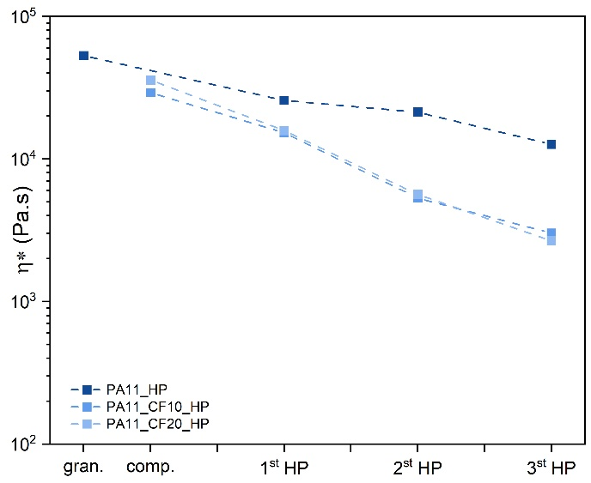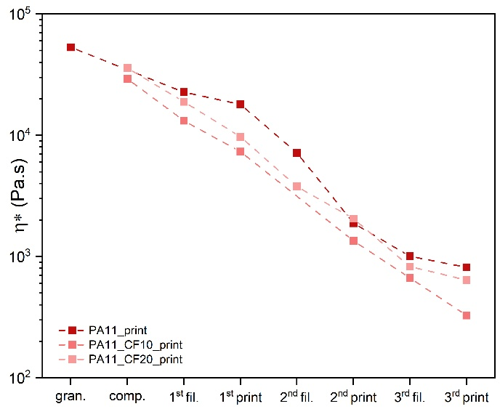
(a) | (b)

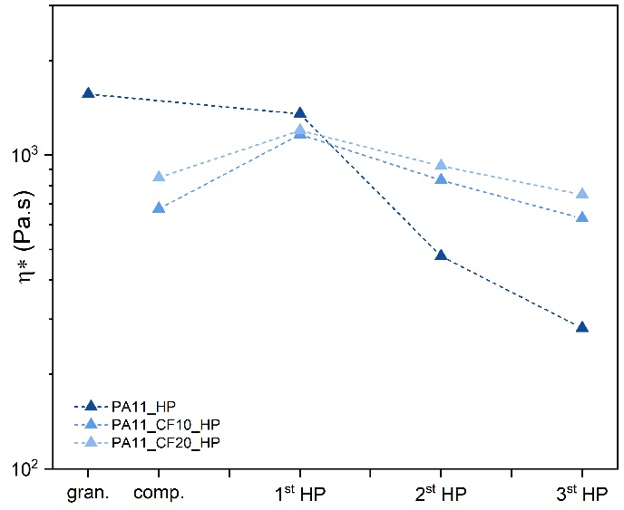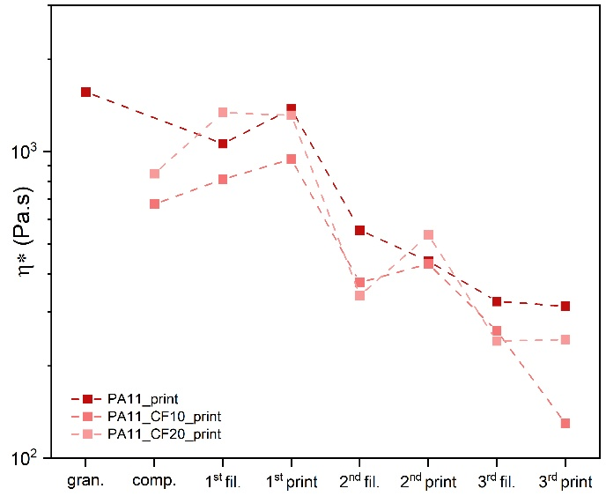
(a) | (b)
Figure 4: Complex viscosities (η*) in Pa·s at 250 ◦C obtained through dynamic rheological tests at (a) 0.05 rad/s on HP samples, (b) 0.05 rad/s on printed samples, (c) 102 rad/s on HP samples, (d) 102 rad/s on printed samples.
  - Optical microscopy
Figure 5a shows the optical micrographs of a PA11_20CF produced by hot pressing. The HP process does not introduce any preferred orientation in the rCF. Figure 5b shows a panorama of the entire width of a 3D printed reinforced specimen with 45° infill orientation. In the picture the walls (magnified in Figure 5c) can be clearly distinguished form the infill region (magnified in Figure 5d). In both zones the fibers are well oriented along the printing direction with exception of the transition area between the two regions where the fibers have a more random distribution due to the change in direction during printing.

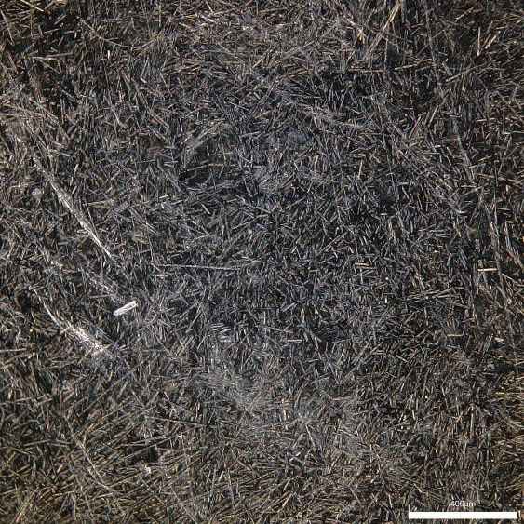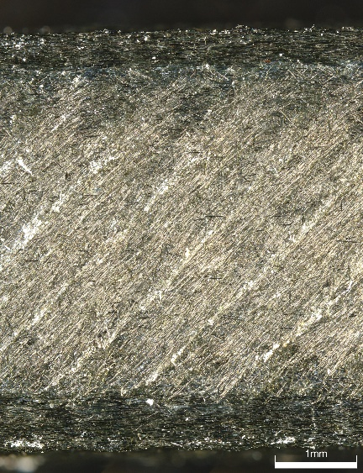
(a) | (b)

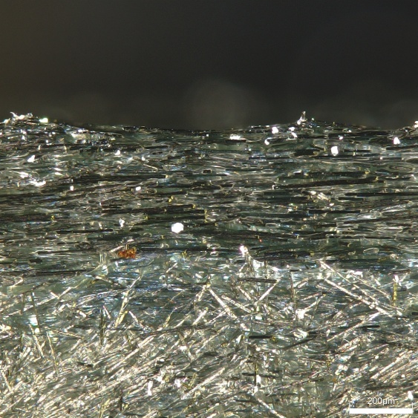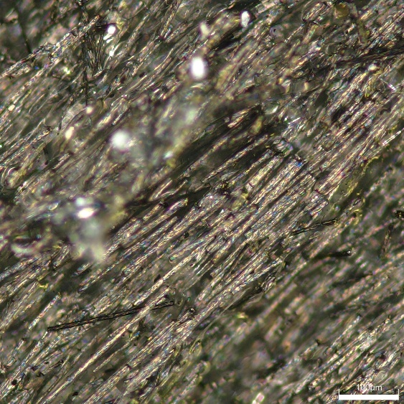
(a) | (b)
Figure 5: Optical micrographs of a PA11_20CF printed specimen under polarized light taken at different magnifications. (a) Panorama of the entire width of the specimen, (b) magnification of the wall-infill interface, (c) magnification of the infill.
  - Dynamic mechanical thermal analysis (DMTA)
The main problem in 3D printing PA11 is that it extensively crystallizes and shrinks during the cooling phase giving rise to high stresses between the polymer and the heated bed, thus, causing the material to easily detach from the printing surface. The DMTA is employed to understand how much the material shrinks while cooling in solid phase. The results obtained from the dynamic mechanical thermal analysis tests are reported in Figure 6. DMTA tests were also performed on an industrial PETG reinforced filament (PETG_CF20), a typical and easy to print composite material, to compare the results. The neat PA11 shrinks of about 1.6% while cooling from 140 to 40 °C. The addition of 10 wt% of rCF strongly reduces this value down to 0.4%. Increasing the rCF content to 20 wt% furtherly improves the dimensional stability of the material lowering the final strain of almost 90% making it almost possible to print it on a typical glass hotbed. When printing 1BA specimens, only the grip zones slightly detach from the base. PETG_CF20, instead, shows basically no shrinking confirming that is an easily printable material. It must be reminded that this test only looks at the length variation in the solid state but most of the dimensional change that PA11 undergoes during the printing process happen when transitioning from liquid to solid. Nevertheless, this technique gives important information about the behaviour of the materials while cooling.
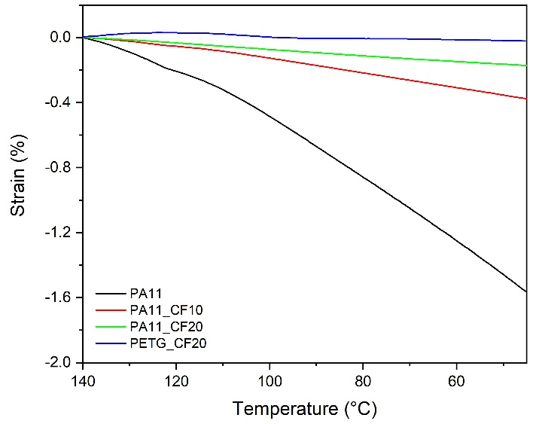
Figure 6: Results of the dynamic mechanical thermal analysis tests from 140 °C to 40 °C at a cooling rate of 10 °C/min in controlled force applying a load of 0.001 N.
  - Optical dilatometry
Figure 7 shows the linear contraction of the samples while cooling from 250 to 53 °C. Between 165 - 140 °C the materials crystallize, in accordance with the results obtained from the cooling step of the DSC (Figure S5). At around 90 °C it is possible to notice a small change in the thermal expansion coefficient (i.e. a variation of the slope of the curve) which represents a solid - solid transition. Literature data show that PA11 displays a polymorphism in its crystalline structure and the pseudohexagonal γ-phase, which is stable at high temperature, progressively turns into a triclinic α-phase at lower temperatures^{30,31}. All three materials follow a similar trend, and if only the region from about 170 °C downward is considered, it can be seen that the curves are almost identical, reaching a contraction of around 6-7% from the nozzle temperature to the solid state. This result suggests that the addition of CF does not affect the shrinkage of the material upon cooling if the fibers are randomly oriented (specimens obtained by HP).
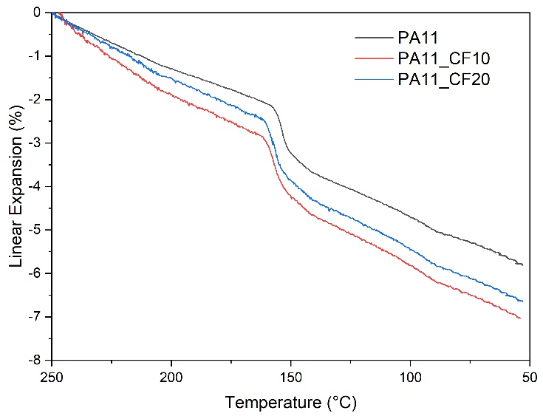
Figure 7: Results of the optical dilatometry from 250 °C to 53 °C at a cooling rate of 10 °C/min.
  - Thermo gravimetric analysis (TGA)
The TGA and differential thermo gravimetric (DTG) curves, the temperatures values relative to 1%, 2% and 5% of mass loss ($T_{1\%}{, T}_{2\%}$, $T_{5\%}$), the decomposition temperature ($T_{D}$) and the residual mass ($m_{fin}$) of all the samples, both in nitrogen and air atmosphere are reported in Figure S9 and Table S8, respectively. The residual mass ($m_{fin}$) resulting from the TGA tests in inert (N₂) atmosphere confirms the presence of the expected rCF inside the materials. The addition of rCF favours the heat conduction inside the material anticipating all the decomposition temperatures, especially at 1% and 2% of mass loss. From the TGA curves in nitrogen atmosphere it can be noticed that, at around 500 °C the matrix is basically completely degraded and only the fibers remain as residual mass. Therefore, performing a TGA with an isothermal step at this temperature removes all the PA11, allowing thus the analysis of the rCF content. The collected fibers from the isothermal TGA at 500 °C were observed at the microscope (Nikon SMZ25) and their length was measured using ImageJ® software (about 1500-2000 fibers were measured). The frequency distribution of the rCFs length and the fitting curves were calculated using a LogNormal distribution function expressed by Equation (2). The results are reported in Figure 8. The mean (μ) and standard deviation (σ) of the LogNormal distribution function and the average length (L_{f}) of the carbon fibers are summarized in Table S9 and Table S10.
 | $$y=y_{0}+\frac{A}{\sqrt{2π}wx}e^{\frac{-{\left(ln\frac{x}{xc}\right)}^{2}}{2w^{2}}}$$ | (2)
where $y_{0}$ is the offset from the y axis, $xc$is the centre of the curve, $w$ is the log standard deviation and $A$ is the area. The effects of the production processes and of the recycling stages on the fiber length can be seen in Figure 8. After compounding, the initial fiber length of 6 mm is severely reduced by below 300 μm due to the high mechanical stresses induced by the rotors. The PA11_CF_ compounded distribution is broader with more fibers in the 150 - 300 μm range compared to the other curves. The extrusion step narrows the curve and increases the number of fibers in the 50 - 60 μm. The printing stage do not influence much these values since the material is not subjected to high internal shear stresses. Subsequent recycling steps tend to further enhance this behaviour but not as much as the first extrusion.
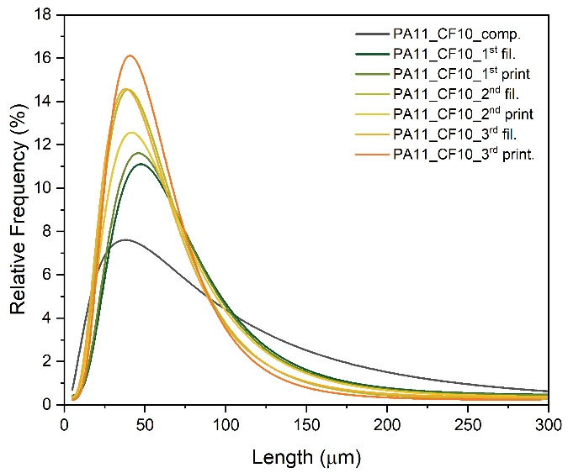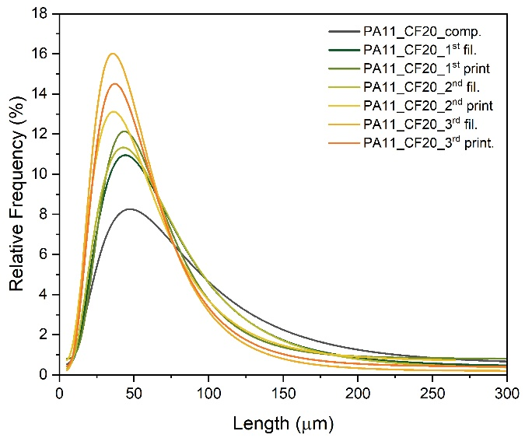
(a) | (b)
Figure 8: CF length frequency distributions of (a) PA11_CF10, (b) PA11_CF20 after compounding, extrusion, printing and the following recycling processes.
  - Quasi-static tensile tests
The values of elastic modulus (E), elongation at break ($ε_{b}$), and ultimate tensile strength (UTS) on virgin (before the recycling processes) HP and 3D printed samples are reported In Figure 9. PA11 produced by FFF, compared to the hot pressed, has similar elastic modulus but slightly lower strength. The elongation at break is instead much higher for the 3D printed specimens but with a very large standard deviation. Higher $ε_{b}$ values could be the result of the anisotropicity caused by the printing pattern that favour the orientation of the molecules along the load direction, with respect to the HP treatment that tends to produce isotropic materials. Another possible explanation could be given by the higher crystallinity of HP specimens (5% higher than 3D printed ones), induced by a slower and more controlled cooling rate, that makes the material stronger (as it can be seen from the UTS results) but more brittle. These two effects are then cancelled out by the addition of rCF that reinforce but at the same time embrittle the PA11 nullifying the positive effect of the raster angle and crystallinity. For the HP samples, the addition of carbon fibers almost linearly improves both elastic modulus and UTS while reducing the elongation at break. For the 3D printed specimens, the introduction of 10 wt% rCFs almost triples the elastic modulus while the UTS increases by 42%. Doubling the carbon content further increase both the stiffness and strength but only by an additional 20% and 9% respectively. Contrarily to E and UTS, $ε_{b}$ strongly decreases as the rCFs wt% increases, in fact, the printed PA11_CF20 has 10% of the elongation of the neat PA11 value. HP an FFF composites show similar properties at brake. In Figure 10 are reported the tests results on HP and 3D printed samples as virgin and after the two recycling steps. Virgin PA11 seems to not be affected by the thermal treatment maintaining a constant value of E and UTS for both production processes. As mentioned before $ε_{b}$ values are highly scattered. The low values after the first recycling could be caused by a suboptimal printing process that has more effect at higher elongations when the brake happen. This suggests that the decrease in E and UTS found for PA11_CF_print is probably caused by the fiber length reduction following the recycling steps. HP specimens’ properties are in general more constant than the 3D printed ones, especially for the stiffness. In fact, the HP process does not create large shear stresses preventing the breakage of the rCF inside the materials less affecting the mechanical properties. All the numerical values obtained from these tests are shown and listed in the from Table S11 to Table S17.

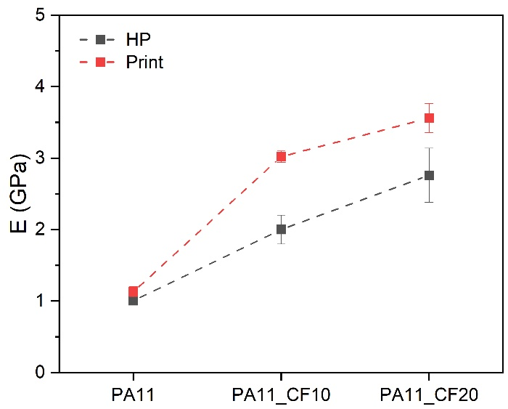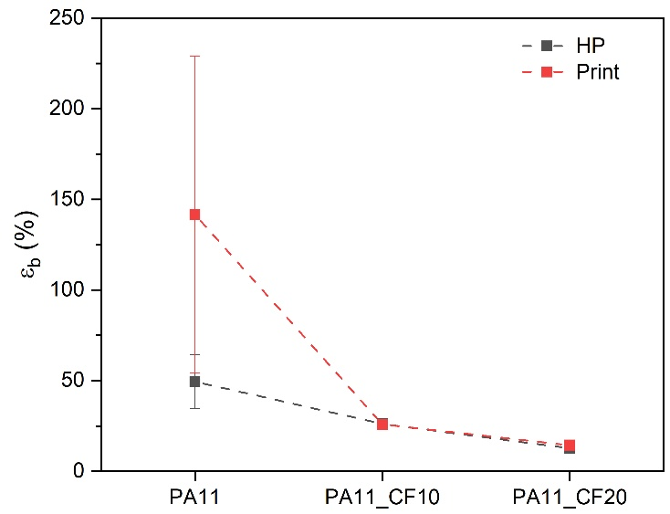
(a) | (b)

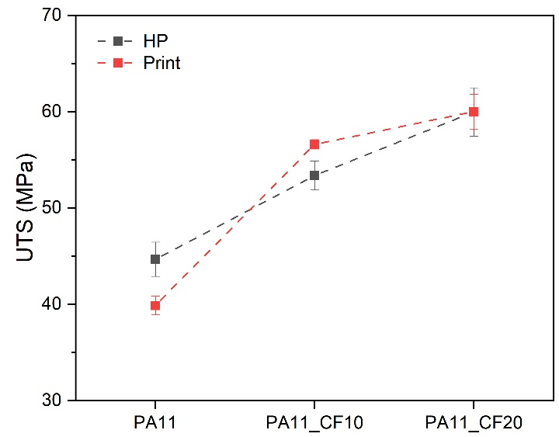
(c)
Figure 9: Results of the quasi-static tensile tests on virgin HP and 3D printed samples. (a) Elastic modulus, (b) strain at break, (c) ultimate tensile strength.
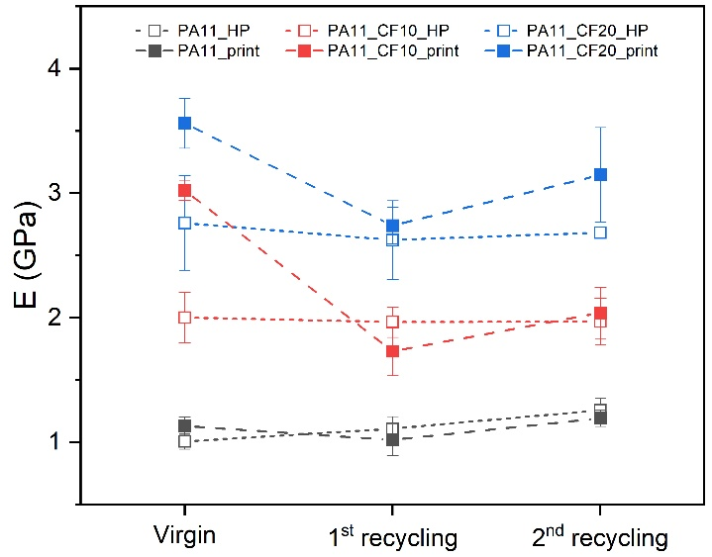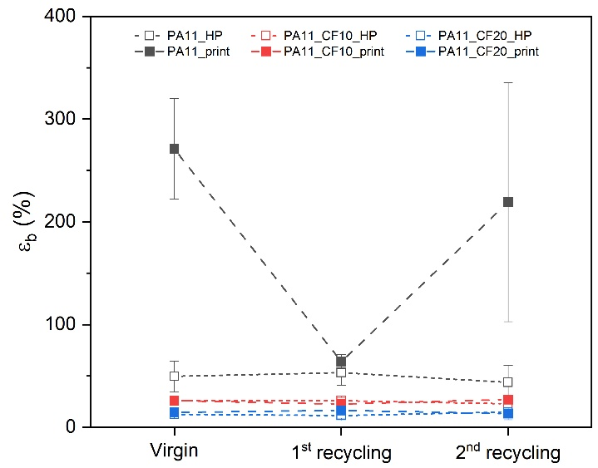
(a) | (b)

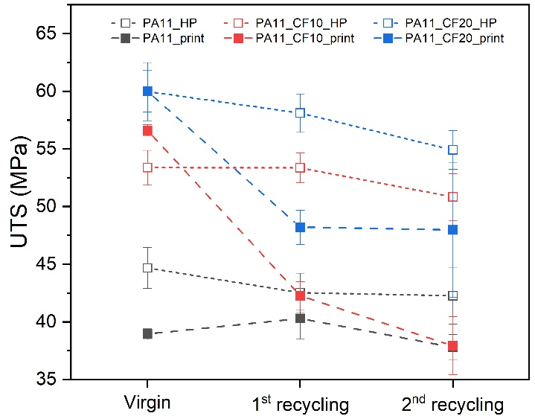
(c)
Figure 10: Results of the quasi-static tensile tests on HP and 3D printed samples at different recycling stages. (a) Elastic modulus, (b) strain at break, (c) ultimate tensile strength.

  - Evaluation of the impact strength
The maximum force (F_{max}) and impact strength of the materials are reported in Figure 11. In general, 3D printed specimens show slightly higher impact strength compared to their HP counterparts even though, especially for PA11, the deviation is sufficiently high to be considered similar. The introduction of 10% of rCF strongly reduces both the maximum force and the impact strength of the material. The fibers increase the brittleness of the material and favour the propagation of the crack. Instead, the sample containing 20% rCF has almost identical impact strength with respect to the lower rCF content sample but a higher maximum force, which is still lower than the neat PA11 for printed specimens. This means that the fibers can increase the load needed to crack initiation, but once formed the fracture easily propagates trough the specimen. Figure 12 reports the impact tests results on HP and 3D printed samples for different recycling stages. For HP specimens, maximum force and impact strength are more affected than tensile properties. PA11 is severely weakened by the recycling steps with both thermal processes. The rCF reinforced materials properties are more or less linearly affected but not as much as neat PA11. It is curious to see that in this case both HP and 3D printed specimens follow similar decreasing trends along the recycling stages, differently from tensile tests where HP specimens were much more stable. This may suggest that impact properties are more related to the matrix degradation rather than the breakage of the fibers. All the numerical values obtained from these tests are shown and listed in Table S18 to Table S20.

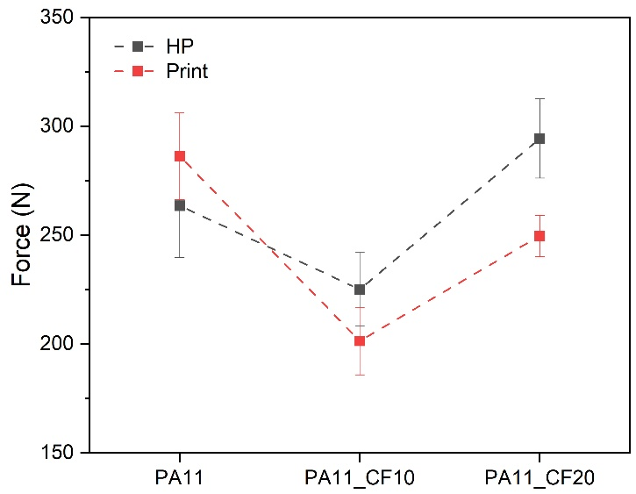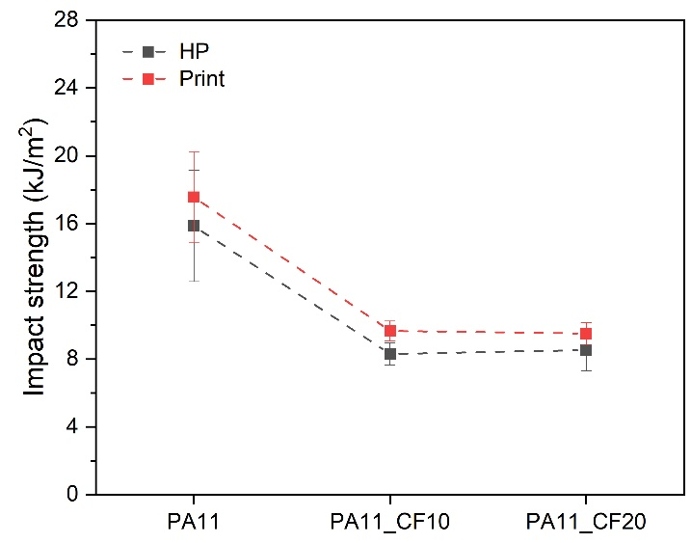
(a) | (b)
Figure 11: Comparison of the results of the Charpy impact tests on virgin HP and 3D printed samples. (a) Maximum force, (b) impact strength.
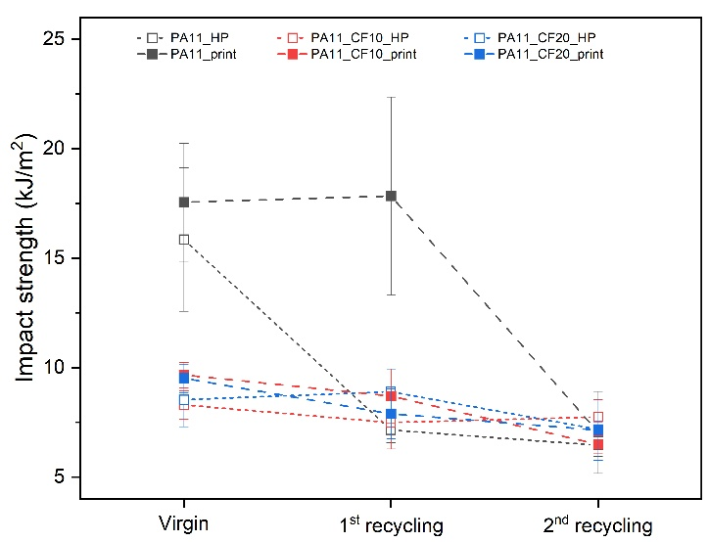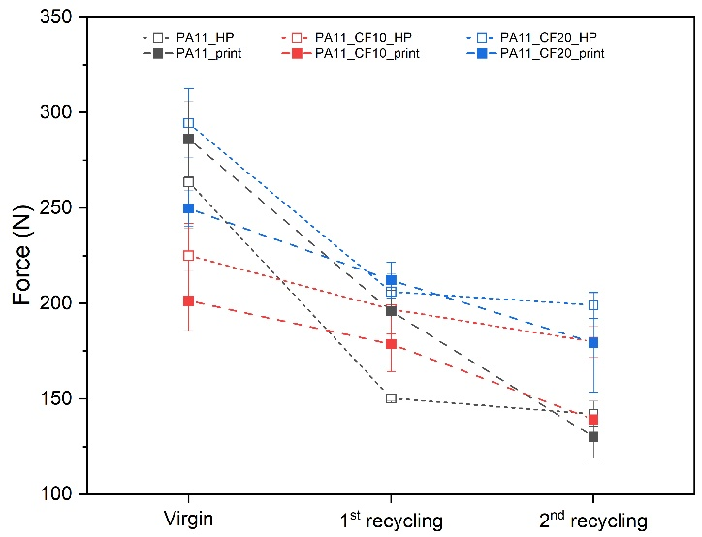
(a) | (b)
Figure 12: Results of the Charpy impact tests on HP and 3D printed samples for different recycling stages. (a) Maximum force, (b) impact strength.
- Conclusions
This study assessed the mechanical performance and recyclability of composites composed by a bio-based polyamide 11 reinforced with recycled carbon fibers and produced by both fused filament fabrication and hot-pressing. The complex viscosity of the composites decreases after each recycling step, with more significant reductions at lower shear rates due to chain scission and therefore reduction in molecular weight. The FFF recycling process induces more degradation than HP due to higher thermal and shear stresses and the additional step to be performed to produce an item. The composites with 20 wt% of rCF show slightly higher viscosity than those with 10 wt% of rCF thus slightly balancing polymer degradation. Dynamic mechanical thermal analysis showed that adding rCFs reduced shrinkage during cooling, with 20 wt% rCF composites achieving almost 90% less shrinkage compared to neat PA11, crucial for improving print quality without warping. Thermogravimetric analysis confirmed the expected fiber content in the composites and revealed that the fiber length distribution in 3D printed specimens is narrowed, and the mean shifted to lower values after each recycling step due to high shear stresses during production that cause the fibers to fragment. PA11 reinforced with rCFs shows improved stiffness and strength compared to neat PA11, though at the cost of reduced elongation at break and impact resistance. Increasing the rCF content from 10 wt% to 20 wt% enhances both elastic modulus and UTS. The improvements are almost linear for HP samples while FFF specimens experience diminishing returns at higher fiber loadings. The stiffness of 3D printed reinforced materials is up to 1 GPa higher with respect to the HP counterparts due to fibers orientation. Recycling by fused filament fabrication and hot-pressing leads to a gradual decrease in mechanical properties, more pronounced in 3D printed specimens due to fiber breakage during processing. Hot pressed PA11 has higher UTS than the 3D printed one probably because of its higher crystallinity induced by a slower cooling rate. The impact strength significantly drops with the addition of carbon fibers, with little difference between 10% and 20% rCF loadings. Both HP and 3D printed samples saw a decline in impact properties after recycling, likely tied to PA11 matrix degradation rather than fiber length reduction. In conclusion, PA11 reinforced with rCFs shows promise for sustainable additive manufacturing, but further optimization is needed to counterbalance mechanical degradation during recycling. While mechanical properties slightly degrade with each recycling stage, the material still retains reasonable performance, supporting its potential for circular manufacturing applications.
Acknoledgements
Funded by the European Union under Next Generation EU issione 4 Componente 2 – CUP E53D23005100006 - Materials sUSTainability for polymer Additive manufacturiNG (MUSTANG)

References
1. Statista. Global 3D printing products and services market size from 2020 to 2026 (in billion U.S. dollars). 2021; https://www.statista.com/statistics/315386/global-market-for-3d-printers/. Accessed 2024-02-20.
2. Dul S, Fambri L, Pegoretti A. High-performance polyamide/carbon fiber composites for fused filament fabrication: mechanical and functional performances. Journal of Materials Engineering Performance. 2021;30:5066-5085.
3. Dul S, Fambri L, Pegoretti A. Development of new nanocomposites for 3D printing applications. In: Structure and Properties of Additive Manufactured Polymer Components. Elsevier; 2020:17-59.
4. Park S, Shou W, Makatura L, Matusik W, Fu KK. 3D printing of polymer composites: Materials, processes, and applications. Matter. 2022;5(1):43-76.
5. Wasti S, Adhikari S. Use of biomaterials for 3D printing by fused deposition modeling technique: a review. Frontiers in chemistry. 2020;8:315.
6. Barera G, Dul S, Pegoretti A. Screw extrusion additive manufacturing of carbon fiber reinforced PA6 tools. Journal of Materials Engineering Performance. 2023;32(21):9579-9597.
7. Dey A, Roan Eagle IN, Yodo N. A review on filament materials for fused filament fabrication. Journal of manufacturing materials processing. 2021;5(3):69.
8. Dul S, Fambri L, Pegoretti A. Fused deposition modelling with ABS–graphene nanocomposites. Composites Part A: Applied Science Manufacturing. 2016;85:181-191.
9. Kováčová M, Kozakovičová J, Procházka M, et al. Novel hybrid PETG composites for 3D printing. Applied Sciences. 2020;10(9):3062.
10. Kanabenja W, Passarapark K, Subchokpool T, et al. 3D printing filaments from plasticized Polyhydroxybutyrate/Polylactic acid blends reinforced with hydroxyapatite. Additive Manufacturing. 2022;59:103130.
11. Jeong H, Rho J, Shin J-Y, Lee DY, Hwang T, Kim KJ. Mechanical properties and cytotoxicity of PLA/PCL films. Biomedical Engineering Letters. 2018;8:267-272.
12. Wachirahuttapong S, Thongpin C, Sombatsompop N. Effect of PCL and compatibility contents on the morphology, crystallization and mechanical properties of PLA/PCL blends. Energy Procedia. 2016;89:198-206.
13. Núñez Carrero KC, Herrero M, Alonso LE, et al. Biopolyamide composites for fused filament manufacturing: impact of fibre type on the microstructure and mechanical performance of printed parts. Progress in Additive Manufacturing. 2024;9(4):857-874.
14. Mollova A, Androsch R, Mileva D, Schick C, Benhamida A. Effect of supercooling on crystallization of polyamide 11. Macromolecules. 2013;46(3):828-835.
15. Heshmati V, Favis BD. High performance poly (lactic acid)/bio-polyamide11 through controlled chain mobility. Polymer. 2017;123:184-193.
16. Herrero M, Peng F, Nunez Carrero KC, Merino JC, Vogt BD. Renewable nanocomposites for additive manufacturing using fused filament fabrication. ACS Sustainable Chemistry Engineering. 2018;6(9):12393-12402.
17. Van de Werken N, Tekinalp H, Khanbolouki P, Ozcan S, Williams A, Tehrani M. Additively manufactured carbon fiber-reinforced composites: State of the art and perspective. Additive Manufacturing. 2020;31:100962.
18. Parandoush P, Lin D. A review on additive manufacturing of polymer-fiber composites. Composite Structures. 2017;182:36-53.
19. Hasan MR, Davies IJ, Pramanik A, John M, Biswas WK. Potential of recycled PLA in 3D printing: A review. Sustainable manufacturing service economics. 2024:100020.
20. Mikula K, Skrzypczak D, Izydorczyk G, et al. 3D printing filament as a second life of waste plastics—a review. Environmental Science Pollution Research. 2021;28:12321-12333.
21. Singh S, Singh G, Prakash C, Ramakrishna S. Current status and future directions of fused filament fabrication. Journal of Manufacturing Processes. 2020;55:288-306.
22. Sun B, Mubarak S, Zhang G, et al. Fused-deposition modeling 3D printing of short-cut carbon-fiber-reinforced PA6 composites for strengthening, toughening, and light weighting. Polymers. 2023;15(18):3722.
23. Calignano F, Lorusso M, Roppolo I, Minetola P. Investigation of the mechanical properties of a carbon fibre-reinforced nylon filament for 3D printing. Machines. 2020;8(3):52.
24. Benobeidallah B, Benhamida A, Dorigato A, Sola A, Messori M, Pegoretti A. Structure and properties of polyamide 11 nanocomposites filled with fibrous palygorskite clay. Journal of Renewable Materials. 2019;7(1):89-102.
25. Okamba-Diogo O, Richaud E, Verdu J, Fernagut F, Guilment J, Fayolle B. Investigation of polyamide 11 embrittlement during oxidative degradation. Polymer. 2016;82:49-56.
26. Mazan T, Berggren R, Jørgensen JK, Echtermeyer A. Aging of polyamide 11. Part 1: Evaluating degradation by thermal, mechanical, and viscometric analysis. Journal of Applied Polymer Science. 2015;132(20).
27. Carnicer V, Alcázar C, Orts M, Sánchez E, Moreno R. Microfluidic rheology: A new approach to measure viscosity of ceramic suspensions at extremely high shear rates. Open Ceramics. 2021;5:100052.
28. Acierno D, Patti A. Fused deposition modelling (FDM) of thermoplastic-based filaments: Process and rheological properties—An overview. Materials. 2023;16(24):7664.
29. Sangroniz L, Fernández M, Partal P, Santamaria A. Rheology of polymer processing in Spain (1995–2020). Polymers. 2021;13(14):2314.
30. Nair SS, Ramesh C, Tashiro K. Crystalline phases in nylon-11: Studies using HTWAXS and HTFTIR. Macromolecules. 2006;39(8):2841-2848.
31. Martino L, Basilissi L, Farina H, et al. Bio-based polyamide 11: Synthesis, rheology and solid-state properties of star structures. European polymer journal. 2014;59:69-77.

