Seismic Retrofitting of RC Buildings Using Cross-Laminated Timber Panels: Insights from the ERIES-STRONG project
Ivan Giongo¹[0000-0002-3867-2334], Francesco Graziotti^{2,3}[0000-0002-0223-0139], Nikolaos Stathas⁴Stathas⁴[0000-0002-5694-8779], Stathis Bousias⁴Bousias⁴[0000-0002-8616-334X], Francesco Smiroldo¹, Andrea Bartolotti¹, Nicolò Damiani^{2,3}[0000-0002-7221-963X], Albino Angeli⁵, Dmytro Dizhur⁶
¹ University of Trento, Department of Civil, Environmental and Mechanical Engineering, Italy
ivan.giongo@unitn.it
- University of Pavia, Department of Civil Engineering and Architecture, Pavia, Italy
- European Centre for Training and Research in Earthquake Engineering (EUCENTRE), Pavia, Italy
- University of Patras, Department of Civil Engineering, Greece
- XLAM DOLOMITI S.r.l., Italy
- PYTHON Fixings Ltd, New Zealand

Abstract. Timber, with strength-to-weight and modulus-to-strength ratios comparable to steel, is increasingly utilized in seismic retrofitting due to its versatility, sustainability, and rapid installation potential. However, concerns exist regarding its capacity to respond effectively to seismic events, particularly the risk of delayed activation compared to existing structural damage. Timber retrofits high deformability, largely attributed to the ductility of metal connections, enables significant displacements without compromising stability. Nonetheless, challenges arise when timber systems interact with brittle materials, such as in retrofits of reinforced concrete (RC) and masonry buildings, questioning the conventional ultimate limit state.
This study examines the application of cross-laminated timber (CLT) panels for retrofitting RC buildings, as part of the Sustainable Timber Retrofit Of reinforced coNcrete buildinGs (STRONG) project conducted at STRULAB, University of Patras, within the ERIES framework. A two-storey RC frame with masonry infill, representative of 1950–1970 Mediterranean construction practice, was retrofitted using a CLT-based technique (RC-TP) and tested under lateral cyclic loading up to ultimate conditions. The intervention prioritized life safety and global stability over damage containment during high-intensity events. This paper outlines the design criteria and experimental results, highlighting the potential of CLT panels to enhance seismic performance while ensuring structural stability.
Keywords: Seismic retrofit, Cross-laminated timber (CLT), Masonry infilled RC frames, Experimental tests, Finite element analysis.
- Introduction
Medium-rise reinforced concrete (RC) frame buildings with masonry infills constitute a significant portion of the built environment in many countries. However, their seismic vulnerability has been widely recognized following past earthquake events, which have highlighted the structural deficiencies of these systems, particularly when subjected to lateral loading [1-3]. Many of these buildings were originally designed considering only gravity loads, neglecting both seismic actions and the structural role of masonry infills [4]. While infills contribute to lateral stiffness and reduce inter-story drifts, their presence leads to increased seismic demands due to shorter fundamental periods [5] and can introduce detrimental effects, such as torsional responses and soft-story mechanisms when irregularly distributed [6,7]. Furthermore, local interactions between the infills and the RC elements may cause brittle failures in the frame, significantly affecting ductility and energy dissipation capacity [8,9].
To mitigate these vulnerabilities, various retrofit strategies have been explored. Common local interventions include external jacketing with reinforced concrete, steel, fibre-reinforced polymers (FRP), or fibre-reinforced cementitious matrices (FRCM), while global strengthening approaches often involve exoskeletons, bracing systems, shear walls, or seismic isolation [10-12]. While these solutions have demonstrated effectiveness, they often present challenges related to high costs, long construction times, and disruptions to building occupancy.
In recent years, timber has gained increasing attention as a viable alternative for seismic retrofitting. With strength-to-weight and stiffness-to-strength ratios comparable to steel, timber offers advantages in terms of sustainability, prefabrication, and rapid installation. However, concerns remain regarding its ability to provide immediate structural response during seismic events, particularly in cases where activation delay could compromise the existing frame’s integrity. The high deformability of timber-based systems, largely due to the ductility of metal fasteners, allows for significant displacements while preserving structural stability. Nonetheless, when combined with brittle materials, such as masonry-infilled RC frames, these systems challenge conventional performance-based design criteria.
This study investigates the application of cross-laminated timber (CLT) panels as a seismic retrofit solution for existing RC buildings. The research is part of the Sustainable Timber Retrofit of Reinforced Concrete Buildings (STRONG) experimental campaign, conducted at the STRULAB facility of the University of Patras within the framework of the ERIES (Engineering Research Infrastructures for European Synergies) project. A two-story, two-bay RC frame with masonry infills, representative of mid-20th century Mediterranean construction, was retrofitted using a CLT-based strengthening technique (RC-TP) and subjected to cyclic lateral loading up to ultimate conditions. This paper discusses the design criteria of the retrofit intervention, which prioritizes life safety and structural stability over damage limitation in high-intensity seismic scenarios.
- The retrofit intervention
The RC-TP (Reinforced Concrete–Timber Panels) retrofit system improves the seismic performance of masonry-infilled RC frames by enhancing lateral strength and deformability. It involves replacing selected infill wythes with cross-laminated timber (CLT) panels mechanically connected to the RC frame. Typical cavity infills consist of a strong outer wythe (solid clay bricks) and a weak inner wythe (hollow clay or concrete blocks). The outer wythe, forming a stiff diagonal strut under seismic loads, increases shear demand on the RC frame, risking brittle column failures. In previous studies (e.g., Smiroldo et al., 2023 [13]), the RC-TP retrofit strategy was tested by removing both wythes and fully replacing the infill with a CLT panel.
This experimental campaign represents the first implementation of an alternative RC-TP variant, where only the external strong wythe is removed, while the internal weak wythe is preserved. This configuration is expected to provide multiple advantages. Firstly, retaining the weak wythe minimizes disruptions to building occupants, reducing downtime and increasing the feasibility of the intervention in operational buildings. Secondly, the low strength and stiffness of the remaining infill are unlikely to induce detrimental frame-infill interactions, thereby avoiding the formation of undesired brittle failure mechanisms. Lastly, this retrofit approach capitalizes on the weak-column strong-beam configuration commonly found in gravity-load-designed RC buildings. By leveraging the inherent strength reserves of the beams, the intervention enhances lateral load resistance while mitigating premature brittle failures due to excessive column shear demand.
The retrofit system consists of installing a CLT panel within the RC frame, secured by a rectangular timber subframe. The panel’s strong direction is oriented vertically to support vertical loads in case of severe damage to the RC elements during earthquakes. The subframe is mechanically anchored to the RC frame using concrete screws designed to remain elastic under design-level seismic demands, ensuring integral movement with the structure. The CLT panel is connected to the subframe via dissipative shear connections using perpendicular, partially threaded screws. These fasteners govern force transfer and dissipate energy through controlled plastic deformation, promoting a ductile response while preventing brittle failures in the RC frame. A small gap between the CLT panel and the RC frame edges ensures load transfer occurs exclusively through the connectors, enhancing energy dissipation. The experimental campaign aims to assess the seismic effectiveness and feasibility of this modified RC-TP strategy for widespread application in existing RC buildings.
A detailed description of the numerical model used for predicting the behaviour of the specimens is provided in Bartolotti et al. (2024) [14]. In the As-Built (MI) configuration, masonry infills are modelled as concentric equivalent struts based on the Liberatore model [15], with adjustments for openings using established strength and stiffness reduction factors [16]. In the Retrofitted configuration, the CLT panel is modelled with orthotropic elastic shell elements, while panel-to-subframe connections are represented by multi-linear plastic links calibrated from experimental data [13].

- Structural design philosophy
The experimental campaign involves testing two full-scale, two-story, two-bay RC frame specimens from the elastic range up to ultimate conditions. One specimen (S1) represents the as-built (unreinforced) configuration, while the second specimen (S2) corresponds to the retrofitted configuration. The geometry and material properties of the RC elements remain identical in both configurations, ensuring that the only difference between S1 and S2 lies in the retrofit intervention itself.
  - As-Built Reference Specimen
The as-built specimen (S1) was designed to represent mid-20th-century Mediterranean RC buildings, a typology that experienced rapid growth during the post-war period. In this era, RC frames with masonry infill walls became the dominant construction method across Southern Europe. For example, in Italy, the number of RC buildings rose dramatically from 77,122 in 1945 to 1,057,267 in 1970, reflecting a twelvefold increase in just 25 years (ISTAT, 2011) [17]. Similar trends were observed in other Mediterranean countries, demonstrating the widespread adoption of this construction technique.
To ensure historical accuracy, Italian building codes and construction practices from the period were used as references, specifically the Regio Decreto Legge (RDL) of 1939 [18] and the Ministerial Circular No. 1472 of 1957 [19]. However, an analysis of original project documentation revealed that code prescriptions were not always strictly followed, mainly due to material shortages, cost-cutting measures, and the absence of rigorous structural inspections.
For both numerical modelling and experimental testing, the materials selected align with those most commonly used in RC construction during this period. The concrete mix followed historical prescriptions, with a minimum compressive strength of 120 kg/cm² at 28 days, as per the RDL 1939 and Circular 1957. The reinforcement steel consisted of plain bars, type AQ42, as documented by Verderame et al. (2011) [20]. However, for the actual construction of the specimens, the most probable material properties for existing buildings were adopted, including a mean concrete compressive strength of f_{cm} = 14.5 MPa, based on the findings of Cristofaro et al. (2012) [21], and a yield strength of f_{ym} = 322.4 MPa for the reinforcement steel, as determined using Stil software (ReLUIS – Stil [22]).
The as-built structure was designed solely for gravity loads, in accordance with common mid-century engineering practices, where seismic considerations were often neglected in ordinary building design. Simulating the original design approach based on historical codes and project documentation led to a weak-column/strong-beam configuration, which is a key factor influencing its seismic performance. The columns emerge as the most vulnerable structural elements, raising concerns about potential brittle shear failures during lateral loading.
To ensure consistency when assessing the as-built and retrofitted configurations, collapse mechanisms and cross section strengths were evaluated following modern Eurocode provisions. The analysis conducted using the most probable materials for the period revealed that the ratio between the shear stress associated to the column flexural failure and its shear strength was = 0.79. This ratio was taken as a reference to determine the target concrete compressive strength, ensuring that the hierarchy of collapse mechanisms remained unchanged even when using the materials available for specimen fabrication. A key challenge emerged, in fact, when sourcing reinforcement bars: only plain bars with a yield strength of f_{ym} = 220 MPa were available. Although this value is within the acceptable range for AQ42 steel from the 1950–1970 period (with a lower bound of 211.9 MPa, according to structural analysis software), it is significantly lower than the expected 322.4 MPa. Given the yield strength of 220 MPa for the reinforcement steel, the required target concrete compressive strength was found to be f_{cm} = 8 MPa.
The reinforcement layout for the RC frame elements was designed based on typical assumptions for mid-20th-century residential buildings. The frame was assumed to be located at the ground floor of a three-story residential building, with a vertical load of 200 kN applied at the top of each column, consistent with standard load distributions for buildings of this period. The top beam of the frame was subjected to loads transmitted by the floor slab and the overlying masonry infill, assuming an influence length of 3 meters. The resulting distributed load acting on the beam was estimated at 16.5 kN/m.
In accordance with construction practices of the time, shear forces were resisted by both stirrups and bent-up bars, following a widely adopted reinforcement strategy in RC construction during the mid-to-late 20th century. This design ensured an effective distribution of shear forces, utilizing both transverse reinforcement and longitudinal bars shaped to enhance resistance. However, it is well known that bent-up bars lose their shear resistance capacity in cases of shear force reversal, which may occur under seismic loading.
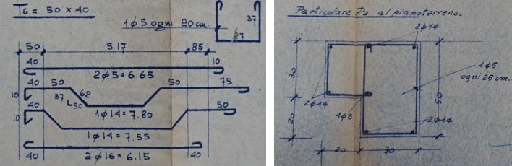
Fig. 1. Example of typical reinforcements in buildings from 1950–1970

To address this issue, the original design relied on the presence of sustained vertical loads on the beam, which inherently provided a margin of safety against shear force reversals. However, since the experimental setup did not allow for the direct application of distributed loads on the beam, the reinforcement layout was modified accordingly. Specifically, the stirrup spacing was adjusted, increasing the density of transverse reinforcement to compensate for the absence of an applied distributed load, thereby ensuring that the margin of safety remained unchanged (Fig. 1).
This adaptation faithfully reproduces realistic service conditions, while also optimizing the experimental setup. By adjusting stirrup spacing, the study ensures that internal force distributions remain consistent with those expected under real building conditions, allowing for an accurate evaluation of structural performance under seismic loading.
The mechanical properties of the masonry infill walls were defined based on data available from the literature [13]. The as-built configuration included a double-wythe cavity wall, composed of an internal weak wythe made of hollow clay blocks and an external strong wythe made of solid clay bricks. In the retrofitted configuration, only the internal weak wythe was retained, while the external wythe was removed and replaced with the RC-TP system. This distinction is critical, as it influences the interaction between the infill and the RC frame, particularly under lateral loads.

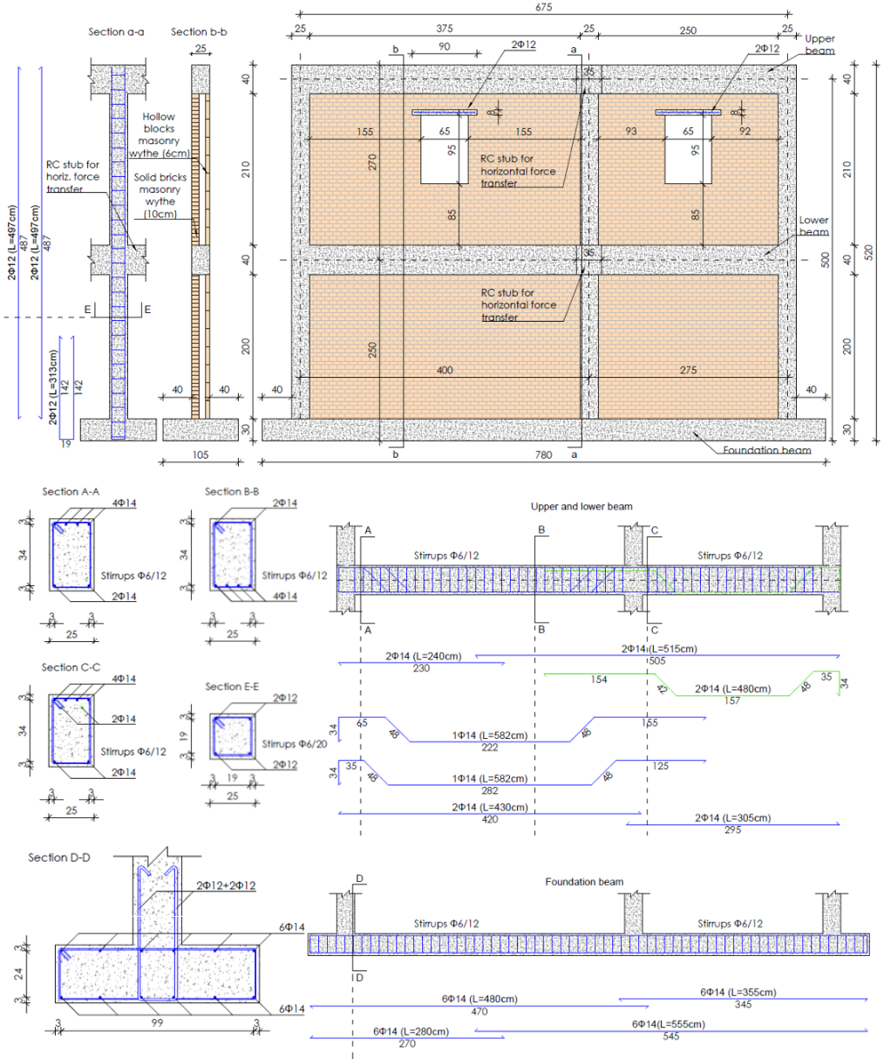
Fig. 1. Details of the as-built specimen S1
  - The retrofit strategy
Previous studies have shown that placing fasteners on the column side can increase the lateral strength of the frame, but it can also lead to a significant rise in shear demand on the columns. To mitigate this effect, the panel-to-subframe fasteners (φ10, 160 mm long partially threaded screws [23]) were placed exclusively on the beam side, ensuring that the seismic load transfer does not excessively amplify shear forces in the columns.
The spacing of the fasteners between the CLT panel and the subframe along the beam was carefully designed to balance two key factors: reducing the spacing enhances the lateral strength of the frame, but at the same time, it increases shear demand on the beams. Therefore, the fastener layout along the beam was calibrated to prevent exceeding the shear capacity of the beams while ensuring an effective load transfer mechanism. Additionally, to account for the distribution of forces along the height of the frame, a larger fastener spacing was adopted at the first floor compared to the ground floor, following the expected force distribution along the structure.
To optimize the retrofit configuration, an advanced finite element analysis was conducted to evaluate the performance of different fastener spacing layouts between the CLT panel and the subframe. The study considered several spacing configurations, including a 10 cm spacing at the ground floor combined with a 15 cm spacing at the first floor (R1), a 10 cm spacing at the ground floor with a 20 cm spacing at the first floor (R2), and a 15 cm spacing at the ground floor together with a 20 cm spacing at the first floor (R3). The numerical results showed that the last configuration provided the best balance between increased lateral strength and delayed brittle failure mechanisms. Specifically, this layout resulted in an estimated 50% increase in lateral strength compared to the unreinforced frame, while also enhancing the deformation capacity of the system and reducing the risk of premature failure. Based on these numerical findings, the selected retrofit configuration for the experimental phase incorporated a 15 cm fastener spacing at the ground floor and a 20 cm spacing at the first floor, ensuring an optimal trade-off between structural resistance and ductility.

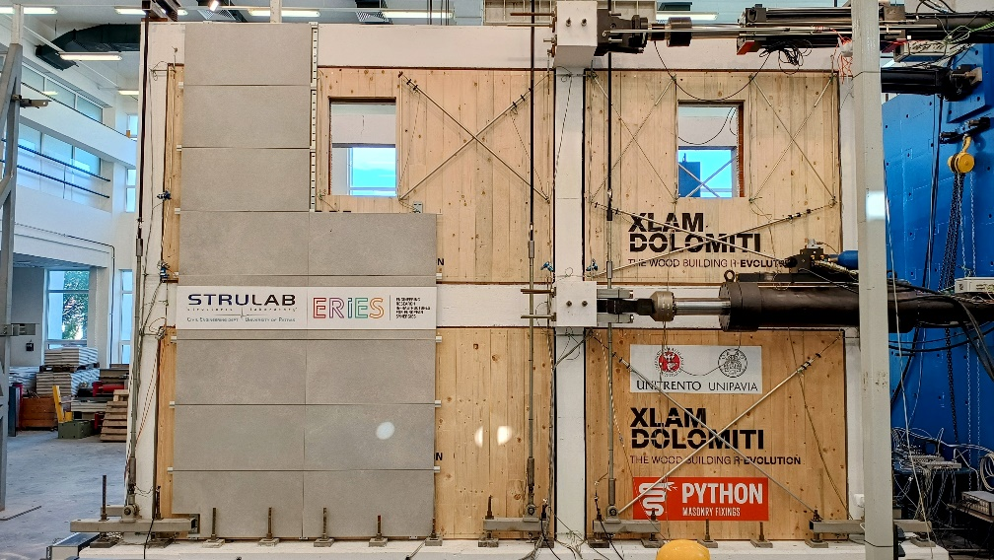
Fig. 2. Specimen S2 ready for testing
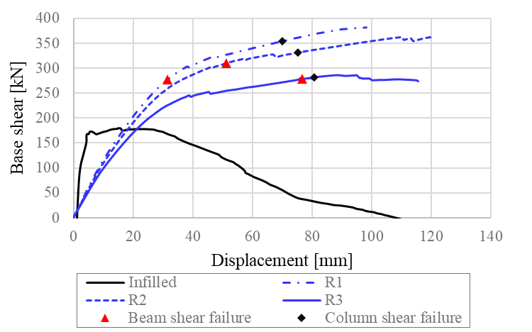
Fig. 3. Numeric simulations: pushover curve comparison
- Material characterization and retrofit design updating
A preliminary experimental testing campaign was conducted to characterize the mechanical properties of materials and connections, providing essential data for refining the numerical models and updating the retrofit strategy accordingly. These tests included compression tests on concrete cubes (f_{c,c}), tensile tests on reinforcing bars (f_{y,b}) and stirrups (f_{y,s}), flexural (f_{f,mr}) and compression tests (f_{c,mr}) on mortar prisms, compression tests on bricks (f_{c,br}) and blocks (f_{c,bl}), compression tests on masonry prisms (bricks f_{c,br,ms}, blocks f_{c,bl,ms}), shear tests on masonry triplets (bricks f_{v,br,mr}, blocks f_{v,bl,mr}), and pull-out (f_{w,TC}) and cyclic/monotonic pushout (elastic stiffness k_{TC}, yielding force f_{vy,TC}, maximum force f_{vu,TC}) tests on timber-to-concrete connections (Fig. 2).

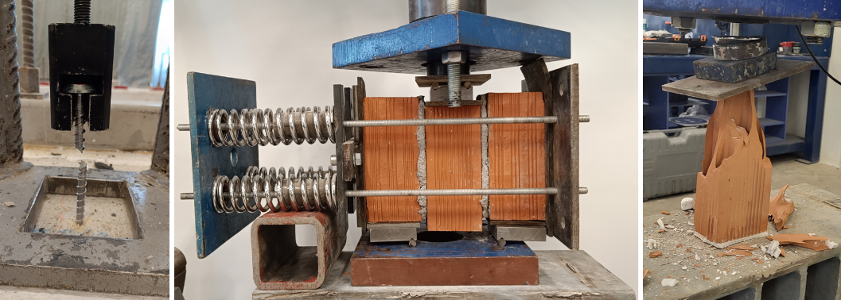
Fig. 2. Selected photos from the preliminary material testing: fasteners pull-out tests; masonry shear tests; block compression tests

The results of the preliminary tests are summarized in tabular form (Table 1).
The updated mechanical properties of the existing materials involve a significant increase in the capacity of the frame in the "as-built" configuration compared to the initially assumed values (Reference Specimen described in section 3.1). Nevertheless, these characteristics remain consistent with the typical range of material properties used in constructions built between 1950 and 1970. In this context, it was considered appropriate not to prioritise an extreme increase in load-bearing capacity (e.g., by introducing connections along the columns), but rather focusing the intervention on enhancing the system's deformation capacity and overall ductility. The proposed configuration was therefore revised to reflect the actual characteristics of the existing frame.
One of the key adjustments involved refining the connection modelling between the RC frame and the timber subframe. Specifically, the behaviour of the panel-to-frame connection link was modified to account for the elastic stiffness of timber-to-concrete (TC) connectors, which were modelled as springs in series (in the original model such connection was assumed as rigid). This adjustment was applied exclusively in the shear direction, parallel to the panel edges, ensuring a realistic representation of the connection's deformability. In contrast, in the direction orthogonal to the panel edges, the extraction and compression behaviour was assumed to be rigid, preserving the original link properties in this direction.
To enhance the reversibility of the intervention and minimize environmental impact, the connection between the RC frame and the timber subframe was designed as a dry joint (made with two rows of 340 mm long equally spaced screw fasteners with a shank diameter of 8 mm [24]), avoiding the use of resins or adhesives. This approach allows for the potential removal of the retrofit system without causing damage to the existing structure, while also simplifying the end-of-life disassembly of the intervention. To ensure the effectiveness of the retrofit, this connection was designed to be sufficiently rigid and to have overstrength relative to the panel-to-subframe connection, preventing premature failure at the interface.
The spacing of the TC fasteners was determined based on the above-mentioned testing and data provided by the manufacturer. The design criteria dictated that the shear demand on the connection should remain below the shear yield limit, while the extraction demand should not exceed the withdrawal threshold. Based on these verifications, an initial spacing of 14 cm at the first floor and 18 cm at the second floor was adopted. The higher-than-expected strength of the masonry infill panels, as observed in the material characterization tests, necessitated a revision of the panel-to-subframe connector spacing. In particular, the spacing was reduced from 15 cm to 12.5 cm at the first floor and from 20 cm to 18 cm at the second floor. Furthermore, supplementary screws were installed at the corners of the CLT panels: three per corner at the ground floor level and two per corner at the upper floor level. This modification was implemented without altering the expected failure mechanism of the system. The higher strength of the stirrups, which increased from the expected 220 MPa to 325 MPa based on preliminary tensile tests, resulted in a higher shear capacity of beams and columns, ensuring that the structural response remained consistent with design assumptions.
The refinements introduced in the numerical modelling and retrofit layout ensure that the RC-TP system effectively improves the lateral resistance and ductility of the retrofitted structure, while also maintaining a balance between strength and deformation capacity. The updated design parameters were subsequently incorporated into the final retrofit strategy, ensuring an optimized structural performance under seismic loading.

Table 1 Material properties

 | f_{c,c} | f_{y,b} | f_{y,s} | f_{f,mr} | f_{c,mr} | f_{c,br} | f_{c,bl} | f_{c,br,ms} | f_{c,bl,ms} | f_{v,br,mr} | f_{v,bl,mr} | f_{w,TC} | k_{TC} | f_{vy,TC} | f_{vu,TC}
N° Test | 12 | 6 | 3 | 18 | 36 | 8 | 8 | 3 | 3 | 3 | 3 | 31 | 3 | 3 | 4
Mean | 15.6  MPa | 278.7  MPa | 323.1  MPa | 1.8  MPa | 3.8  MPa | 8.5  MPa | 24.8  MPa | 7.4  MPa | 1.4  MPa | 0.6*  MPa | 0.4**  MPa | 51.4  kN | 1.9 kN/mm | 7.6  kN | 18.4 kN
CV [%] | 7.4 | 7.6 | 0.6 | 23.5 | 33.9 | 26.6 | 17.3 | 19.3 | 10.9 | 22.2 | 34.0 | 4.2 | 19.4 | 17.7 | 8.2
* Test performed with a constant compression equal to 0.2 MPa
** Test performed with a constant compression equal to 0.1 MPa

- Test results and model updating
Fig. 4 shows the experimental response of specimens S1 and S2 in terms of base shear versus total drift (Dr). It also presents the predictions from the numerical models, which were updated by incorporating the actual material properties measured in the tests described in the previous section. The as-built specimen S1 reached a maximum base shear of 398 kN at approximately 0.5% drift, followed by a softening branch up to Dr = 1.2%, at which point the test was stopped due to the infill walls at the top storey being on the verge of collapse. The retrofitted specimen S2, which involved the removal of the strong external wythe and the application of RC-TP strengthening, showed a 24% increase in capacity, reaching 492 kN at a much larger drift of approximately 2%, when the test was stopped for safety reasons. The pushover responses predicted by the numerical models for both the as-built and retrofitted configurations are represented by the blue curves, which match the experimental data with sufficient accuracy.
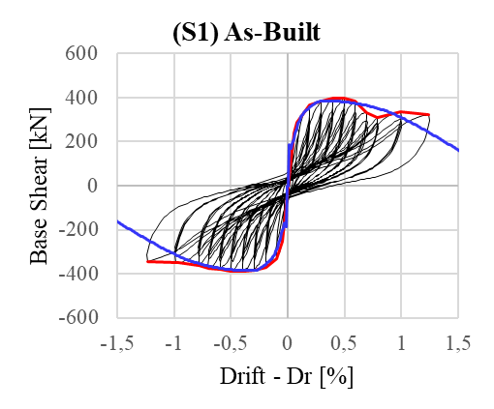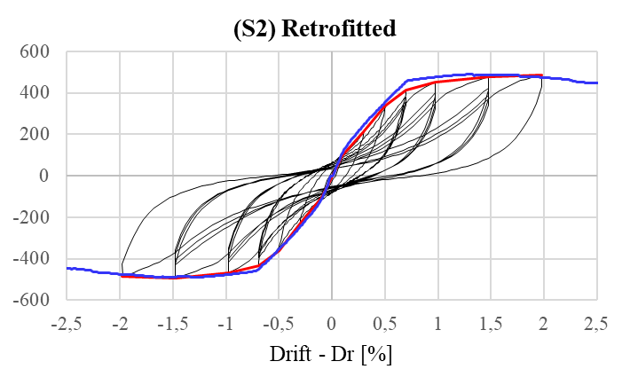
Fig. 4. S1 and S2 specimens: test results and numerical predictions

- Concluding remarks
This study presented the development, modelling, and experimental validation of a cross-laminated timber (CLT)-based retrofit strategy (RC-TP) for improving the seismic performance of existing RC frames with cavity infill walls. The work was carried out within the Sustainable Timber Retrofit Of reinforced coNcrete buildinGs (STRONG) experimental campaign, hosted at the University of Patras as part of the ERIES (Engineering Research Infrastructures for European Synergies) project. The proposed intervention, applied for the first time while retaining the internal masonry wythe, proved effective in enhancing both lateral strength and deformation capacity without altering the expected failure mechanisms. The integration of material characterization into the numerical modelling process enabled accurate prediction of global behavior, which was confirmed by the experimental results. The findings highlight the potential of the RC-TP system as a sustainable and minimally invasive retrofit solution for gravity-load-designed RC buildings.
- Acknowledgements
This work is part of the transnational access project “ERIES-C73”, supported by the Engineering Research Infrastructures for European Synergies (ERIES) project (www.eries.eu), which has received funding from the European Union’s Horizon Europe Framework Programme under Grant Agreement No. 101058684. This is ERIES publication number C73.
The 2024-2026 ReLUIS-DPC Project framework (funded by the Italian Emergency Management Agency, DPC) is also gratefully acknowledged for the support given to the research. XLAM Dolomiti Spa and PYTHON® Fixings are thanked for providing their products.
- References
- Sezen H, Whittaker AS, Elwood KJ, Mosalam KM (2003) Performance of reinforced concrete buildings during the August 17, 1999 Kocaeli, Turkey earthquake, and seismic design and construction practise in Turkey. Eng Struct;25(1):103–14.
- Decanini LD, De Sortis A, et al. (2004) Performance of reinforced concrete buildings during the 2002 Molise, Italy. Earthquake Spectra;20(S1)S221–55.
- Verderame GM, De Luca F, Ricci P, Manfredi G (2011) Preliminary analysis of a soft-storey mechanism after the 2009 L’Aquila earthquake. Earthquake Eng Struct Dyn ;40(8)925–44.
- Masi A (2003) Seismic vulnerability assessment of gravity load designed R/C frames. Bull Earthq Eng 1(3):371–395
- Asteris PG, Repapis CC, Cavaleri L, Sarhosis V, Athanasopoulou A (2015) On the fundamental period of infilled RC frame buildings, Struct. Eng. Mech. 54 (6) 1175–1200.
- Gong M, Zuo Z, Wang X, Lu X, Xie L (2019) Comparing seismic performances of pilotis and bare RC frame structures by shaking table tests. Eng Struct;199:109442.
- Choudhury T, Kaushik HB (2018) Seismic fragility of open ground storey RC frames with wall openings for vulnerability assessment. Eng Struct 155:345–357.
- De Luca F, Morciano E, Perrone D, Aiello MA (2016) MID 1.0: masonry infilled RC frame experimental database. Italian concrete days, Rome, Italy; 27–28 October 2016.
- Xu H and Brodsky A (2022) "Multi-platform simulation of infilled shear-critical reinforced concrete frames subjected to earthquake excitations." Bulletin of Earthquake Engineering: 1-26.
- Gkournelos PD, Triantafillou TC, and Bournas DA (2021) Seismic upgrading of existing reinforced concrete buildings A state-of-the-art review. Eng. Struct. 240 112273.
- Di Lorenzo G, Colacurcio E, Di Filippo A, Formisano A, Massimilla A, & Landolfo R (2020) "State-of-the-art on steel exoskeletons for seismic retrofit of existing RC buildings." International Journal 37.1
- Labo, S., Passoni, C., Marini, A., & Belleri, A (2020) Design of diagrid exoskeletons for the retrofit of existing RC buildings. Engineering Structures, 220, 110899.
- Smiroldo, F., Kallioras, S., Sommacal, G., Bournas, D., Piazza, M., & Giongo, I. (2023). Full-scale testing of masonry-infilled RC frames retrofitted with cross-laminated timber panels. Engineering Structures, 294, 116789. DOI: 10.1016/j.engstruct.2023.116789
- Bartolotti A., Smiroldo F., Giongo I., 2024, "Nonlinear Dynamic Study on Existing Masonry-Infilled Concrete Frames Retrofitted with Timber Panels". STRUCTURES, v. 2024, 69, (2024), p. 1-13. - https://doi.org/10.1016/j.istruc.2024.10732
- Liberatore, L., Noto, F., Mollaioli, F., & Franchin, P. (2018). In-plane response of masonry infill walls: comprehensive experimentally-based equivalent strut model for deterministic and probabilistic analysis. Engineering Structures, 167, 533–548. DOI: 10.1016/j.engstruct.2018.04.057
- Hossameldeen, M., & Romão, X. (2020). Effect of openings on the seismic vulnerability assessment of masonry infilled reinforced concrete frames. Engineering Structures, 205, 110078.
- ISTAT. 154◦Censimento della Popolazione e delle Abitazioni. 2011. (In Italian).
- R.D.L. 16 NOVEMBRE 1939 N◦2228–2232 (Suppl. Ord. alla Gazz. Uff. del 18 aprile 1940 n◦92) Norme per l’esecuzione delle opere in conglomerato cementizio semplice od armato. (In Italian).
- CIRCOLARE 23 MAGGIO 1957 N◦1472, Armature delle strutture in cemento armato. (In Italian).
- Verderame, G. M., Ricci, P., Esposito, M., & Sansiviero, F. C. (2011). Le caratteristiche meccaniche degli acciai impiegati nelle strutture in ca realizzate dal 1950 al 1980. XXVI Convegno Nazionale AICAP.
- Cristofaro M. T., D’Ambrisi A., De Stefano M., Pucinotti R., & Tanganelli M., 2012. Studio sulla dispersione dei valori di resistenza a compressione del calcestruzzo di edifici esistenti. Il Giornale delle Prove non Distruttive, Monitoraggio, Diagnostica, 2, 32-39 (in Italian).
- ReLUIS - Stil Software. STIL: Software for material characterization in historical RC buildings. Available at: https://www.reluis.it/stil/
- ETA 11/0190. Würth self-tapping screws: Screws for use in timber constructions. DIBt; 2018
- https://www.pythonfixings.co.nz/

