Supporting information
Engineering the Hybrid Interfaces in Ladder-Like Polysilsesquioxane/Al₂O₃ Nanocomposites for Enhancing Thermal Conductivity
Chiara Romeo^{a,*}, Emanuela Callone^{a,b}, Riccardo Ceccatoª, Francesco Parrinoª, Giulia Frediª, Alessandra Vitale^{c,d}, Ignazio Roppolo^{c}, Roberta Bongiovanni^{c,d}, Massimiliano D’Arienzo^{e}, Sandra Dirè^{a,b,*}

ª Department of Industrial Engineering, University of Trento, via Sommarive 9, 38123 Trento, Italy
^{b} “Klaus Müller” Magnetic Resonance Lab., Department of Industrial Engineering, University of Trento, Via Sommarive 9, 38123 Trento, Italy
^{c} Department of Applied Science and Technology, DISAT, Politecnico di Torino, Corso Duca degli Abruzzi 24, 10129 Torino, Italy
^{d} INSTM UdR Politecnico di Torino, Via G. Giusti 9, 50121 Firenze, Italy
^{e} Department of Materials Science, University of Milano - Bicocca, Via R. Cozzi 55, 20125 Milano, Italy

* Corresponding authors: C. Romeo, chiara.romeo@unitn.it, S. Dirè, sandra.dire@unitn.it

S1. Sample preparation
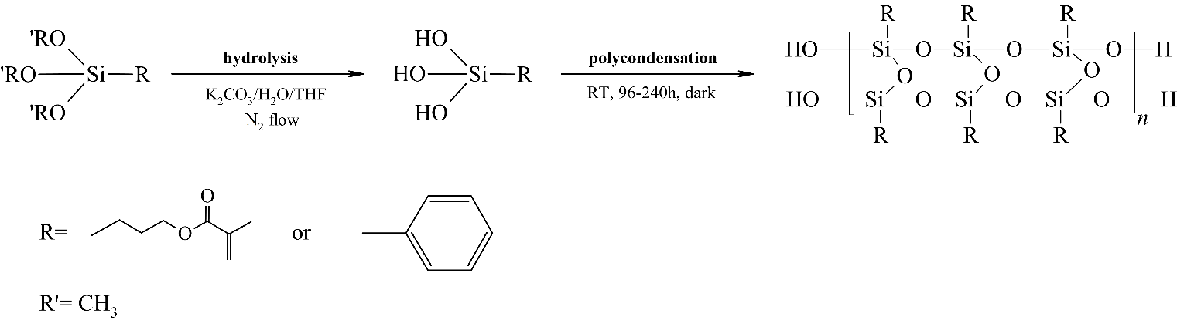
Scheme S1: LPSQs synthesis through base-catalyzed MPTMS and PTMS hydrolysis-condensation.

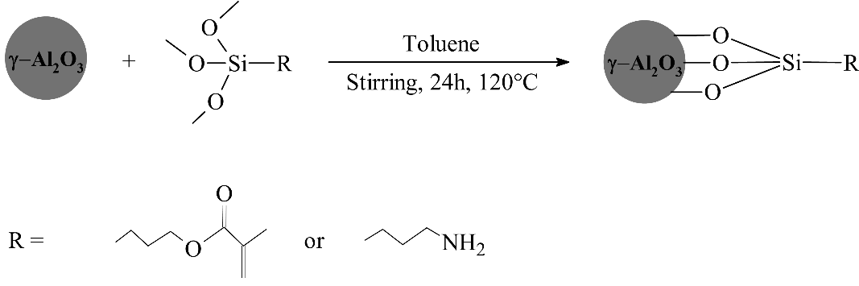
Scheme S2: Functionalization of alumina nanoparticles with MPTMS and APTMS.
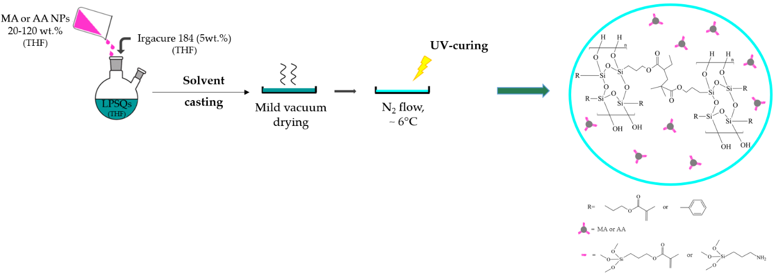
Scheme S3: Preparation of LPSQs/Al₂O₃ nanocomposites with a schematic representation of the cured nanocomposite film.

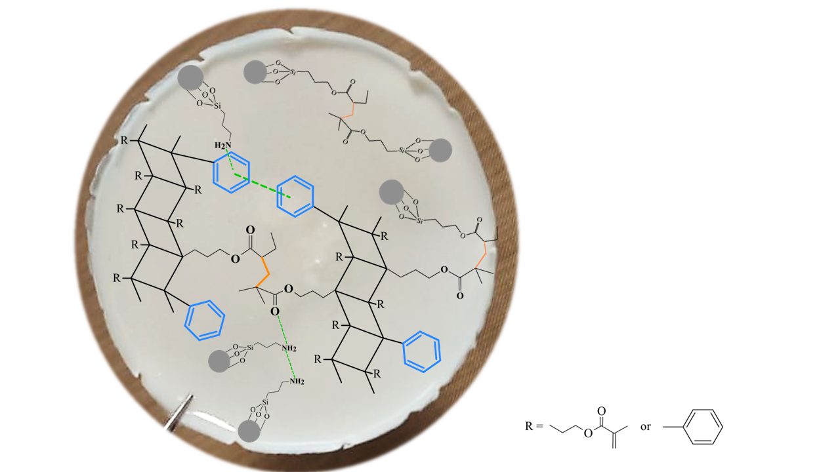

Scheme S4: Schematic illustration of possible interfacial interactions in LPSQ-based nanocomposites. Orange lines represent covalent interactions, whereas green dotted lines indicate weak interactions (e.g., hydrogen bonding, van der Waals forces, π-π stacking).

a) 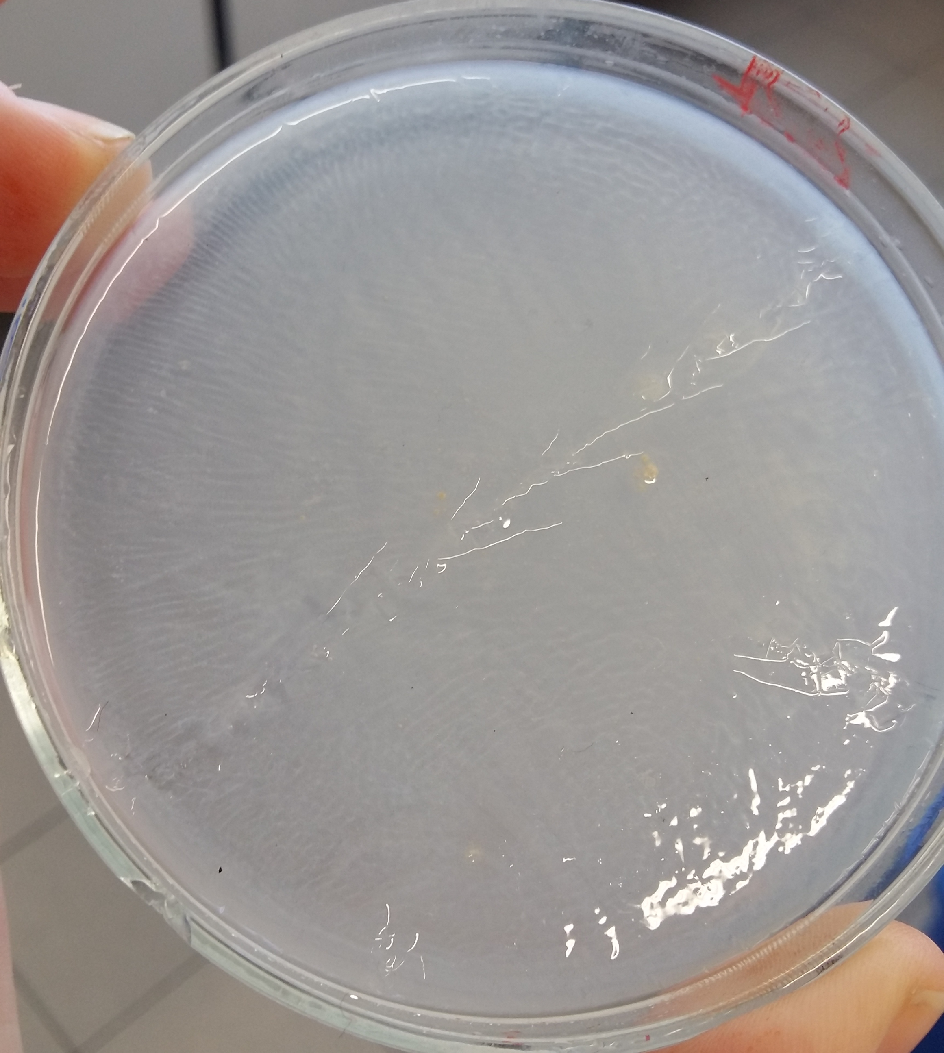 b) 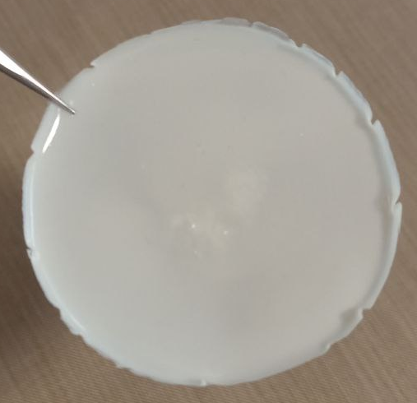
1 cm
1 cm
Figure S1: Images of photocured LPMASQ (a) and photocured 80MA_L (b) samples. The selected images are representative of the appearance of the matrices and of the nanocomposites, respectively.

S2. FTIR characterization of photo-crosslinked ladder matrices
FTIR spectra (Figure S2) show the Si-O-Si asymmetrical stretching bands centered at 1100 cm⁻¹ and 1025 cm⁻1, typical of ladder-like structures. In addition to the aliphatic C−H stretching vibrations below 3000 cm⁻¹ present in LPMASQ spectrum, MAPSQ(64) and MAPSQ(46) exhibited also the aromatic C−H stretching vibrations around 3100 cm⁻¹. The Si–C vibration from the aryl silyl group (at 1120 ± 20 cm⁻¹) [32] cannot be distinguished due to the overlapping of the siloxane vibration. Both carbonyl stretching vibrations (1716 cm⁻¹) and vinyl stretching vibrations (1637 cm⁻¹) of methacryloxypropyl groups are clearly detected in all samples. Adsorbed water and possible residual silanols are responsible for the weak OH stretching band near 3500 cm⁻¹.
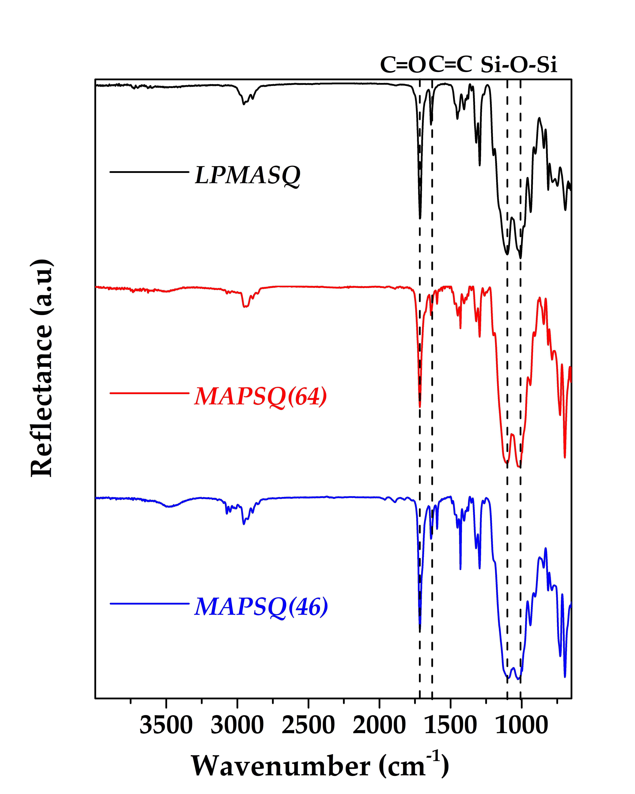
Figure S2: ATR-FTIR spectra of the three ladder matrices.

S3. Structural characterization of functionalized Al₂O₃ NPs
The functionalization of alumina nanoparticles was checked by FTIR and SS-NMR (Figures S3 and S4).
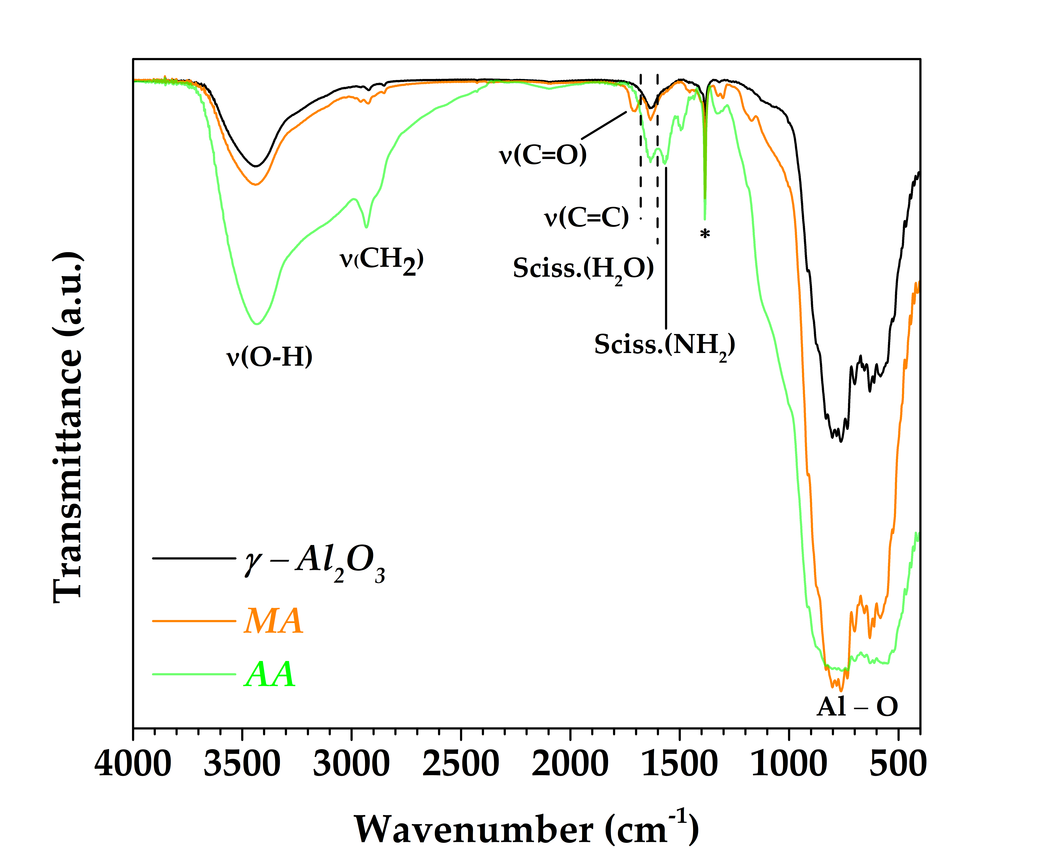
Figure S3: FTIR spectra of bare γ-Al₂O₃ (black line), MPTMS-capped Al₂O₃ nanoparticles (orange line) and APTMS-capped Al₂O₃ nanoparticles (green line). * : impurity.

The FTIR spectrum of bare γ-Al₂O₃ (black line in Figure S3) shows the broad band at 3440 cm⁻¹ due to the O–H stretching vibration of surface hydroxyl groups and adsorbed water, the latter proved by the water scissoring band at 1635 cm⁻¹; the characteristic absorption band of γ-Al₂O₃ below 1000 cm⁻¹ results from the overlapping of two signals at 800 and 600 cm⁻¹, assigned to Al–O stretching and bending vibrations, respectively.
New peaks can be observed in the spectra of functionalized NPs: the characteristic peaks of the methacryloxy group appear in the MA spectrum at 1710 cm⁻¹ (C=O stretching) and 1635 cm⁻¹ (C=C stretching), the latter being overlapped with water scissoring vibration. Additional bands between 3000 and 2800 cm⁻¹ and a peak at 1456 cm⁻¹ are assigned to the stretching and deformation vibrations of methylene groups in the organosilane propyl chain; these bands are also detectable in AA spectrum together with the N–H scissoring vibration of amino groups observed at 1568 cm⁻¹. Moreover, both functionalized samples display shoulders in the 1100-950 cm⁻¹ range that probably account for the Si-O stretching vibrations of the grafted organosilanes.
The ²⁹Si NMR spectrum of AA NPs (Figure S4a) confirmed the effective functionalization of the alumina surface, revealing the presence of T₁, T₂, and T₃ components of the silane resonance. ¹³C NMR spectrum (Figure S4b) assessed the structural integrity of the aminopropyl functional group and the absence of the -OCH₃ resonance (d) at 50 ppm, which indicate complete silane hydrolysis; the downfield shift of the Si-CH₂- signal, compared to pristine APTMS proved the occurred condensation, already observed in the ²⁹Si NMR spectrum.

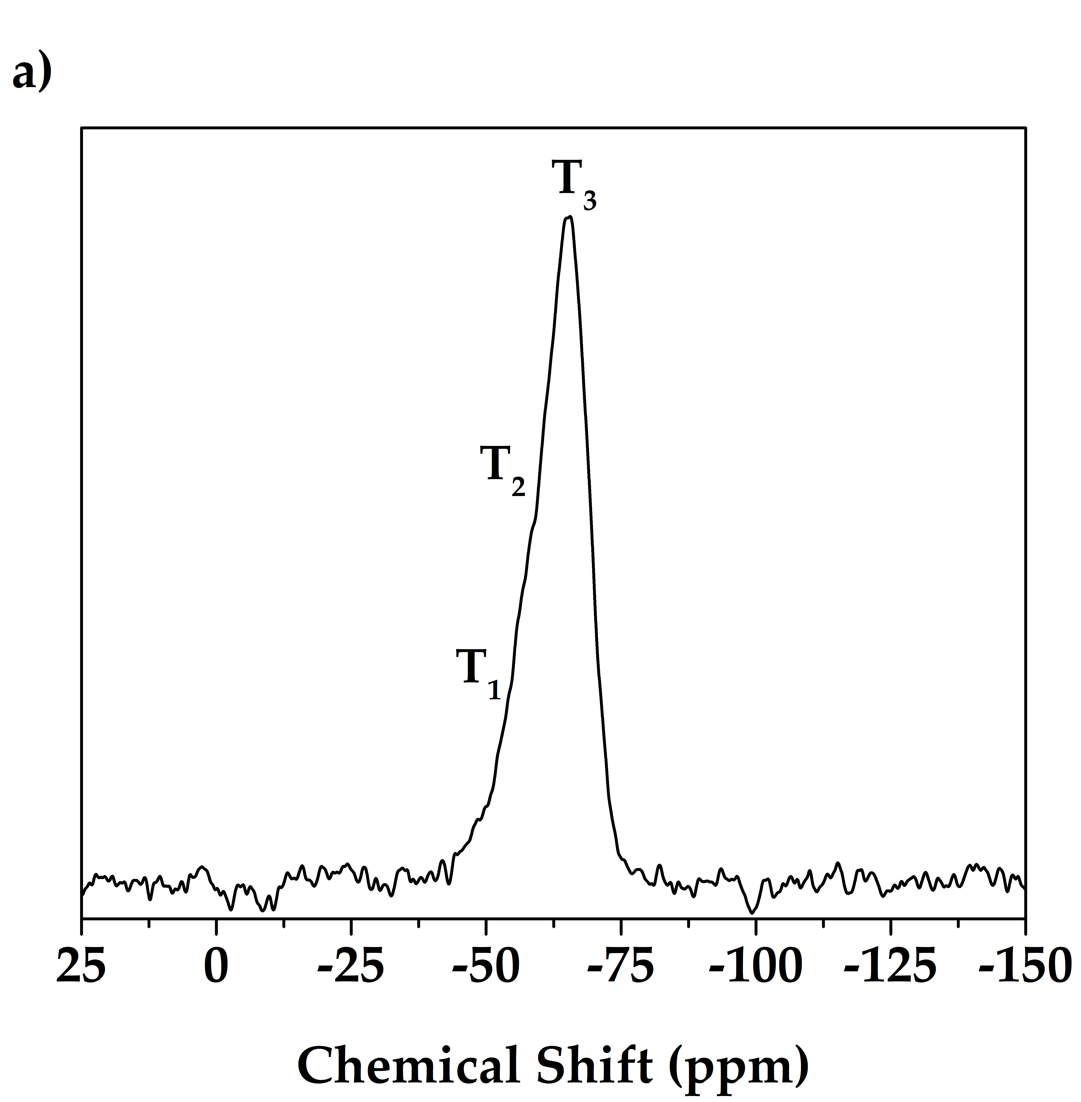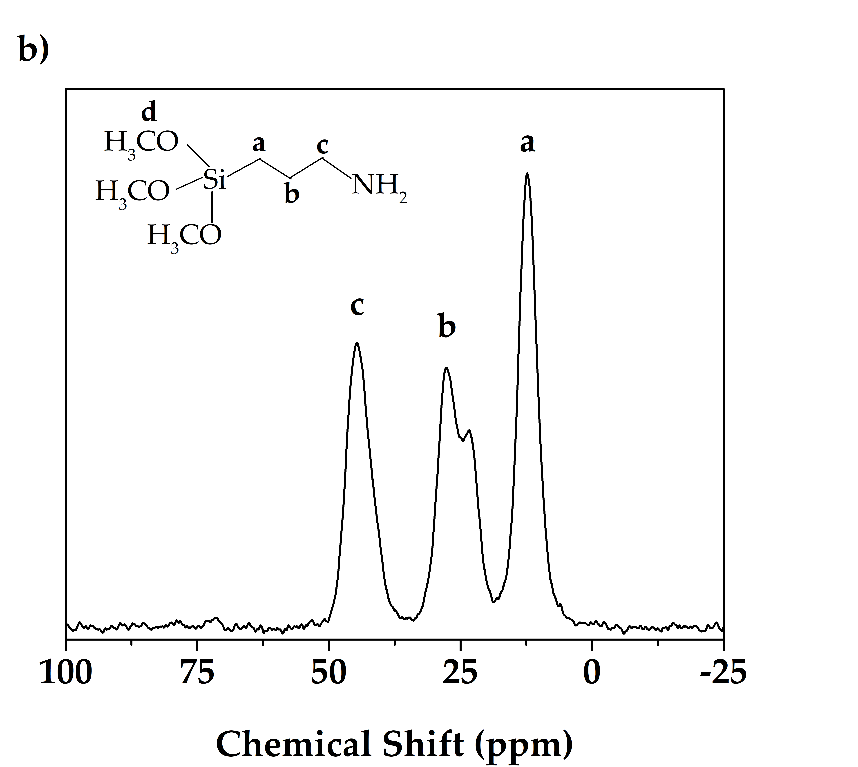

Figure S4: a) ²⁹Si and b) ¹³C CPMAS NMR spectra of AA particles. APTMS structure with carbon labeling is reported in the inset.

The ²⁹Si and ¹³C spectra of MA particles are not shown since perfectly superimposable to those previously published [22, 23]; data confirmed both the functionalization and the integrity of the methacryloxypropyl function, since no indication of double bond polymerization was detected.

The silane grafting density (σ) was determined from the results of the thermogravimetric analyses recorded on bare and functionalized NPs, applying a method previously reported [37]. Functionalization yield was assessed by comparing the mass % changes of bare and functionalized alumina nanoparticles between 150 and 850 °C, excluding the contribution from bare alumina. As shown in Figure S5, AA particles exhibited a net weight loss of 2.9 wt.%, corresponding to a grafting density of 3.94 molecules/nm². These values revealed a more effective functionalization using APTMS than MPTMS: in fact, a grafting density of 1.5 molecules/nm² was found for MA NPs, in agreement with previous reports [22, 23].
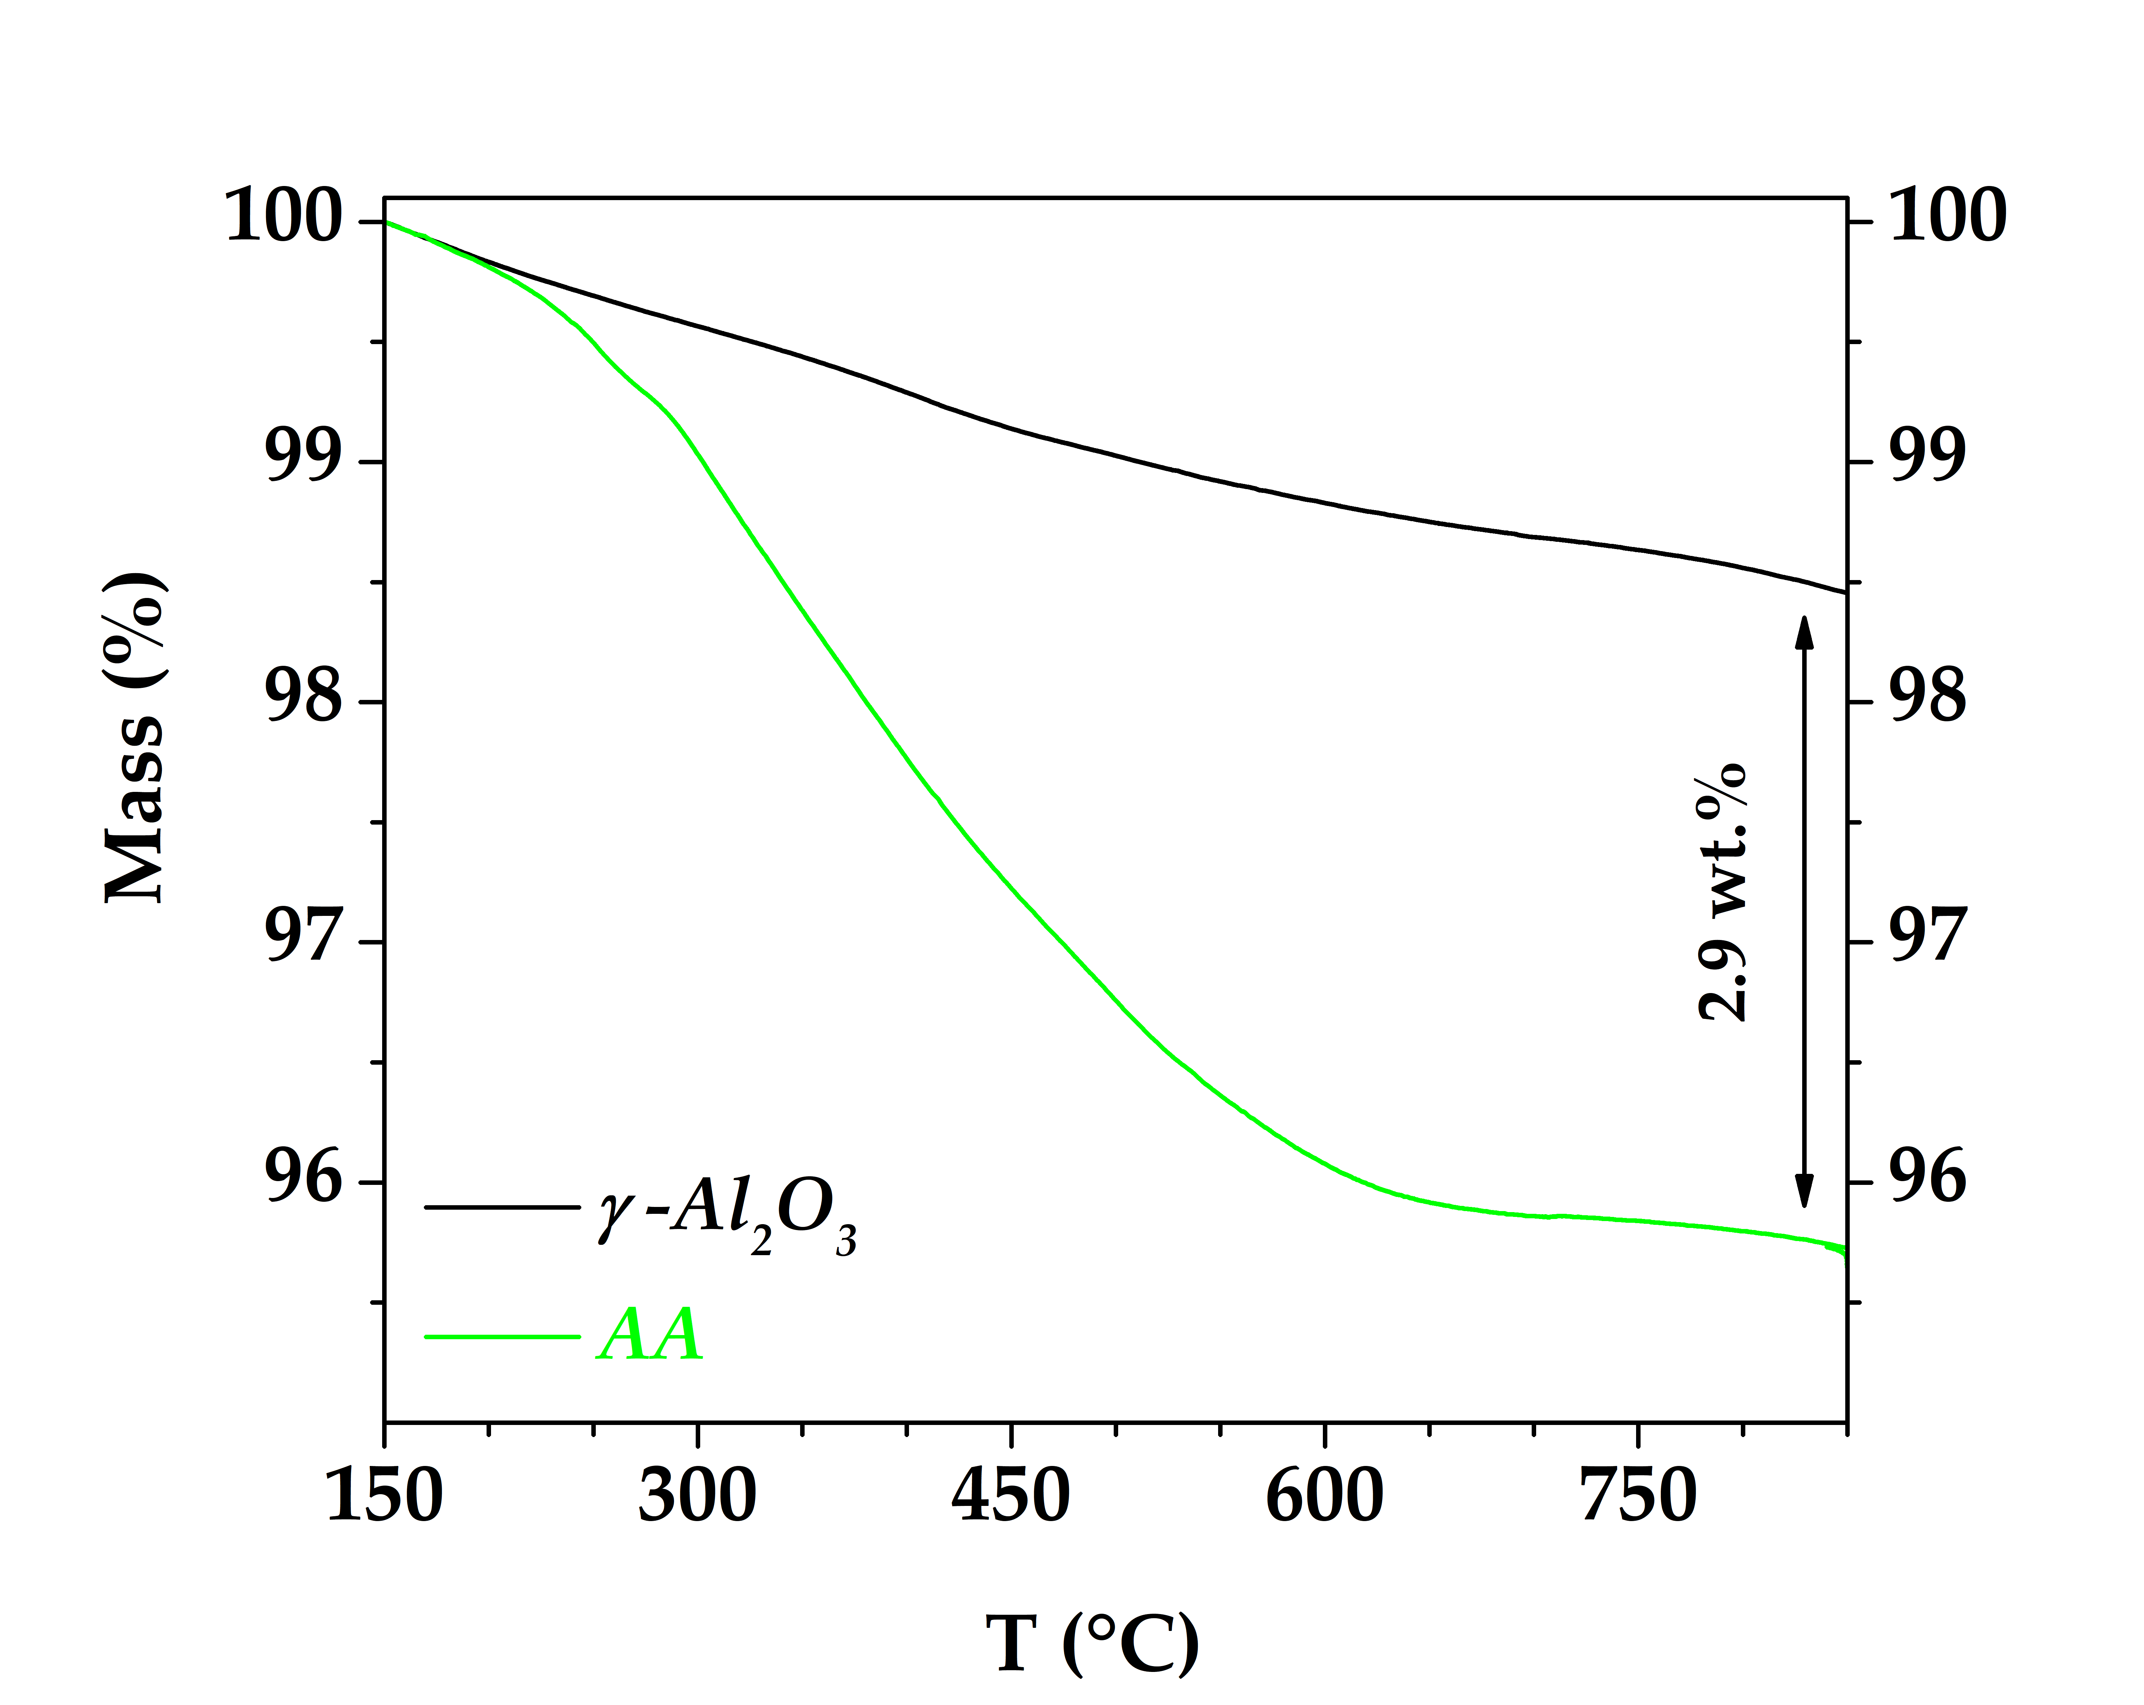
Figure S5: Thermogravimetric curves of bare γ-Al₂O₃ and APTMS-capped Al₂O₃ nanoparticles.

S4. Characterization of LPSQs-based nanocomposites
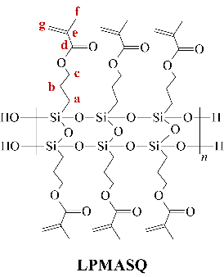
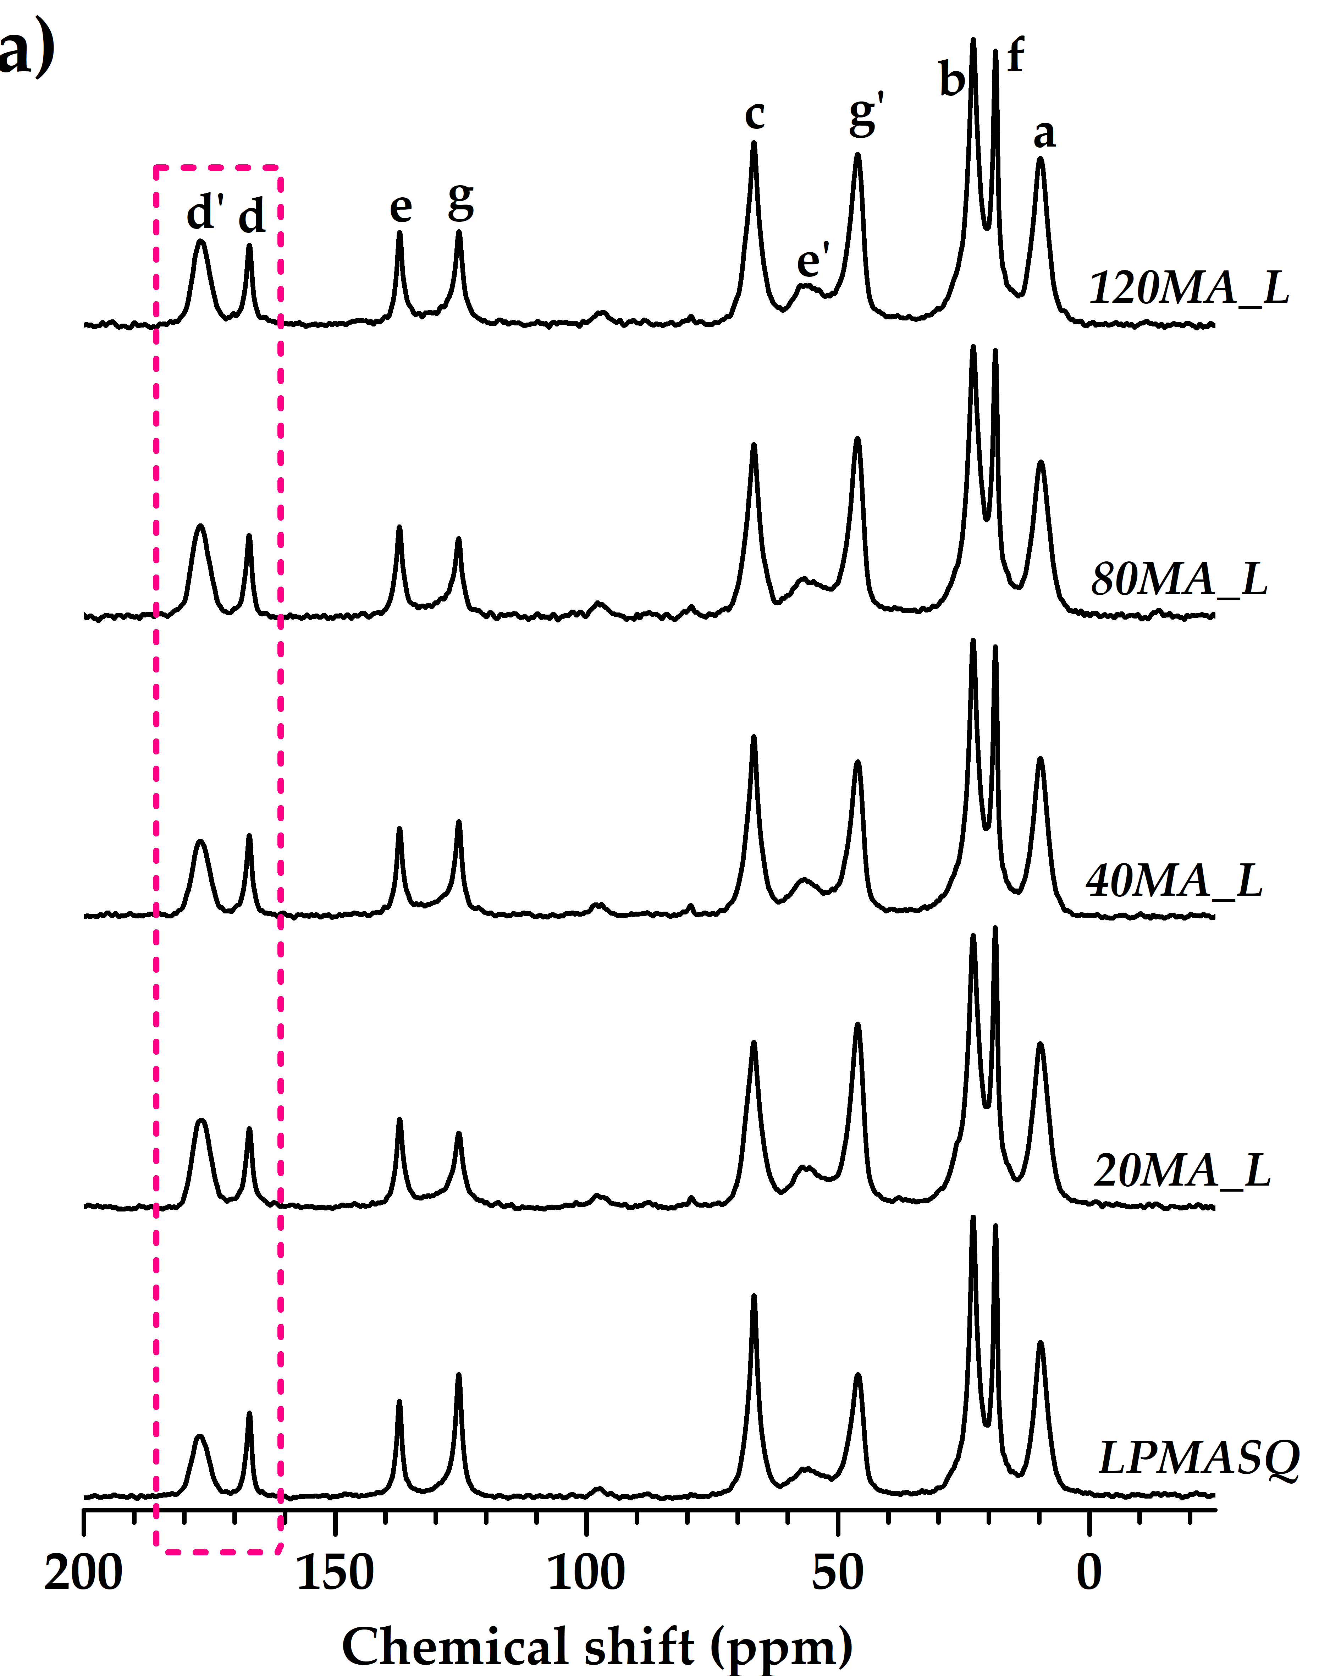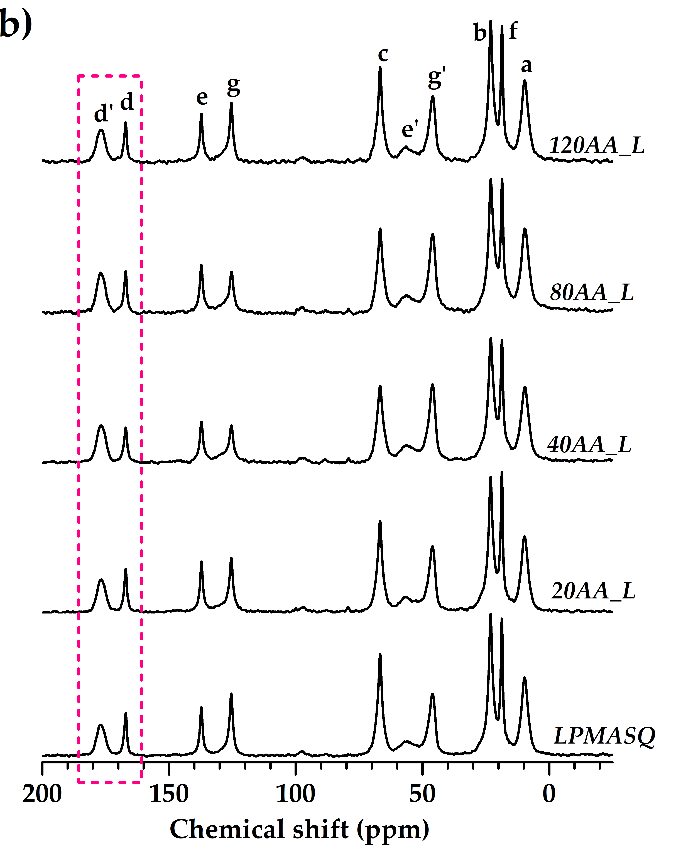
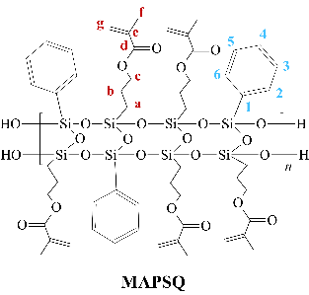
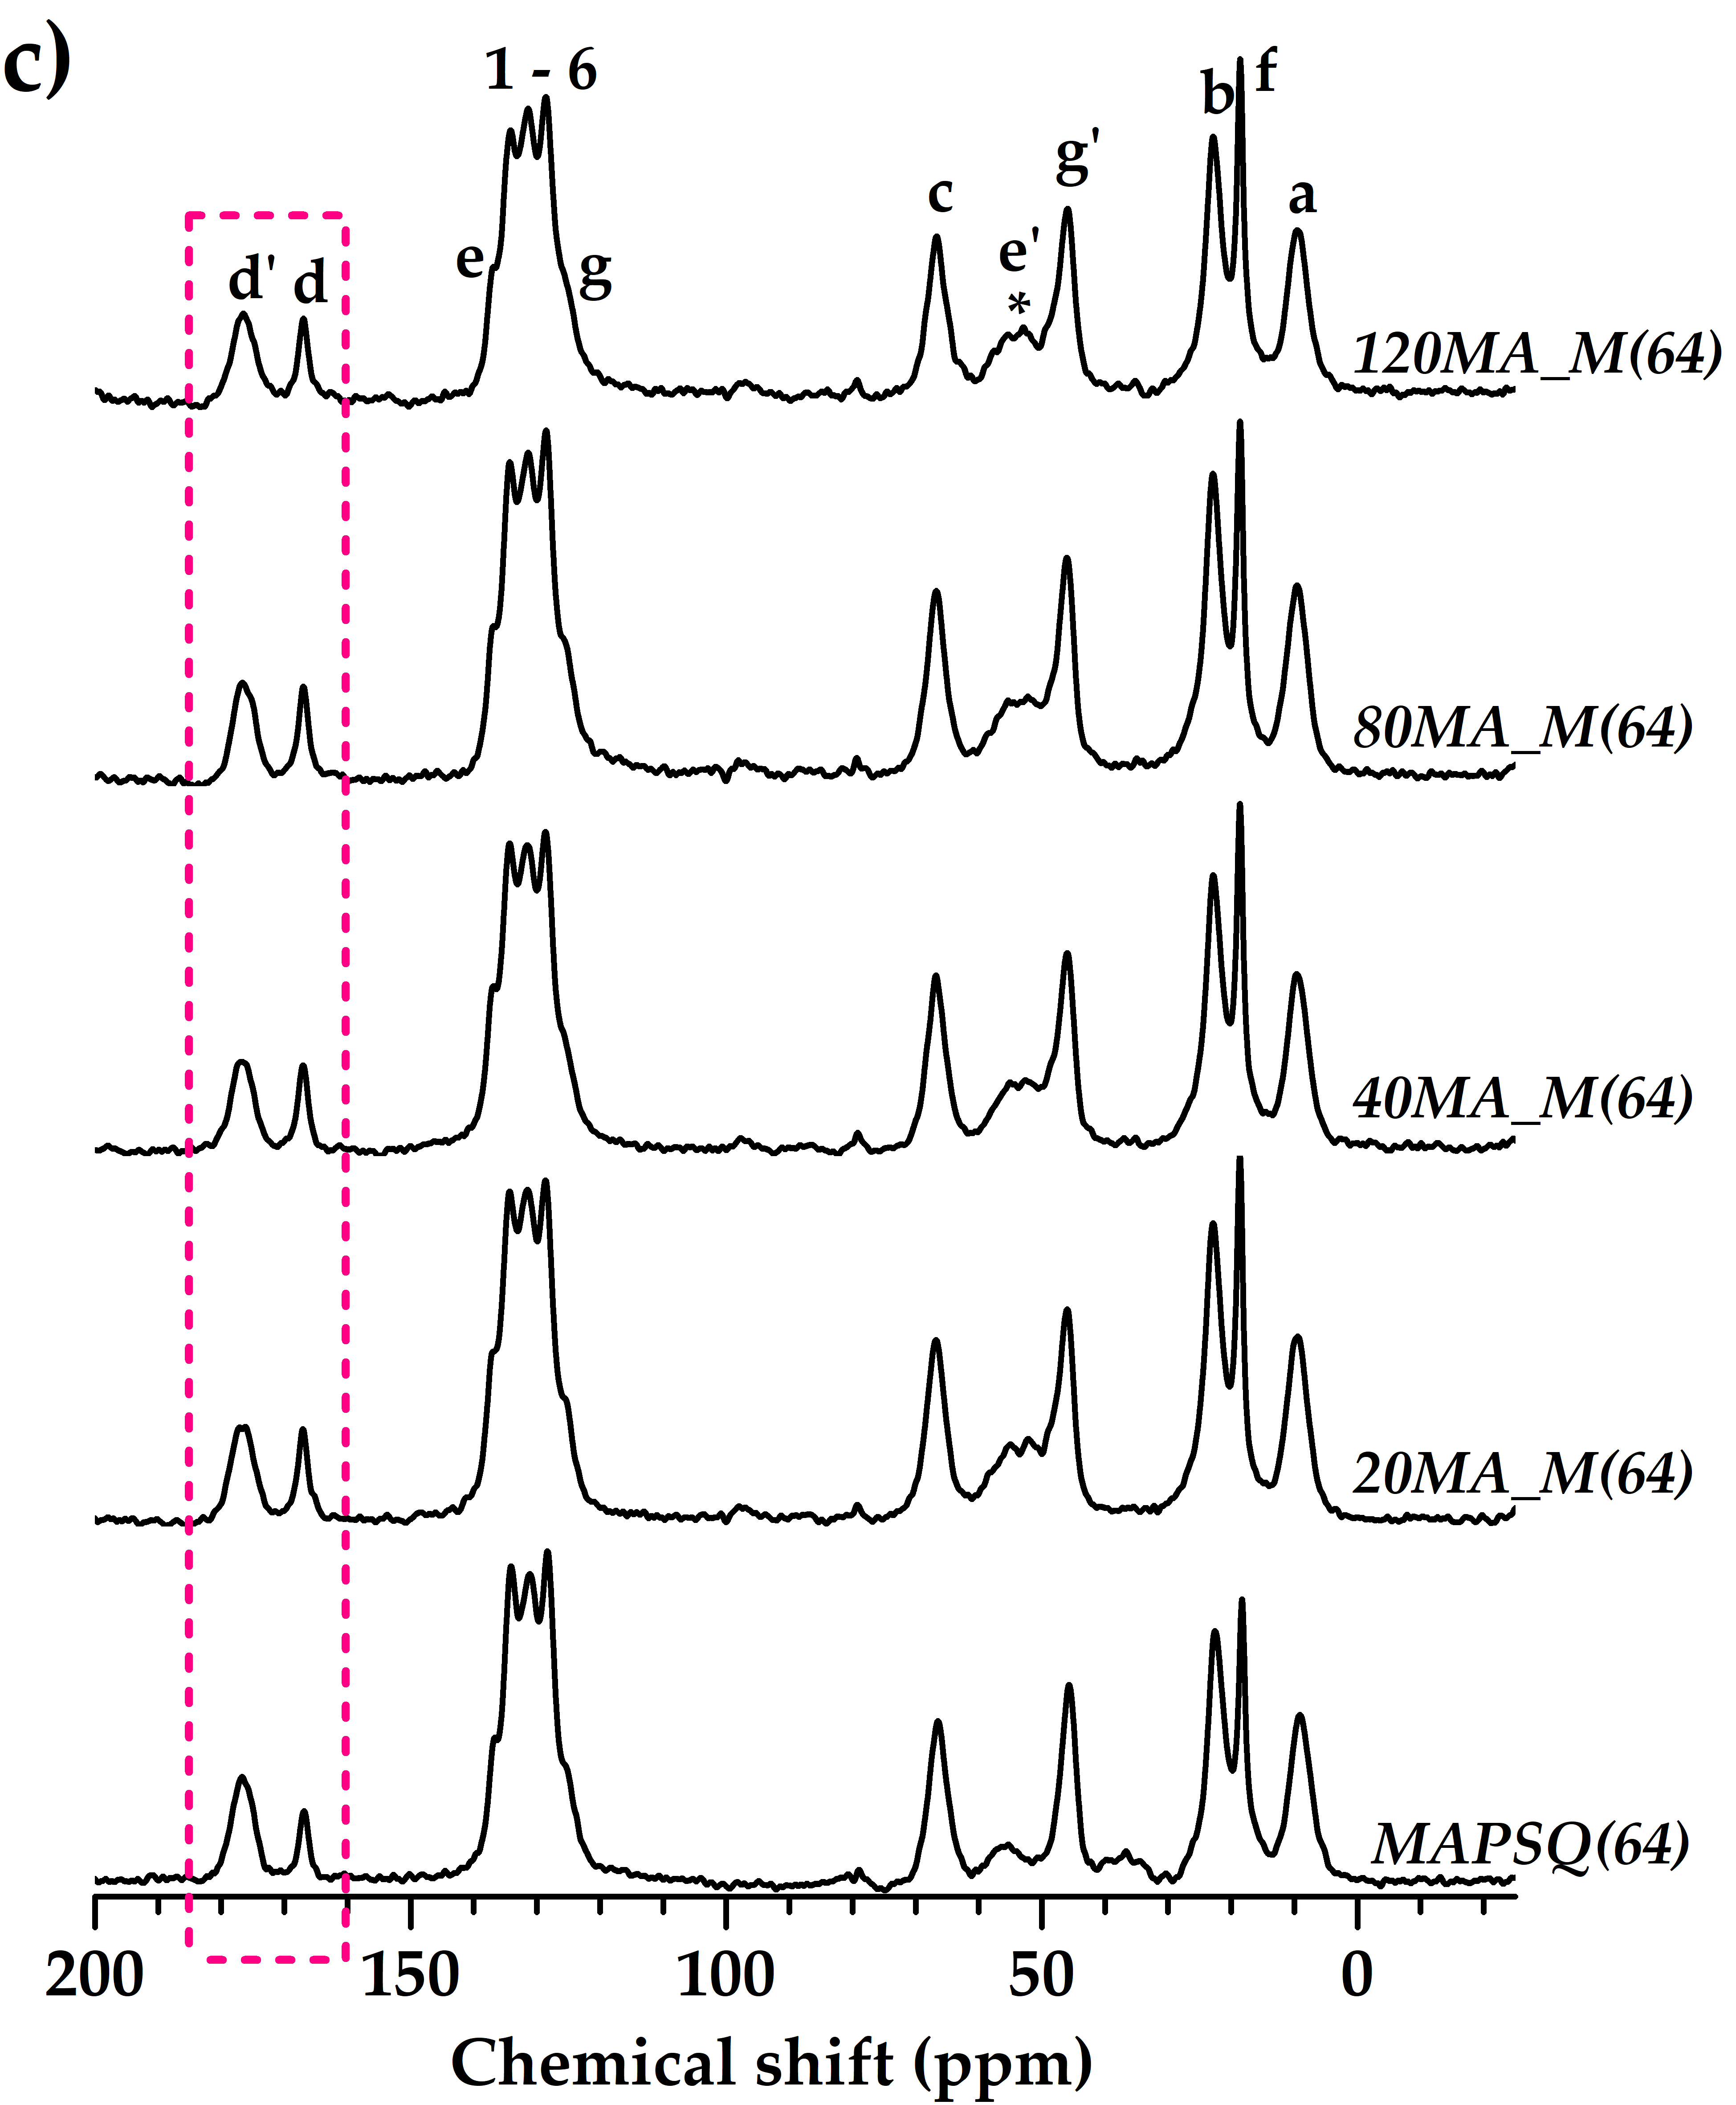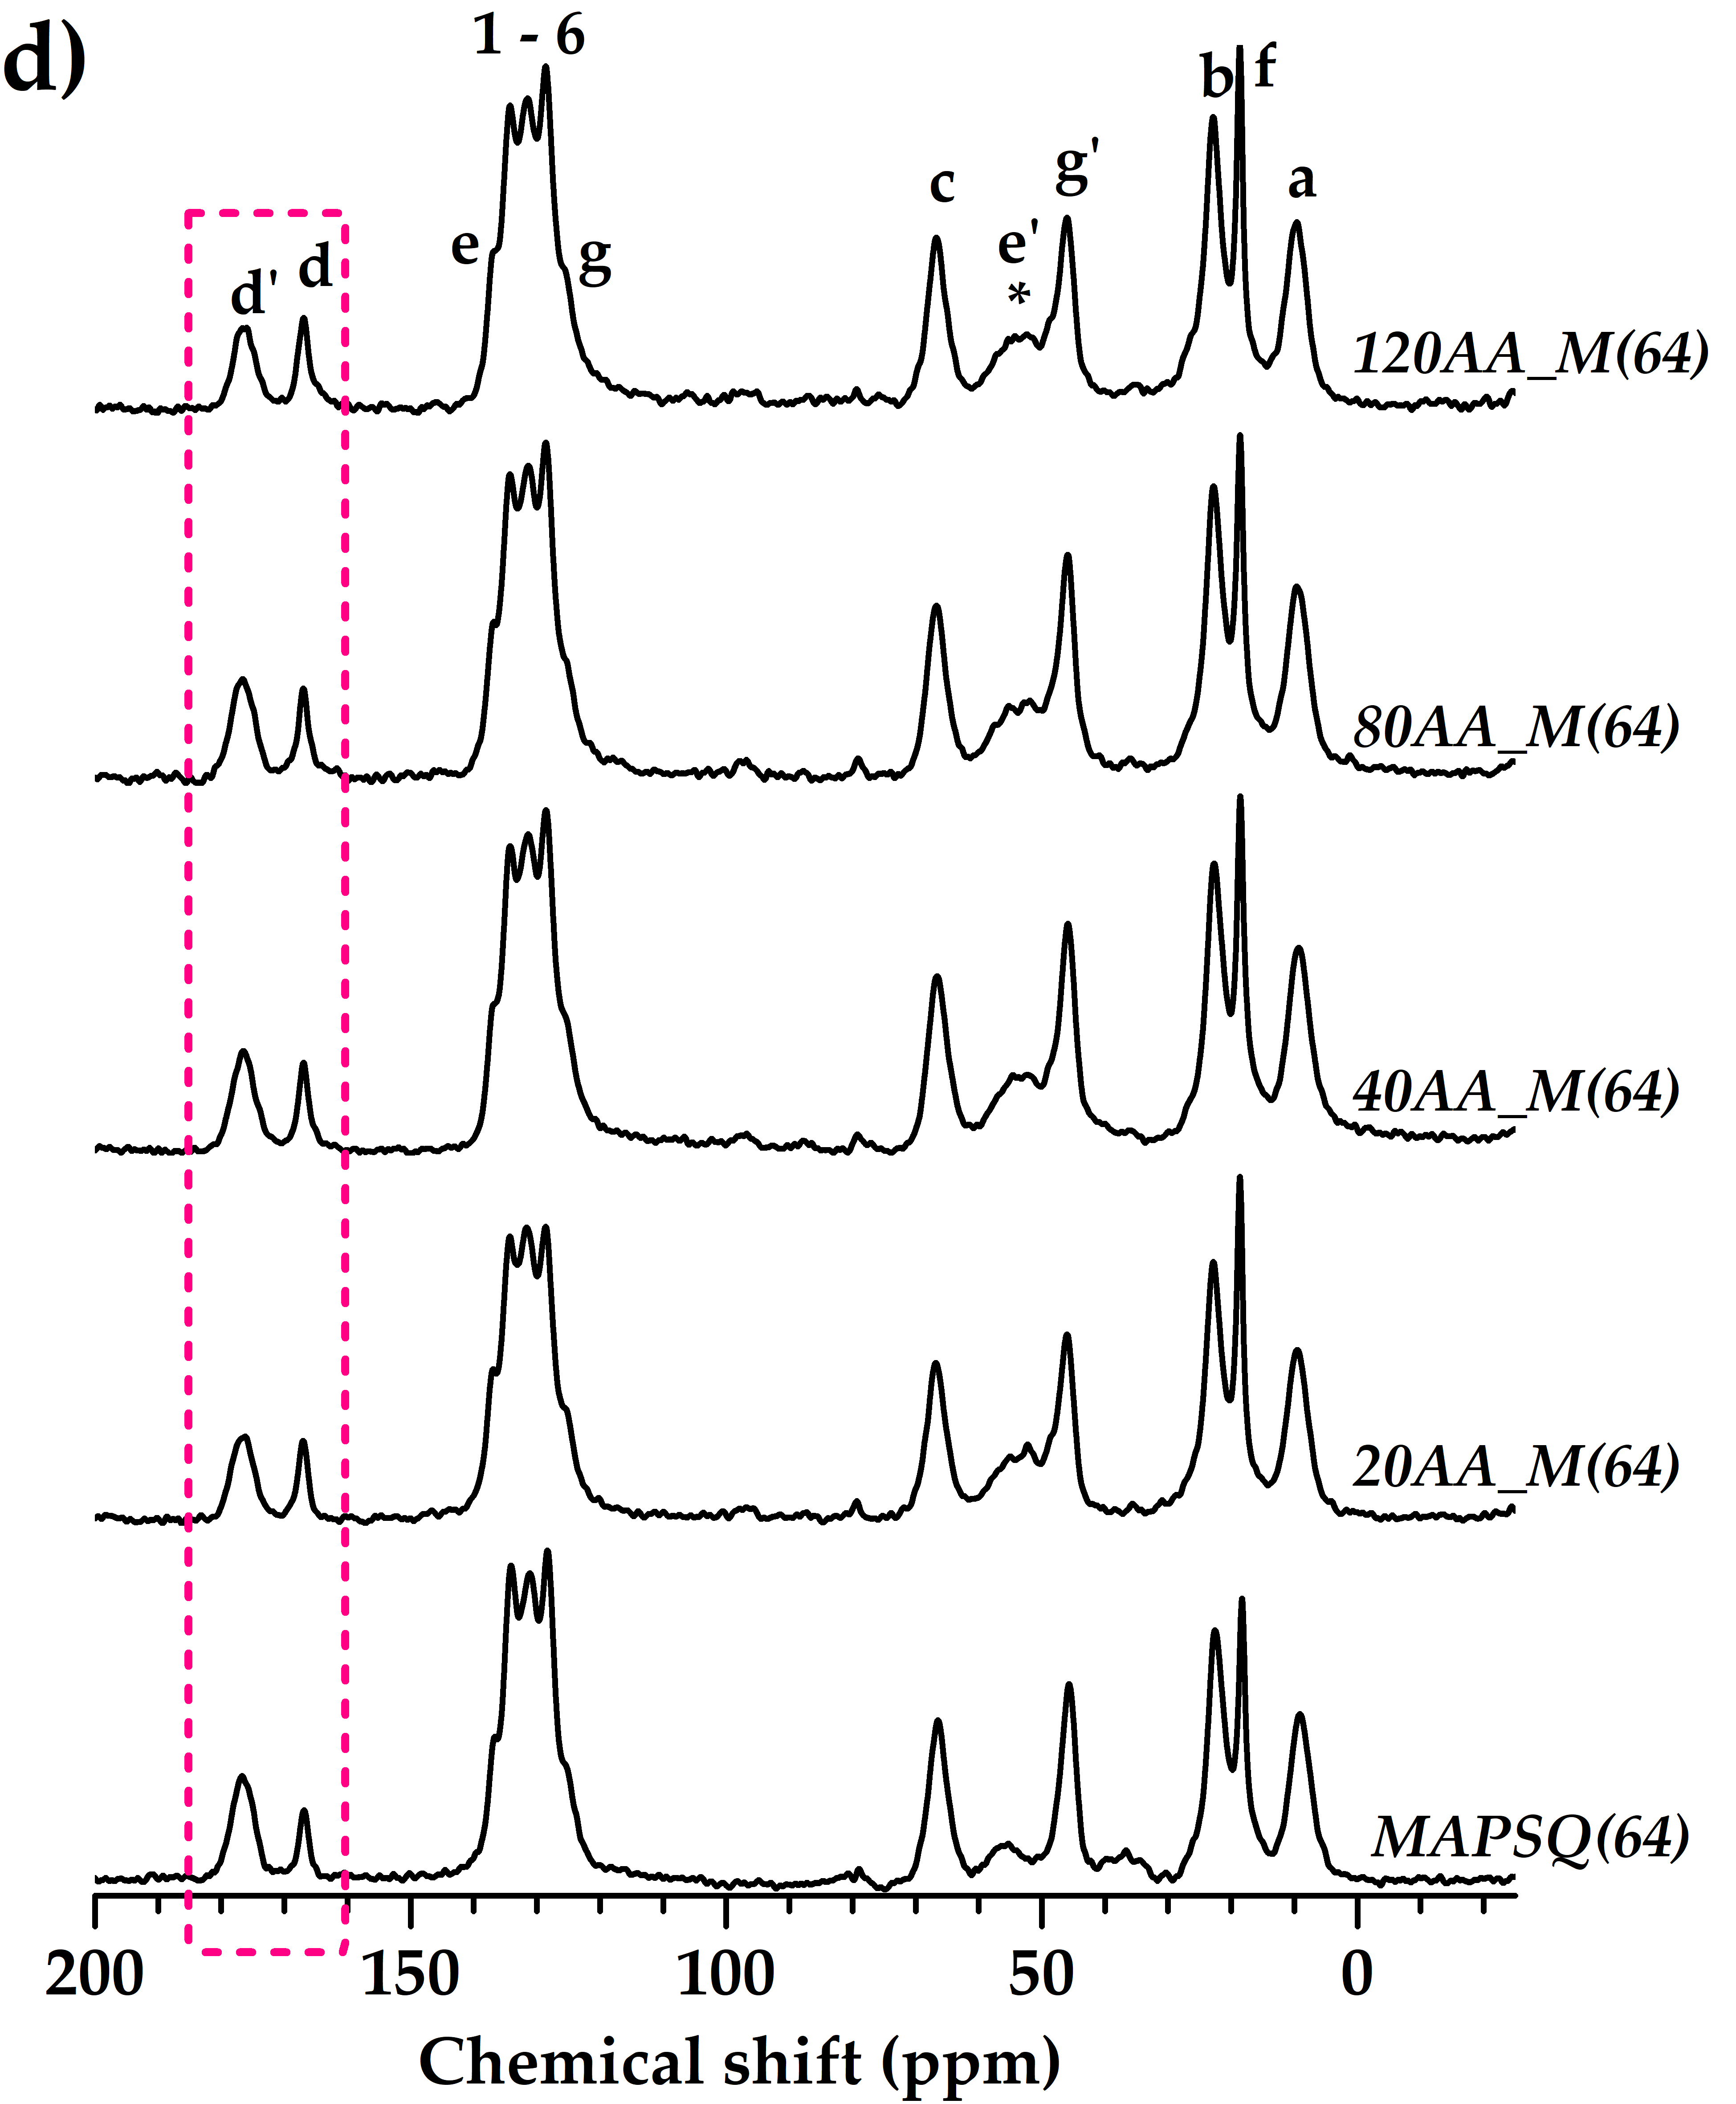

Figure S6: ¹³C CPMAS NMR spectra of photocured L-based (a, b) and M(64)-based (c, d) nanocomposites; ladder structures with carbon labeling are also shown. * : spinning sidebands.
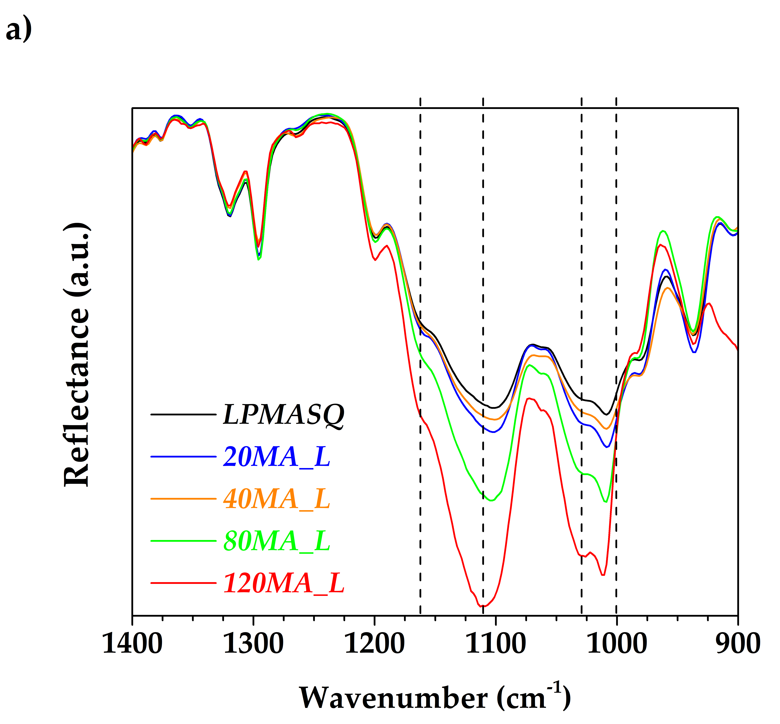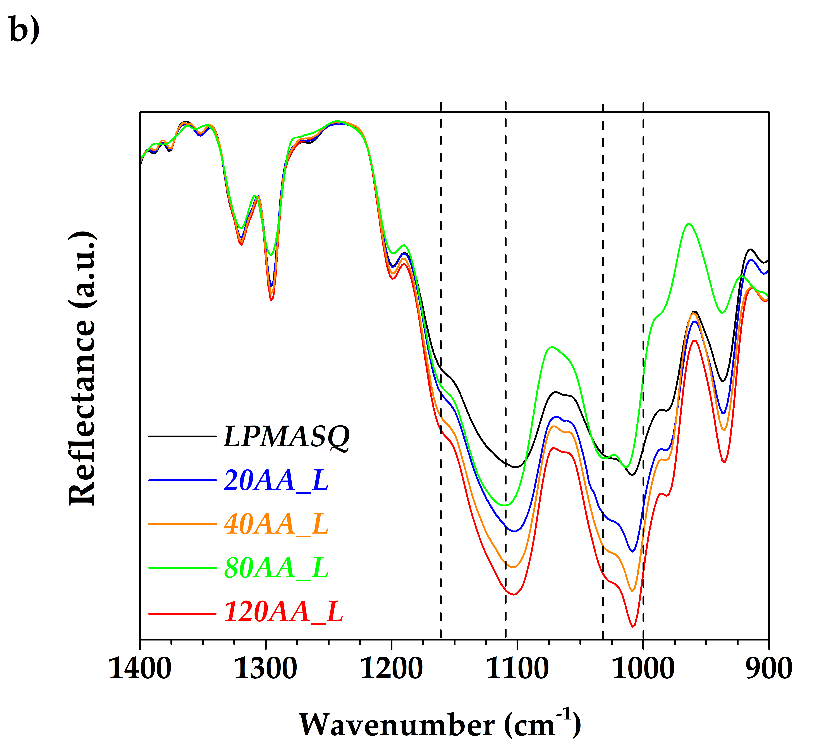
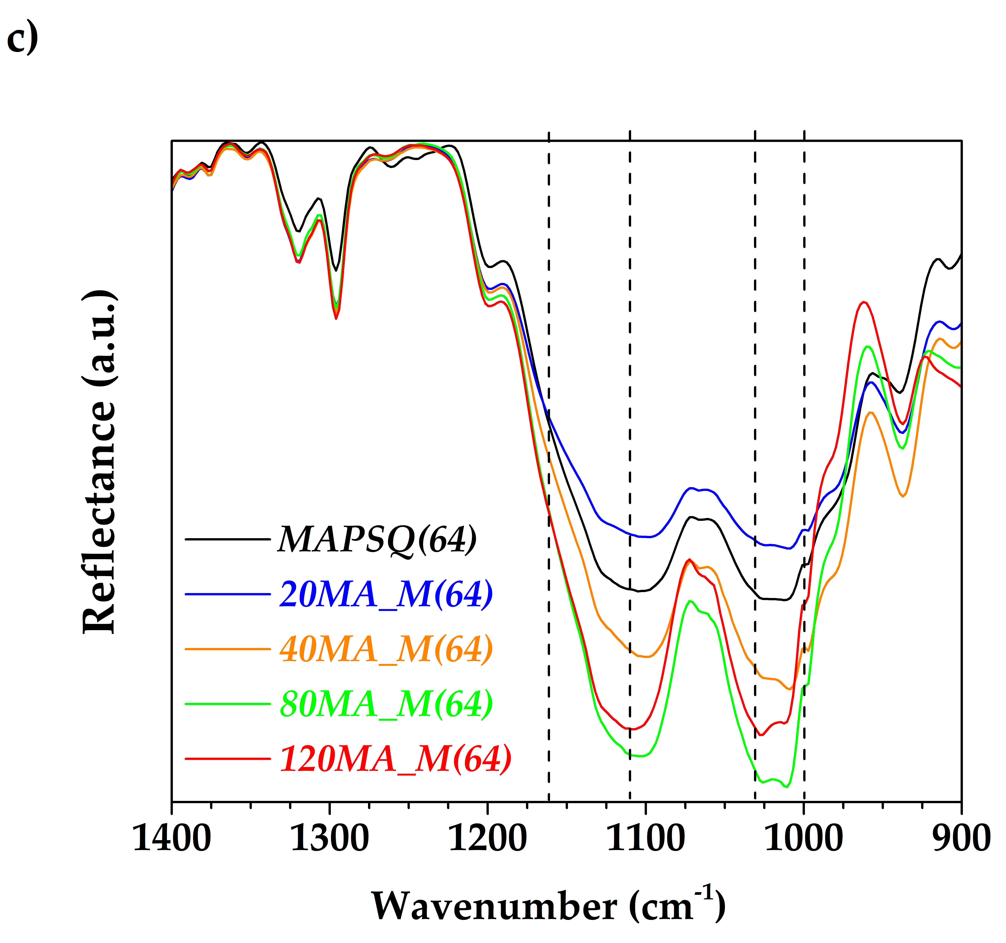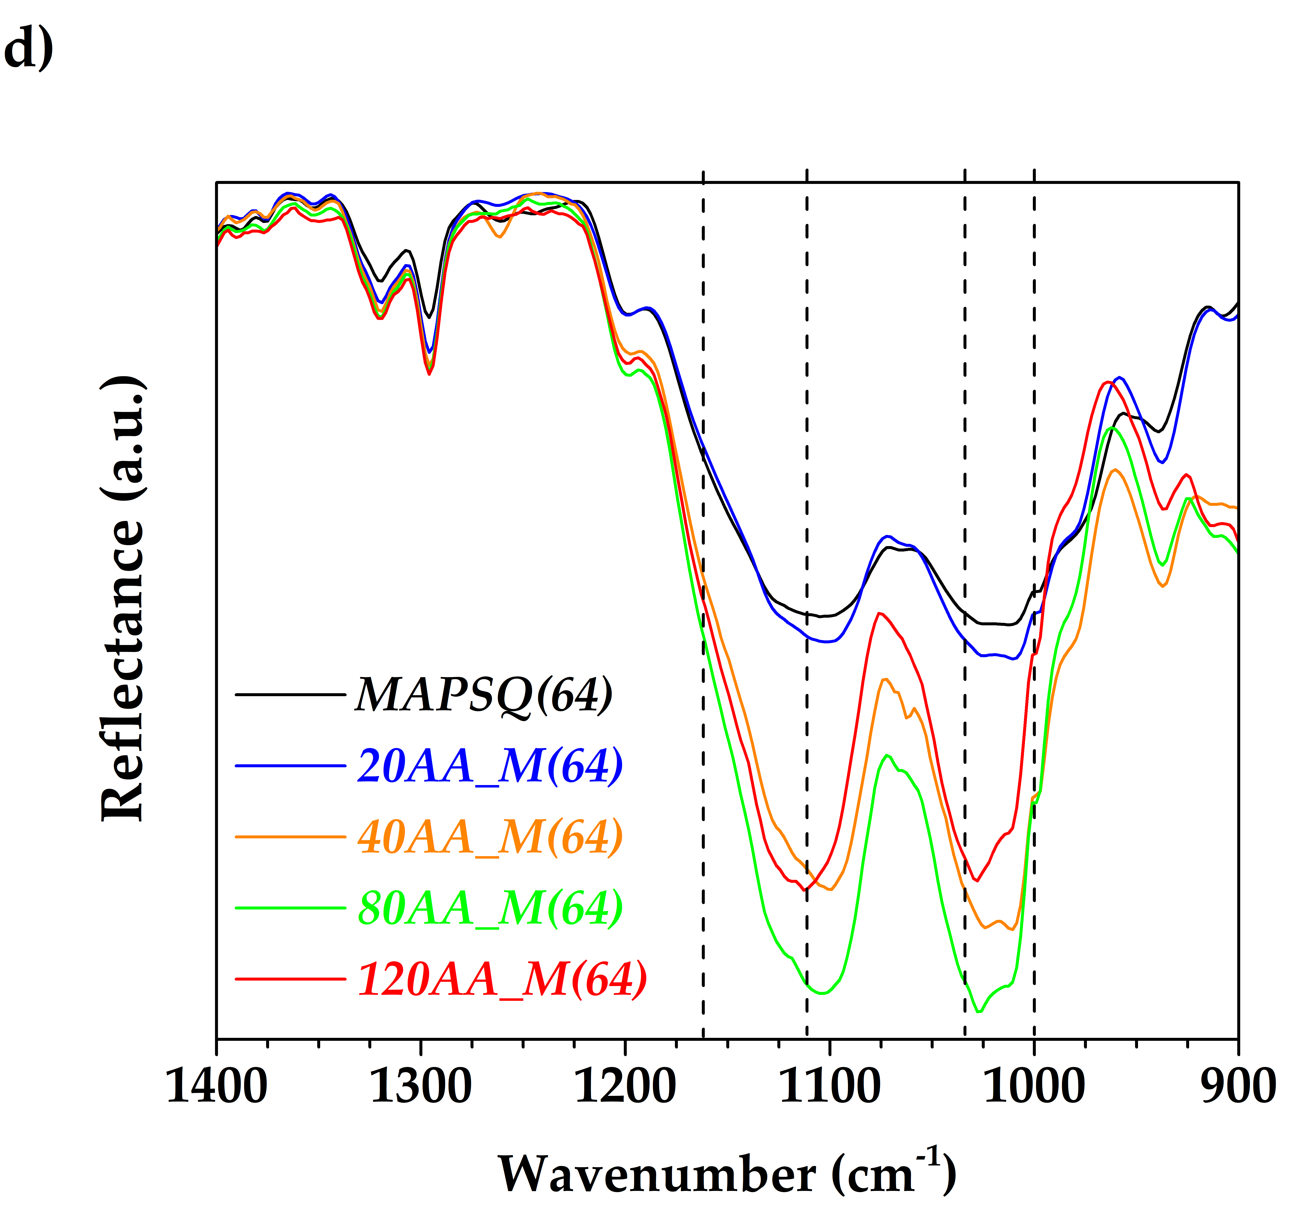

Figure S7: FTIR-ATR spectra of LPSQs-Al₂O₃ nanocomposites. Magnification of 900–1400 cm⁻¹ region for (a) MA_L, (b) AA_L, (c) MA_M(64), and (d) AA_M(64) nanocomposites.

The spectra shown in Figure S7 report a magnification of the siloxane vibration region (1200–1000 cm⁻¹) which is particularly sensitive to structural variations. Peak intensities were normalized to the carbonyl (C=O) stretching vibration at 1716 cm⁻¹ for consistency. The siloxane band originates from the superposition of several components: signals in the range 1030 -1000 cm⁻¹ are produced by linear ladders of different length, the band at about 1110 cm⁻¹ and the shoulder at 1159 cm⁻¹ are respectively attributable to cage polymers and T₇OH₃ or T₈OH₂ open cage structures, produced by ladders folding [11, 32, 34]. In all samples, the signals in the Si–O–Si asymmetric stretching region increased in intensity with the addition of NPs, probably due to polymer-filler interactions and NPs distribution in the NCs.
In the NCs with the maximum filler loading (i.e. 120 wt.%) the relative intensity of the low frequency band respect to the one at about 1110 cm⁻¹ increases with the exception of 120MA_L where a decrease is observed. These variations suggest changes in the local silsesquioxane structure due to polymer-filler interface; however, they could also arise from additional overlapping effects, such as different filler aggregation and matrix rigidity.
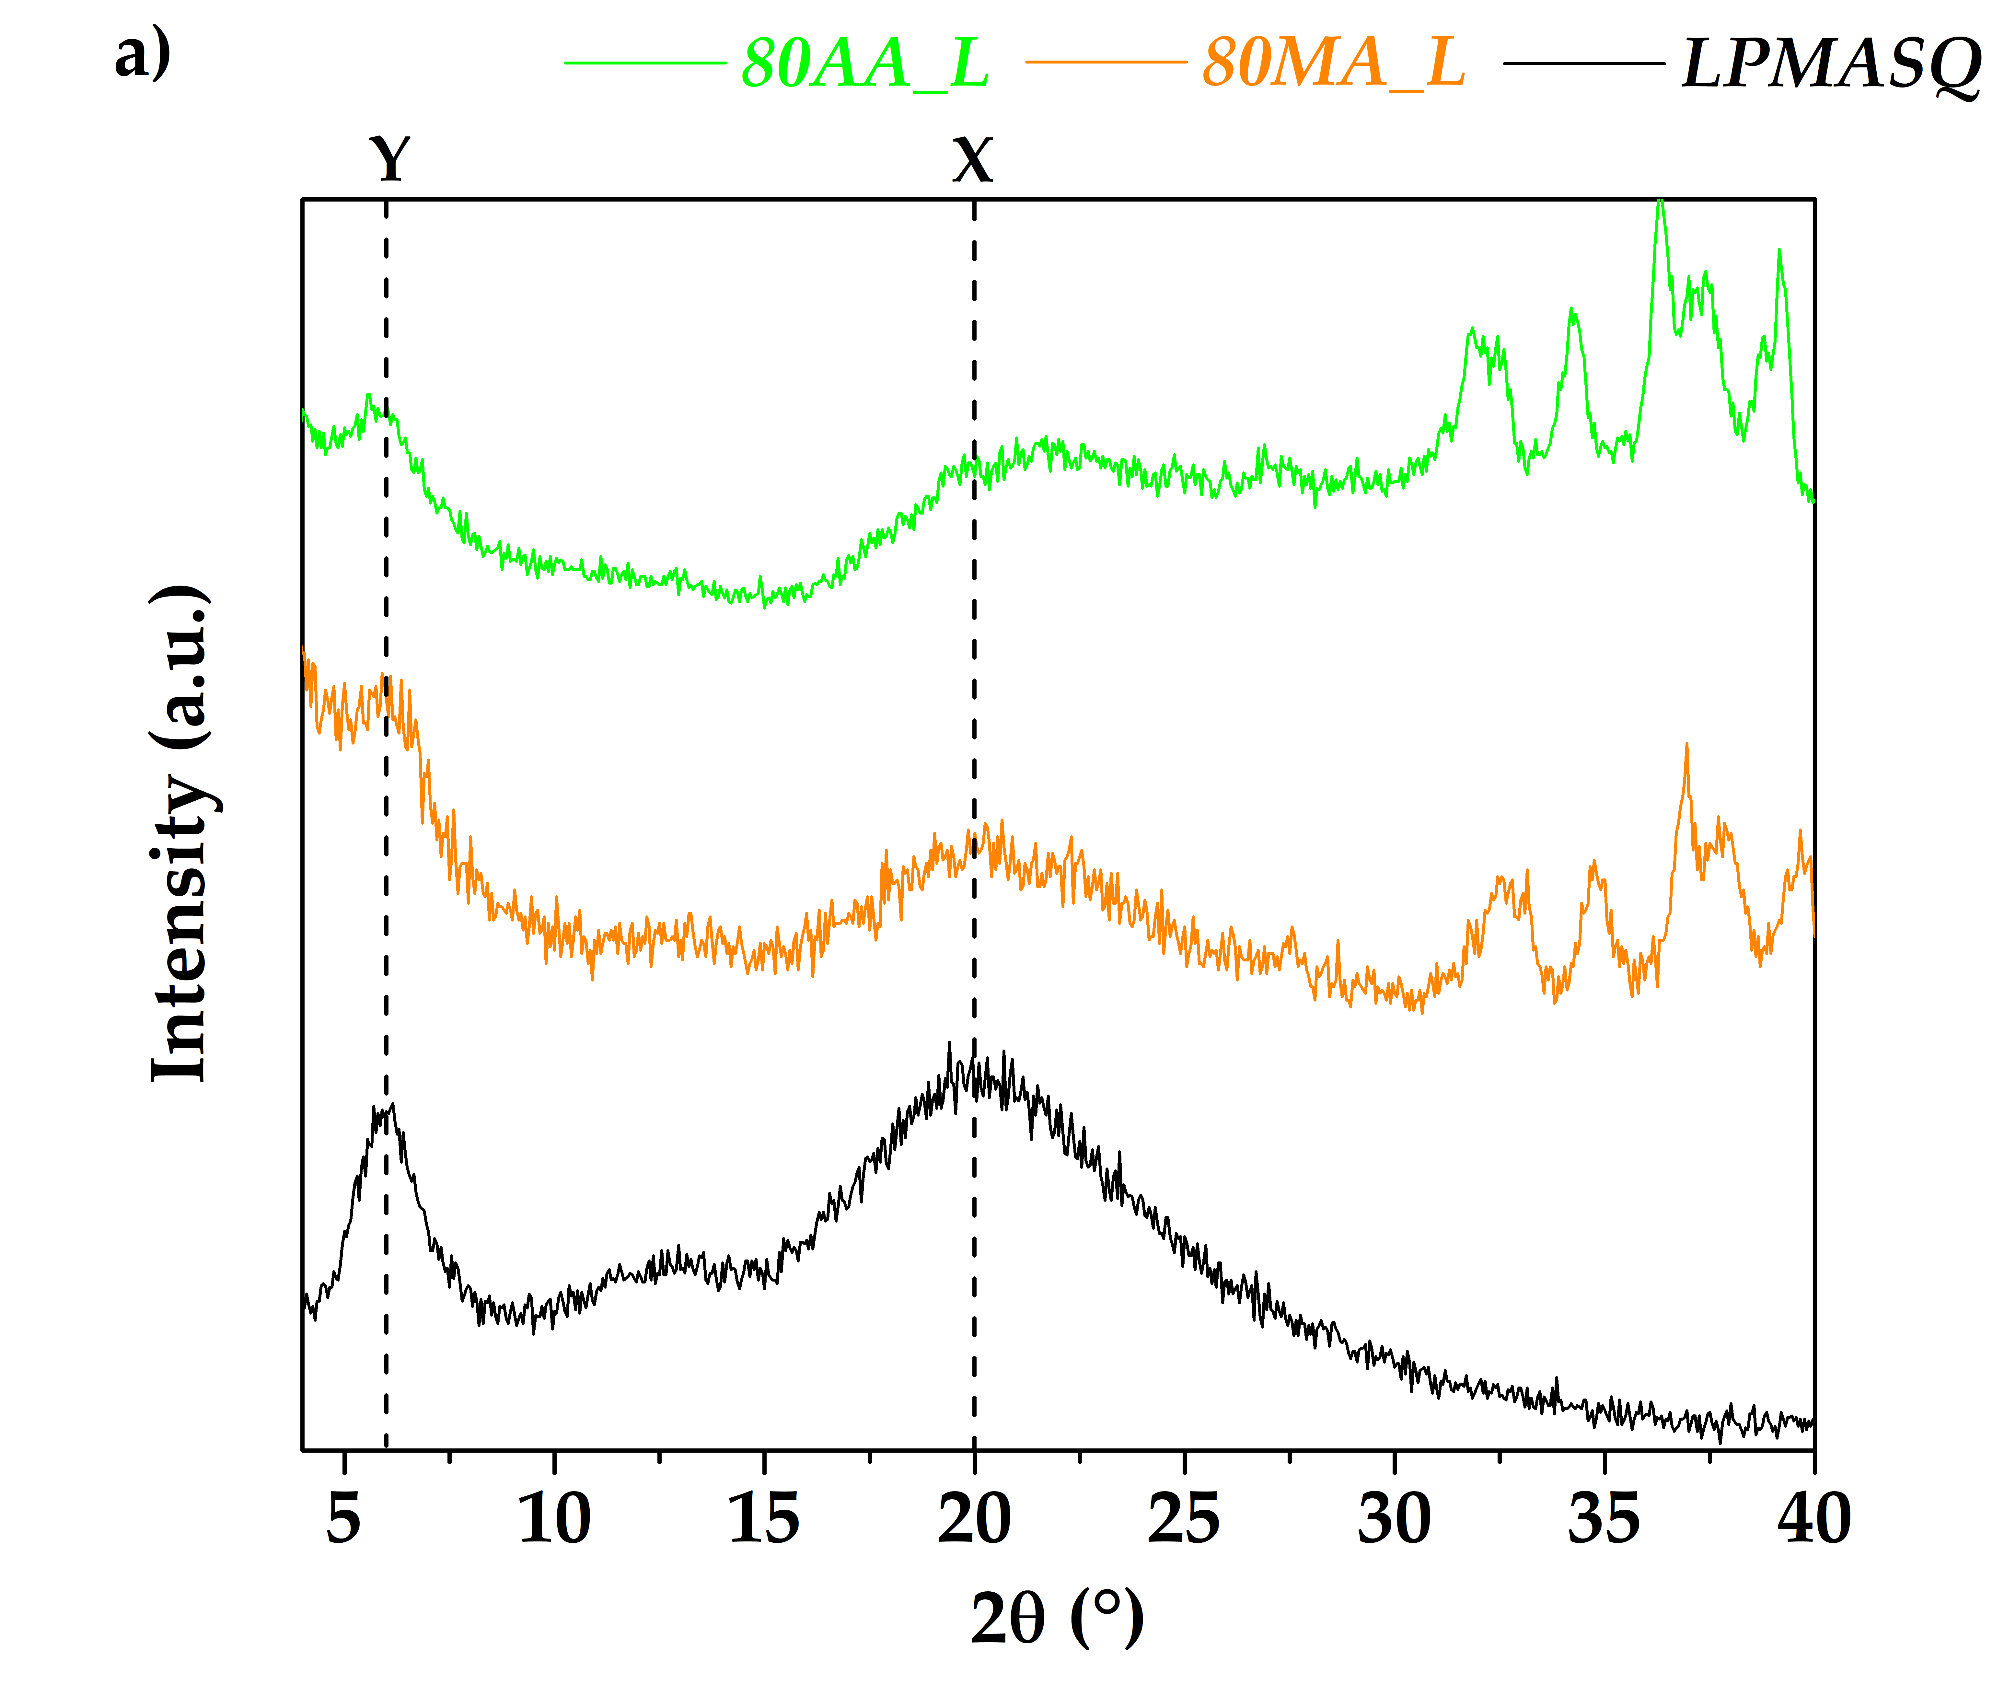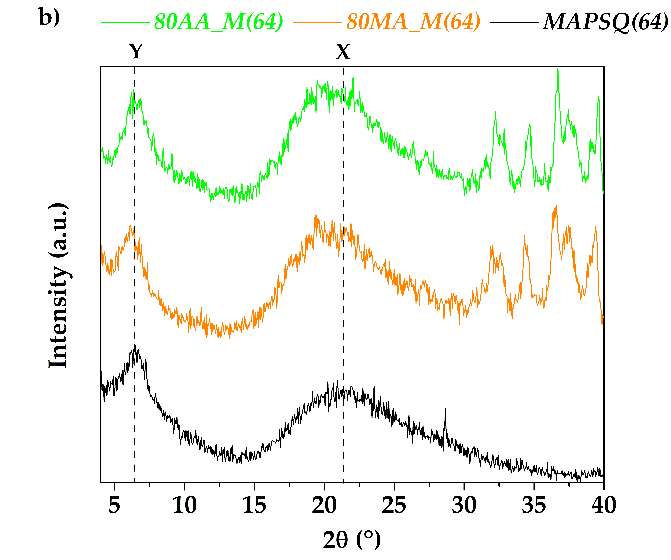
Figure S8. XRD patterns of a) LPMASQ and b) MAPSQ(64)-based nanocomposites with 80 wt.% of functionalized alumina nanoparticles.

NCs’ XRD patterns are compared in Figure S8 with those of the corresponding matrices. The signals due to alumina NPs were found in the range 2θ = 30 – 40°; as reported previously [10], the co-existence of γ and δ alumina phases was detected. The visual comparison of patterns of NCs and corresponding matrices revealed that NPs addition led to: i) variable changes of the chain-to-chain distance (Y); ii) a sharp decrease in intensity of the broad component relative to Y' in the L-based samples, until the disappearance in 80AA_L. Finally, the average backbone distance X was almost unaffected by particles addition, despite changes in shape of the corresponding halo. The results of the profile fitting analysis are reported in Table S1.

Table S1. Results of the profile fitting analysis of NCs XRD patterns.

Sample | d_{Y}, nm  (FWHM, °) | d_{Y’}, nm  (FWHM, °) | d_{X}, nm  (FWHM, °) | R (I_{Y}/I_{X})
80MA_L | 1.43  (1.6) | 0.67  (3.1) | 0.44  (8.1) | 0.65
80AA_L | 1.54  (1.6) | - | 0.44  (7.5) | 0.81
80MA_M(64) | 1.44  (1.9) | - | 0.45  (7.8) | 0.67
80AA_M(64) | 1.40  (2.1) | - | 0.45  (7.7) | 0.77

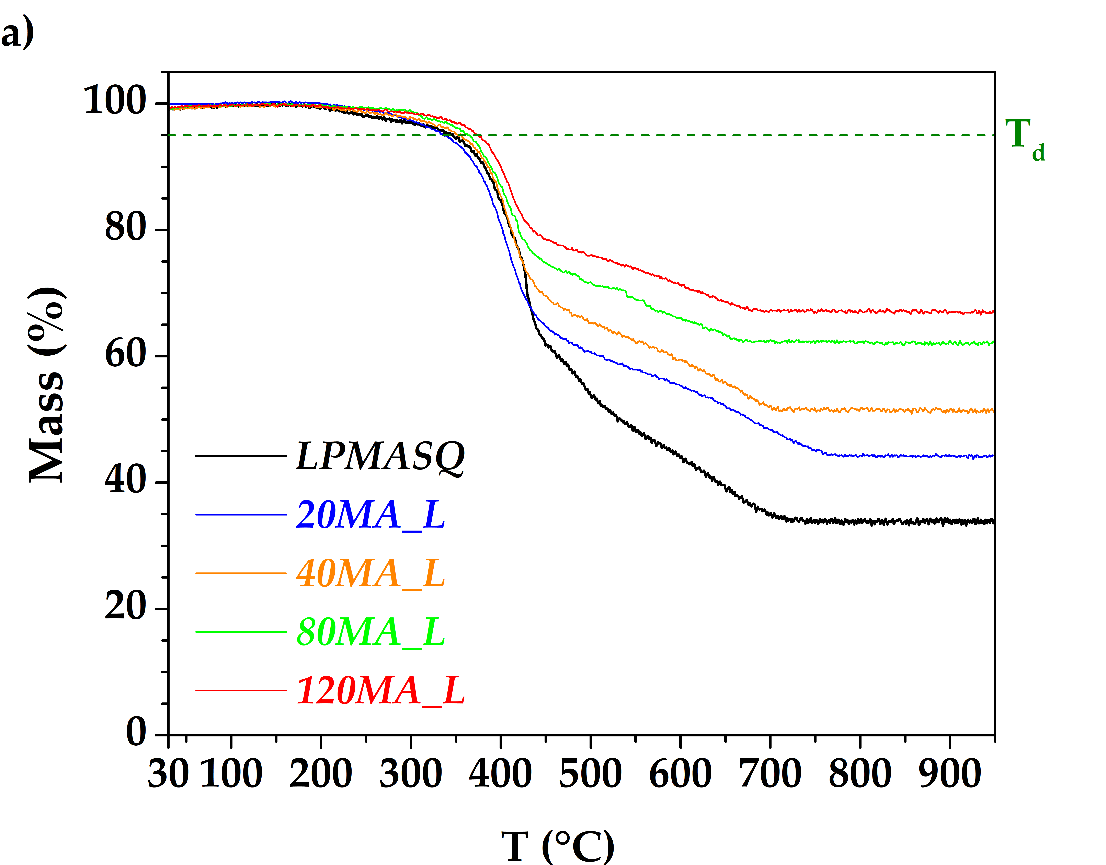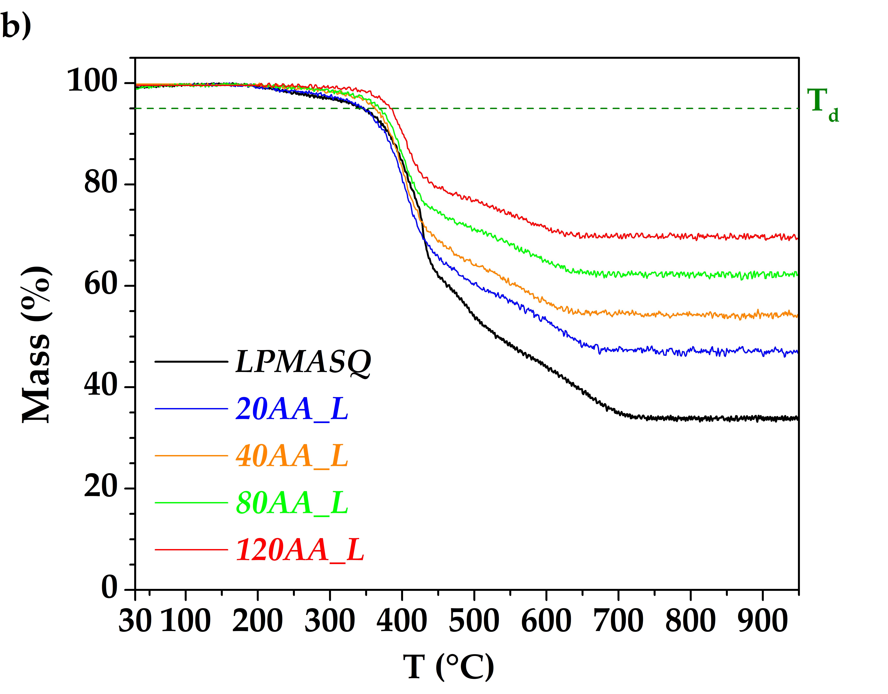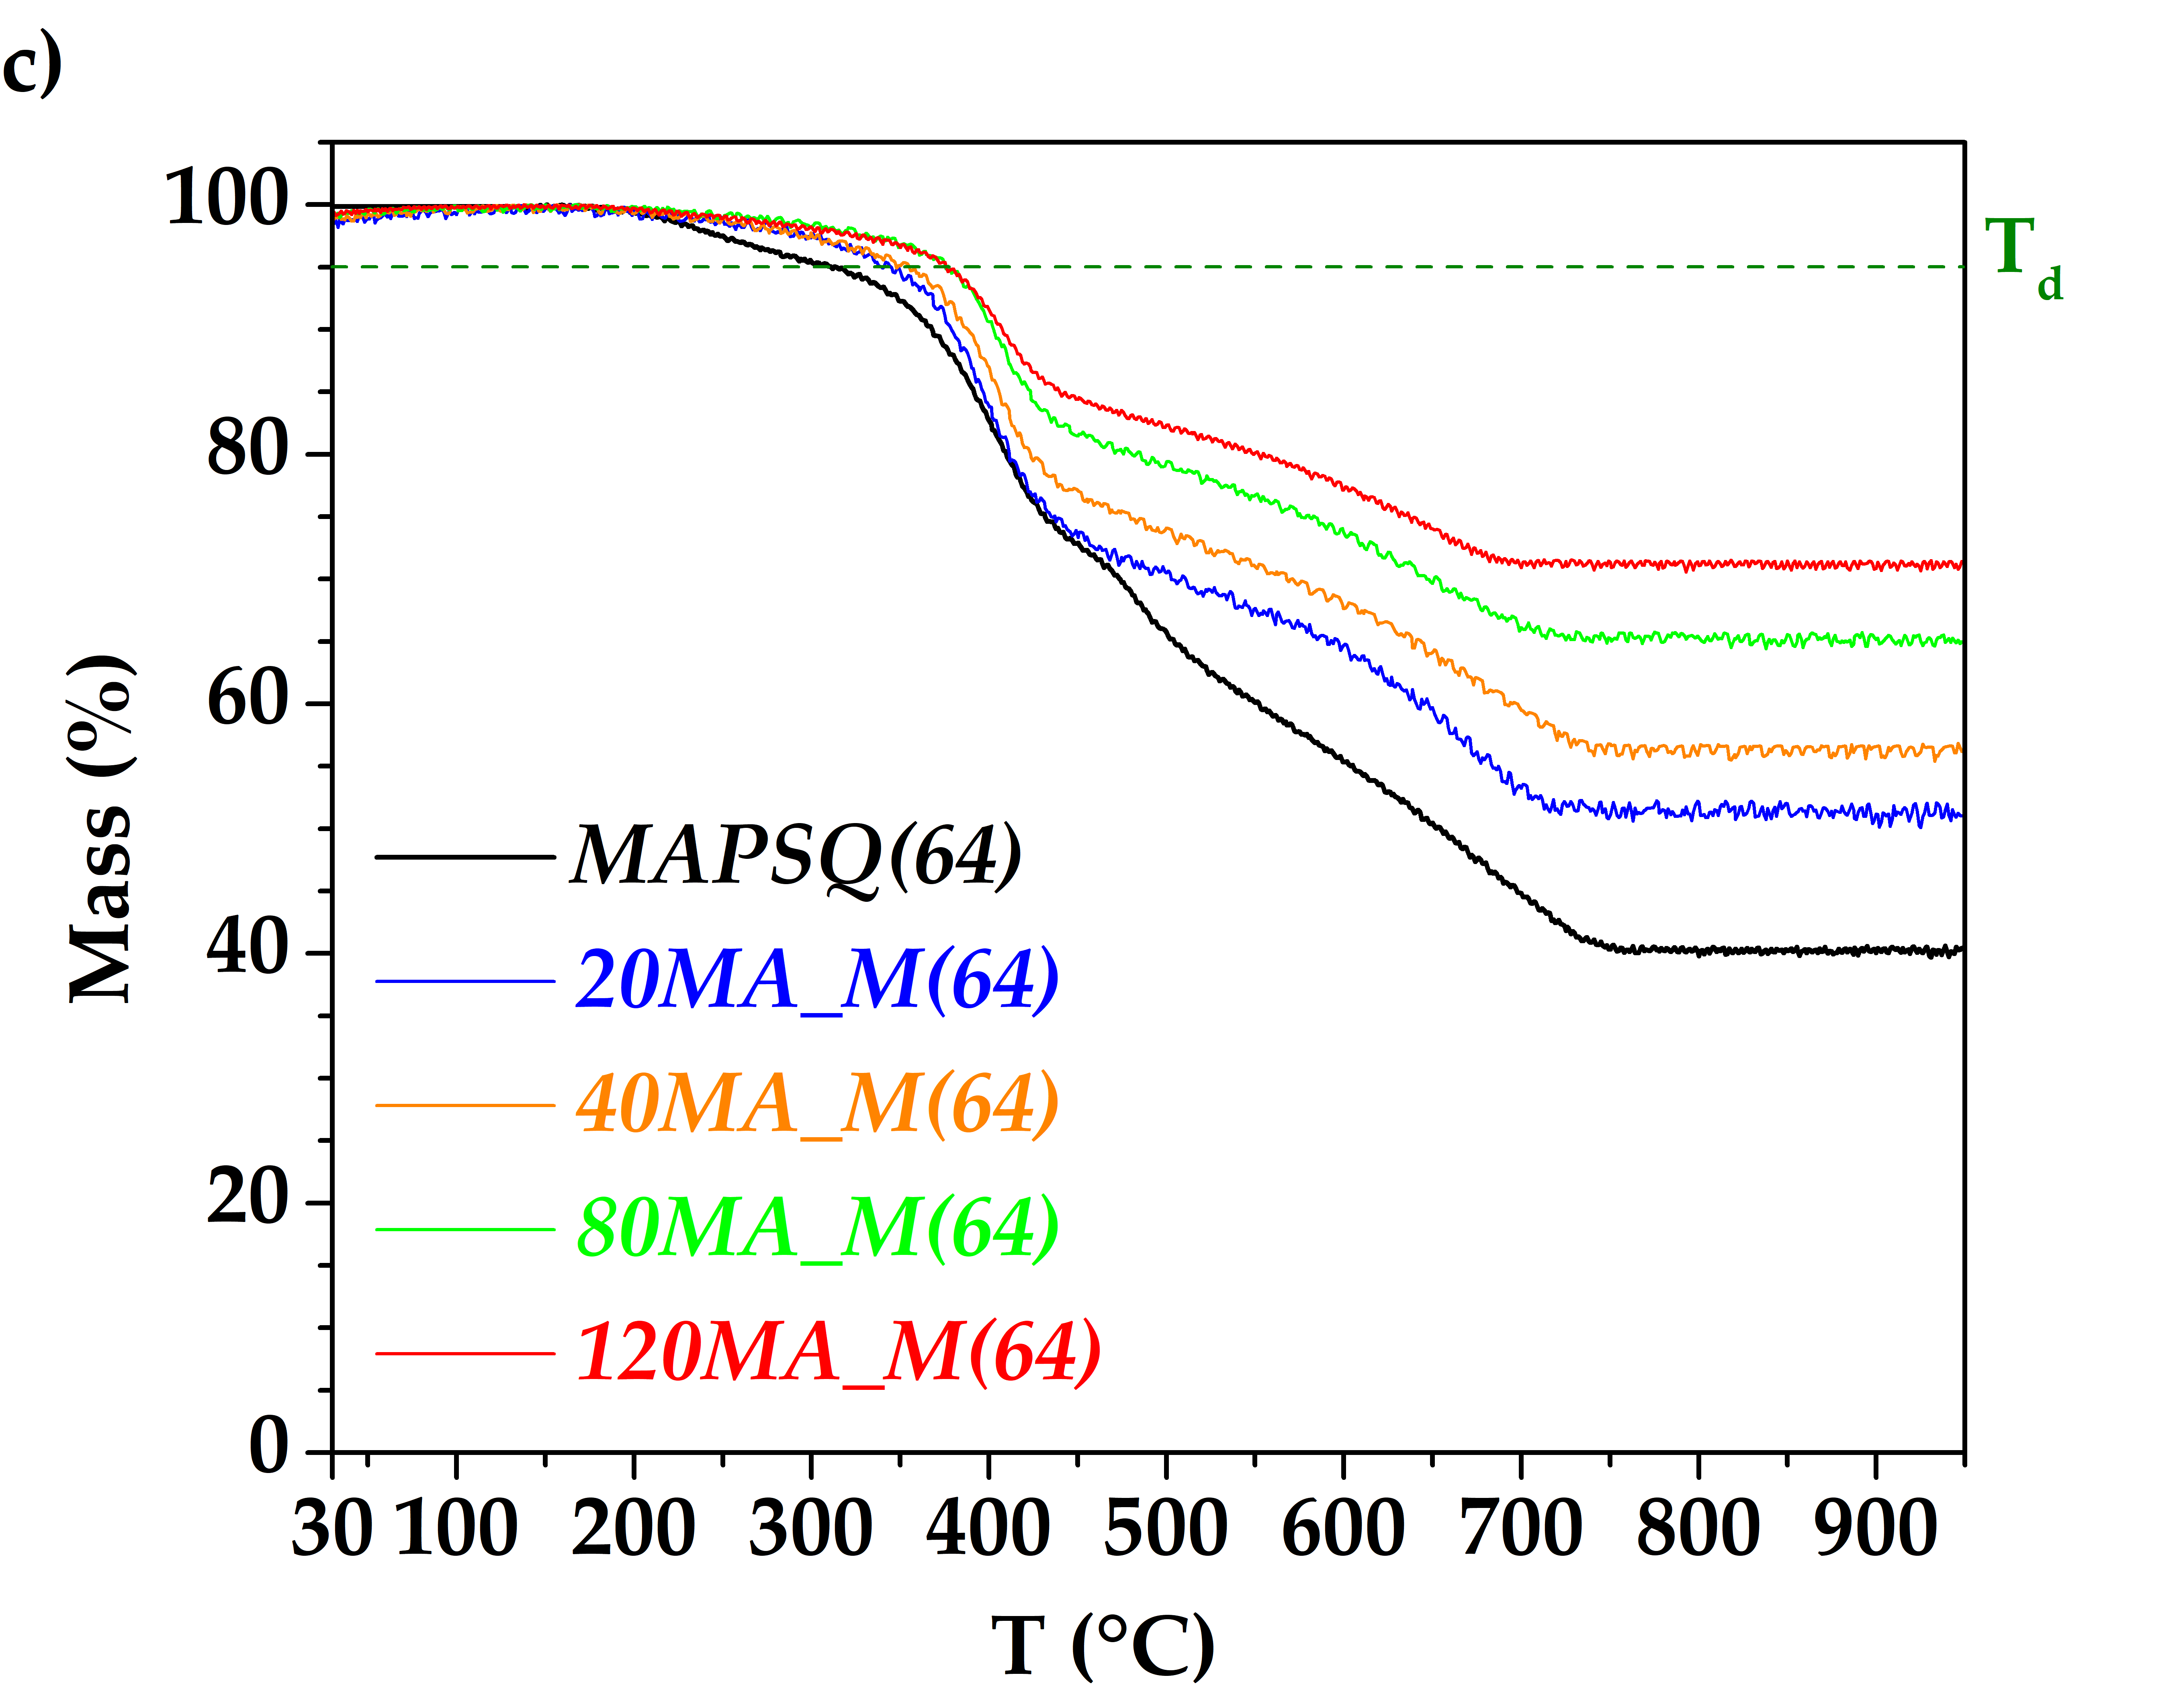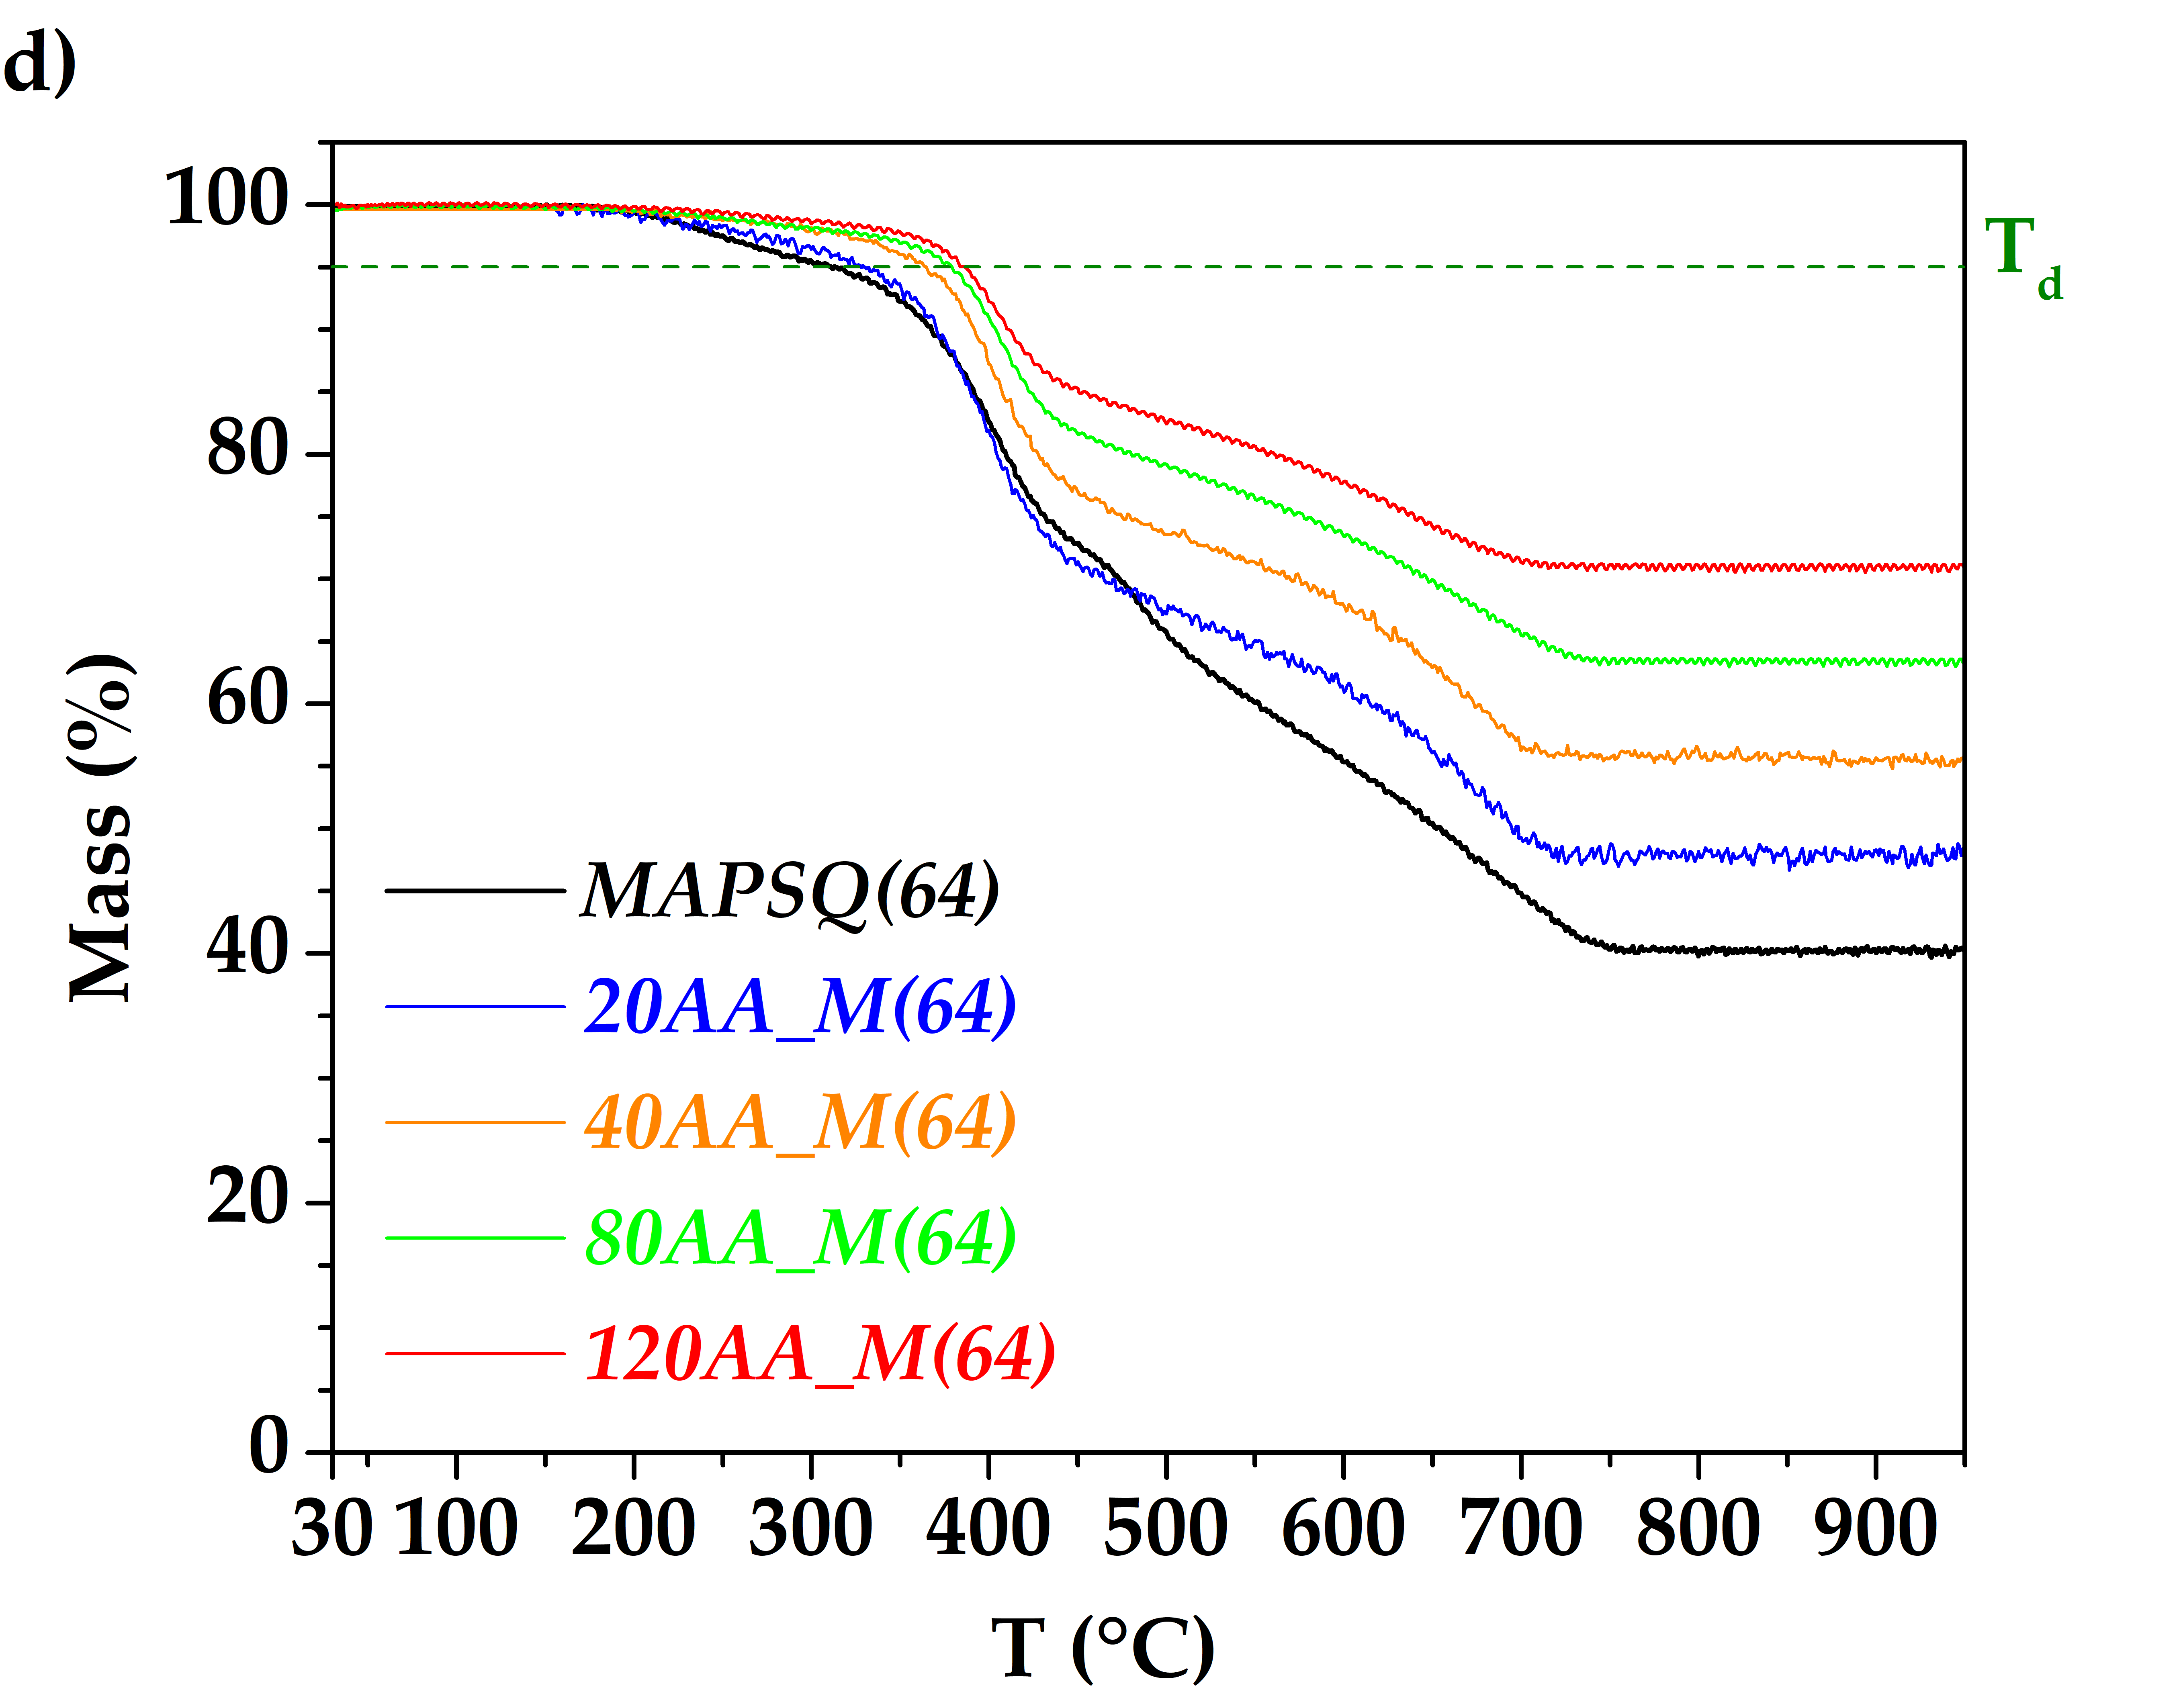
Figure S9: TG curves of (a) MA_L, (b) AA_L, (c) MA_M(64), and (d) AA_M(64) nanocomposites. Green dotted lines point out the decomposition temperature (T_{d}), measured at 5% weight loss.

Table S2. Experimental values of density (ρ), specific heat capacity (c_{P}), and thermal diffusivity (α) of matrices and NCs.
Sample ID | ρ (g/cm³) | c_{P} (J/g∙K) | α (mm²/s)
Ladder matrices
LPMASQ | 1.23 ± 0.01 | 1.45 ± 0.01 | 0.146 ± 0.001
MAPSQ(64) | 1.245 ± 0.004 | 1.26 ± 0.02 | 0.1120 ± 0.0001
MA_L composites
20MA_L | 1.37 ± 0.02 | 1.33 ± 0.02 | 0.169 ± 0.001
40MA_L | 1.46 ± 0.03 | 1.25 ± 0.02 | 0.206 ± 0.003
80MA_L | 1.70 ± 0.01 | 1.14 ± 0.02 | 0.2340 ± 0.0005
120MA_L | 1.82 ± 0.02 | 1.07 ± 0.02 | 0.255 ± 0.001
AA_L composites
20AA_L | 1.392 ± 0.007 | 1.36 ± 0.03 | 0.156 ± 0.001
40AA_L | 1.534 ± 0.005 | 1.29 ± 0.03 | 0.178 ± 0.001
80AA_L | 1.718 ± 0.008 | 1.21 ± 0.03 | 0.1890 ± 0.0001
120AA_L | 1.873 ± 0.007 | 1.15 ± 0.03 | 0.2071 ± 0.0001
MA_M composites
20MA_ M(64) | 1.43 ± 0.01 | 1.17 ± 0.03 | 0.1005 ± 0.0001
40MA_ M(64) | 1.565 ± 0.009 | 1.11 ± 0.03 | 0.1900 ± 0.0001
80MA_ M(64) | 1.749 ± 0.008 | 1.03 ± 0.03 | 0.204 ± 0.003
120MA_ M(64) | 1.943 ± 0.009 | 0.98 ± 0.03 | 0.223 ± 0.001
AA_M composites
20AA_ M(64) | 1.428 ± 0.007 | 1.20 ± 0.04 | 0.1590 ± 0.0001
40AA_ M(64) | 1.53 ± 0.01 | 1.16 ± 0.04 | 0.194 ± 0.005
80AA_ M(64) | 1.75 ± 0.01 | 1.10 ± 0.04 | 0.2250 ± 0.0001
120AA_ M(64) | 1.87 ± 0.01 | 1.06 ± 0.04 | 0.251 ± 0.003

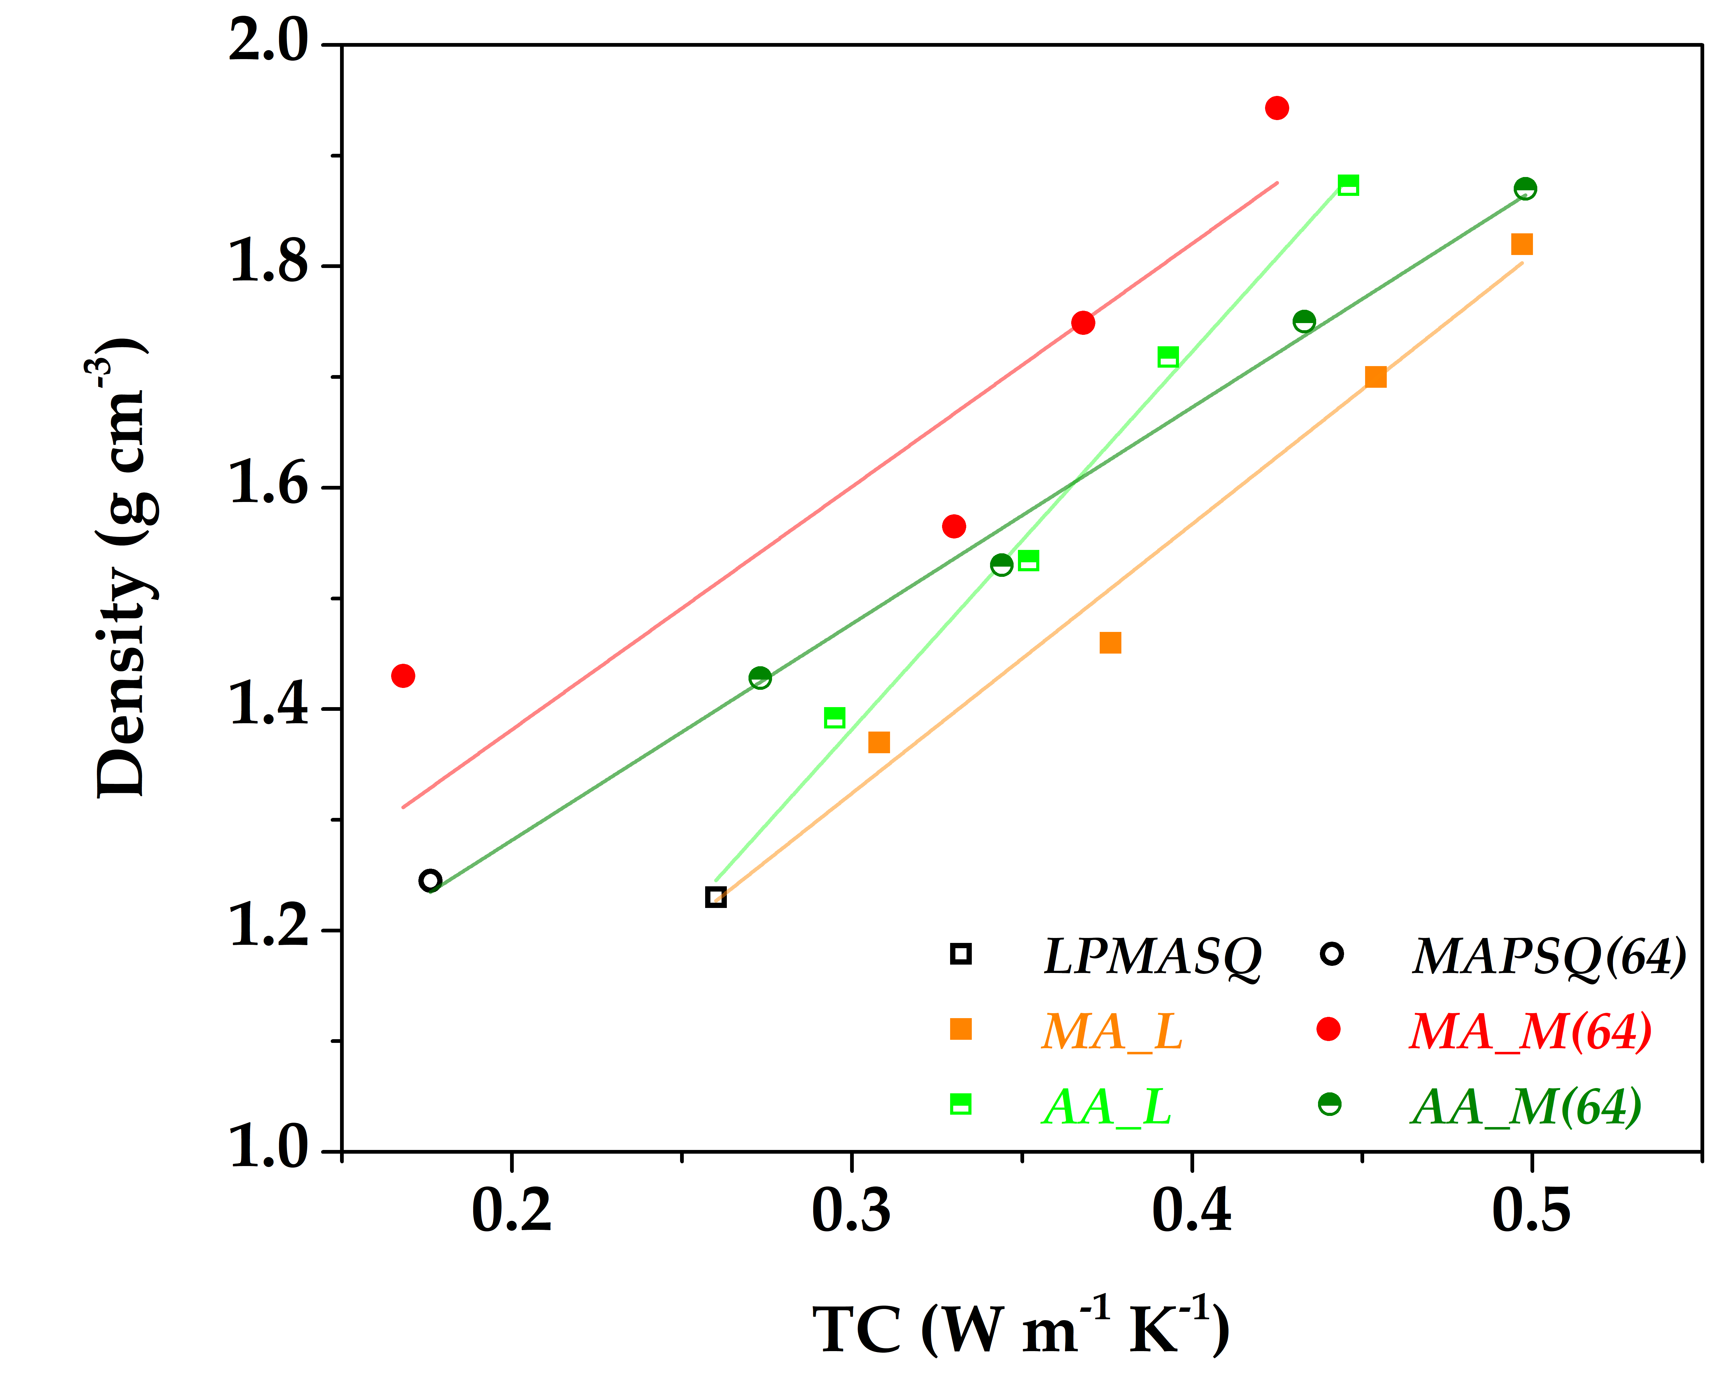
Figure S10: correlation of thermal conductivity with density for all nanocomposites. A linear regression was performed for each nanocomposite formulation, showing R² values above 0.98 in all cases, except for MA_M(64), where the fit yields R² < 0.85.

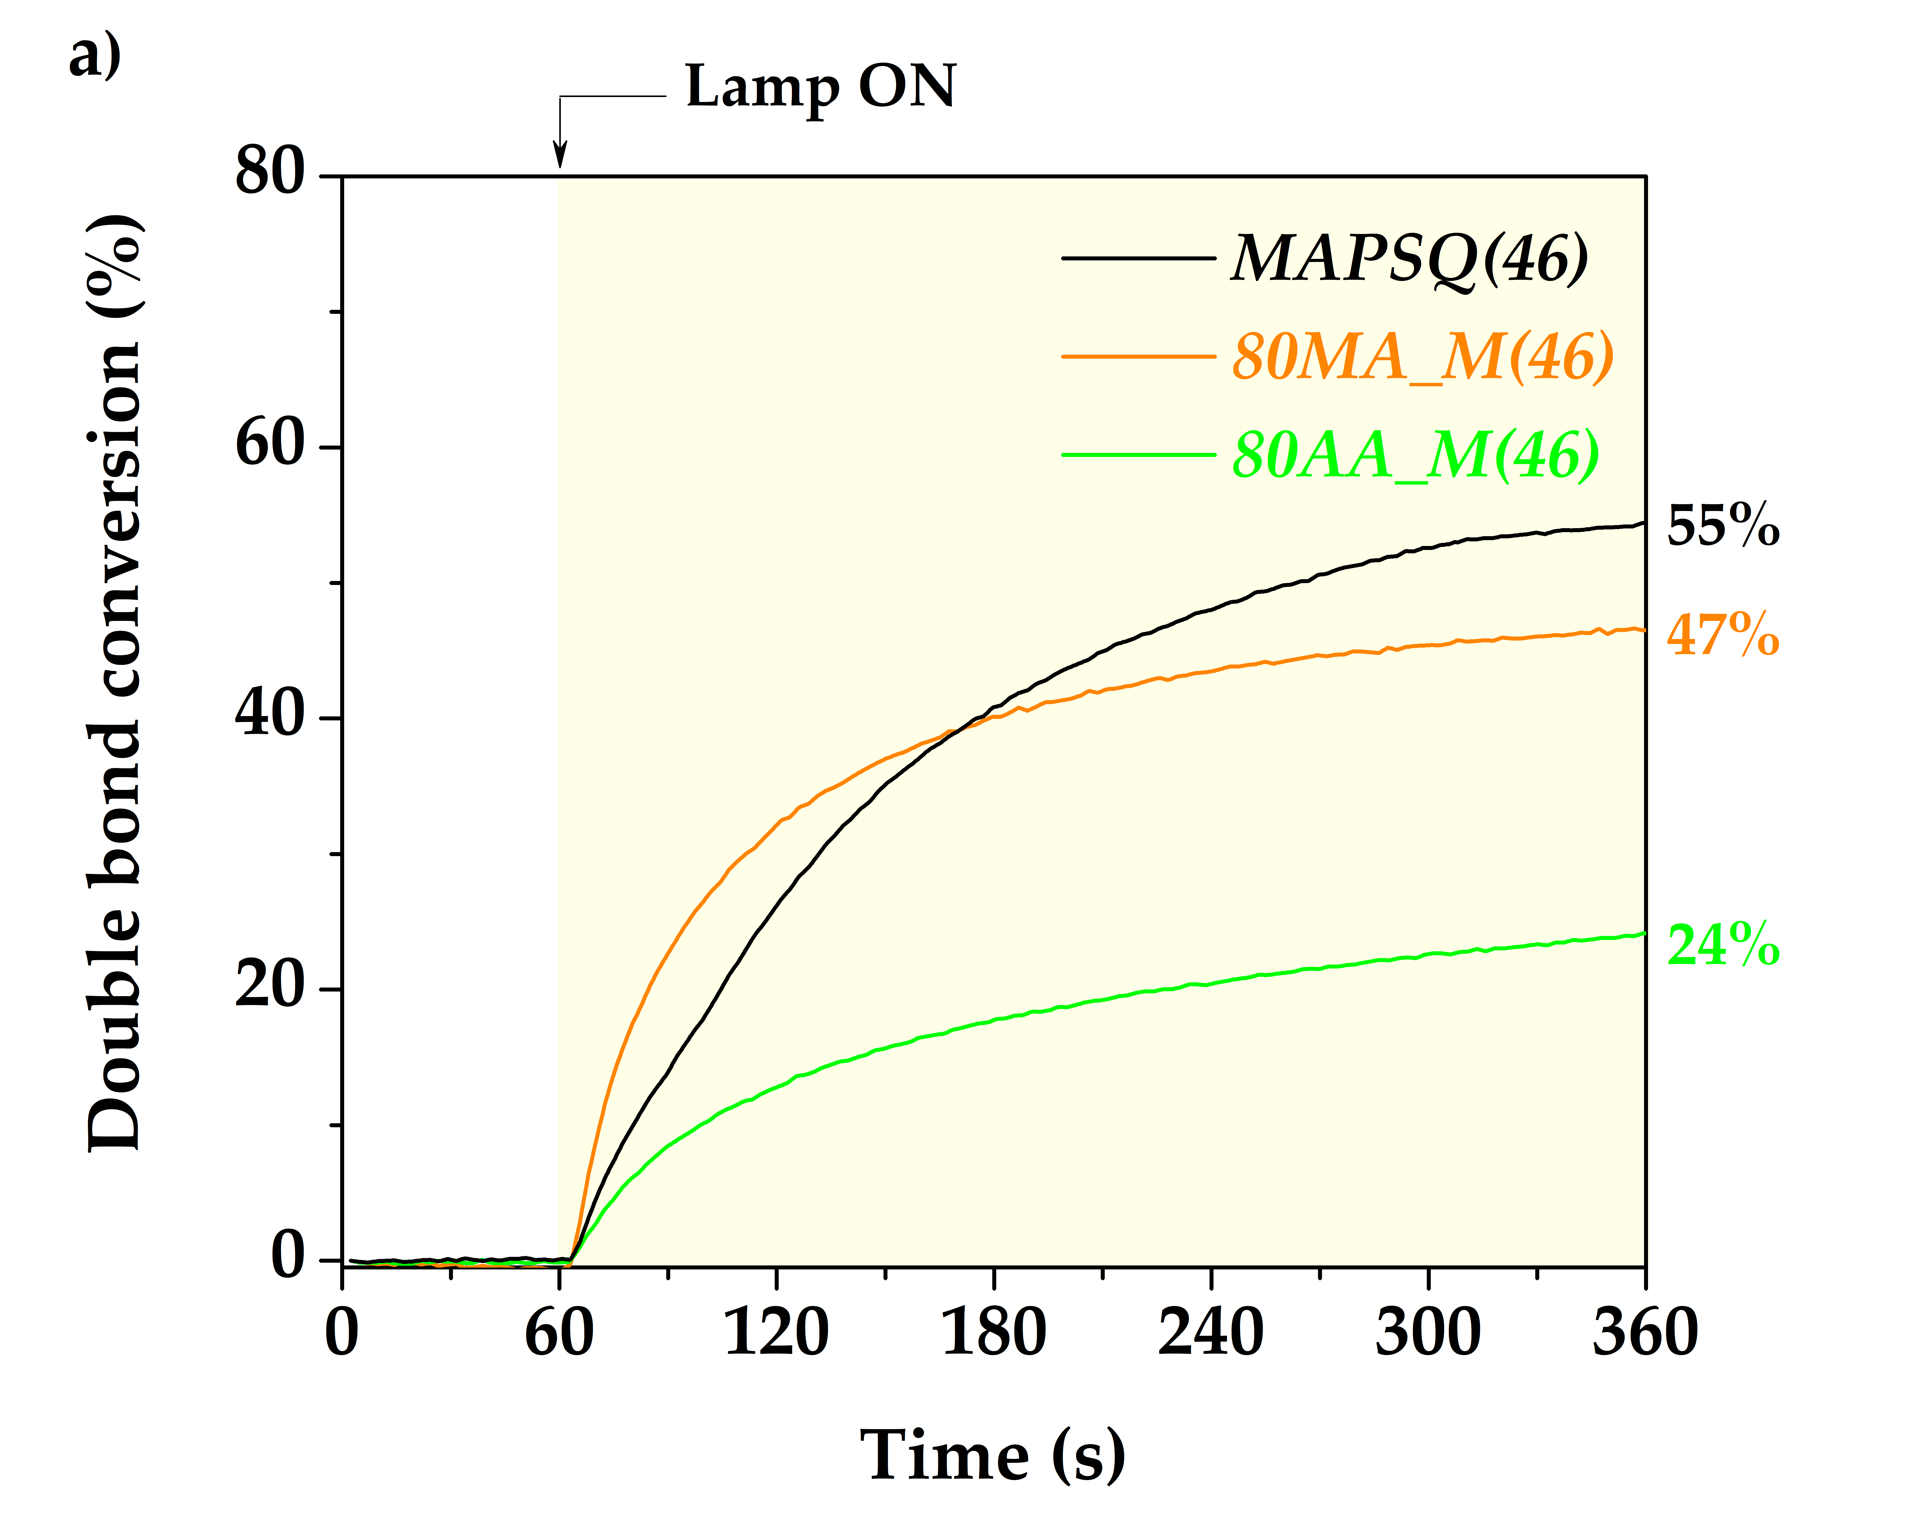
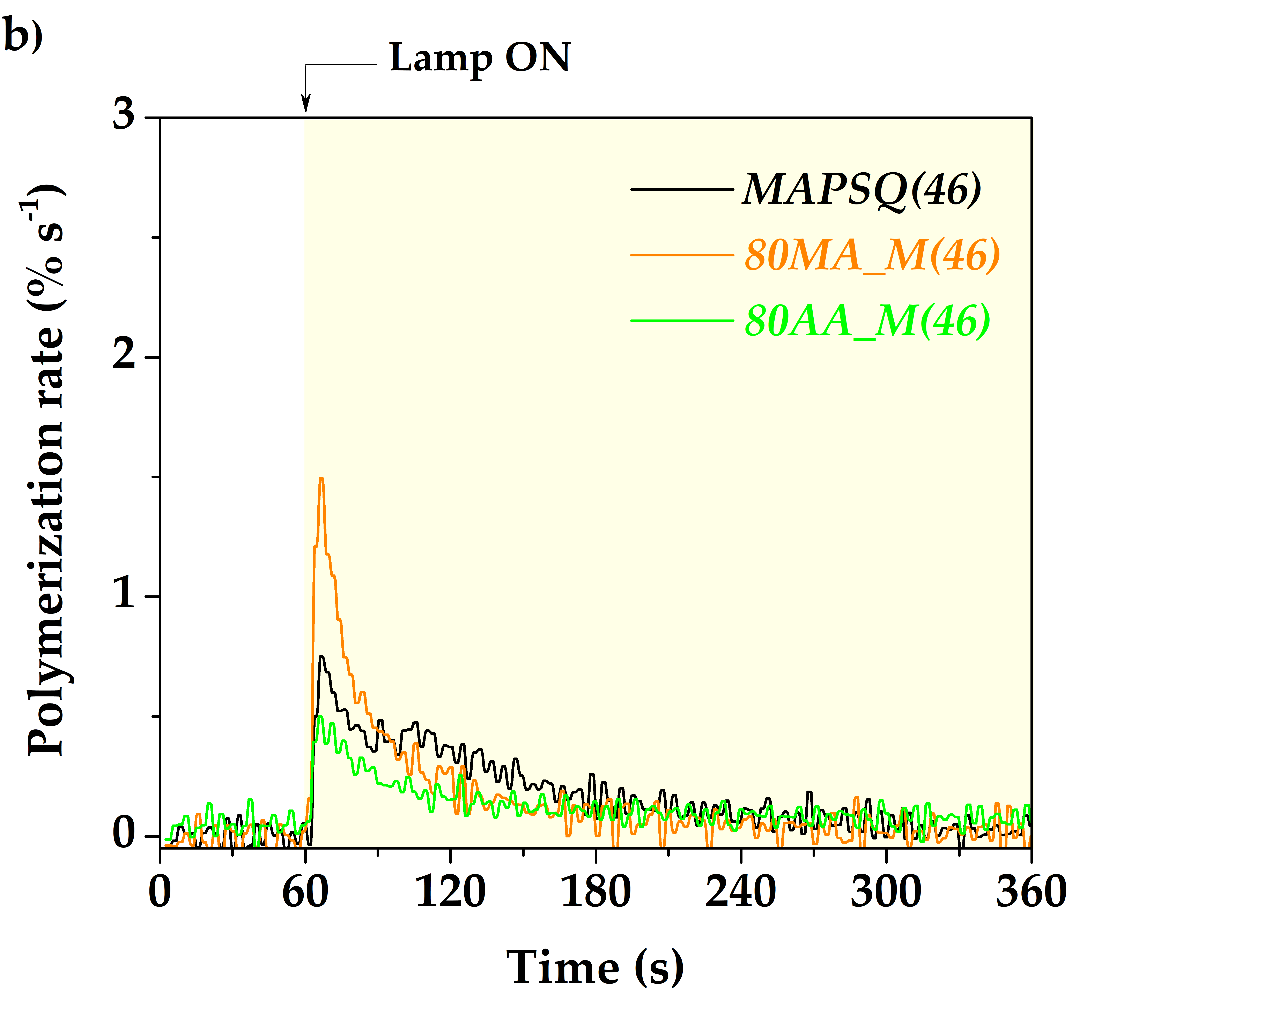
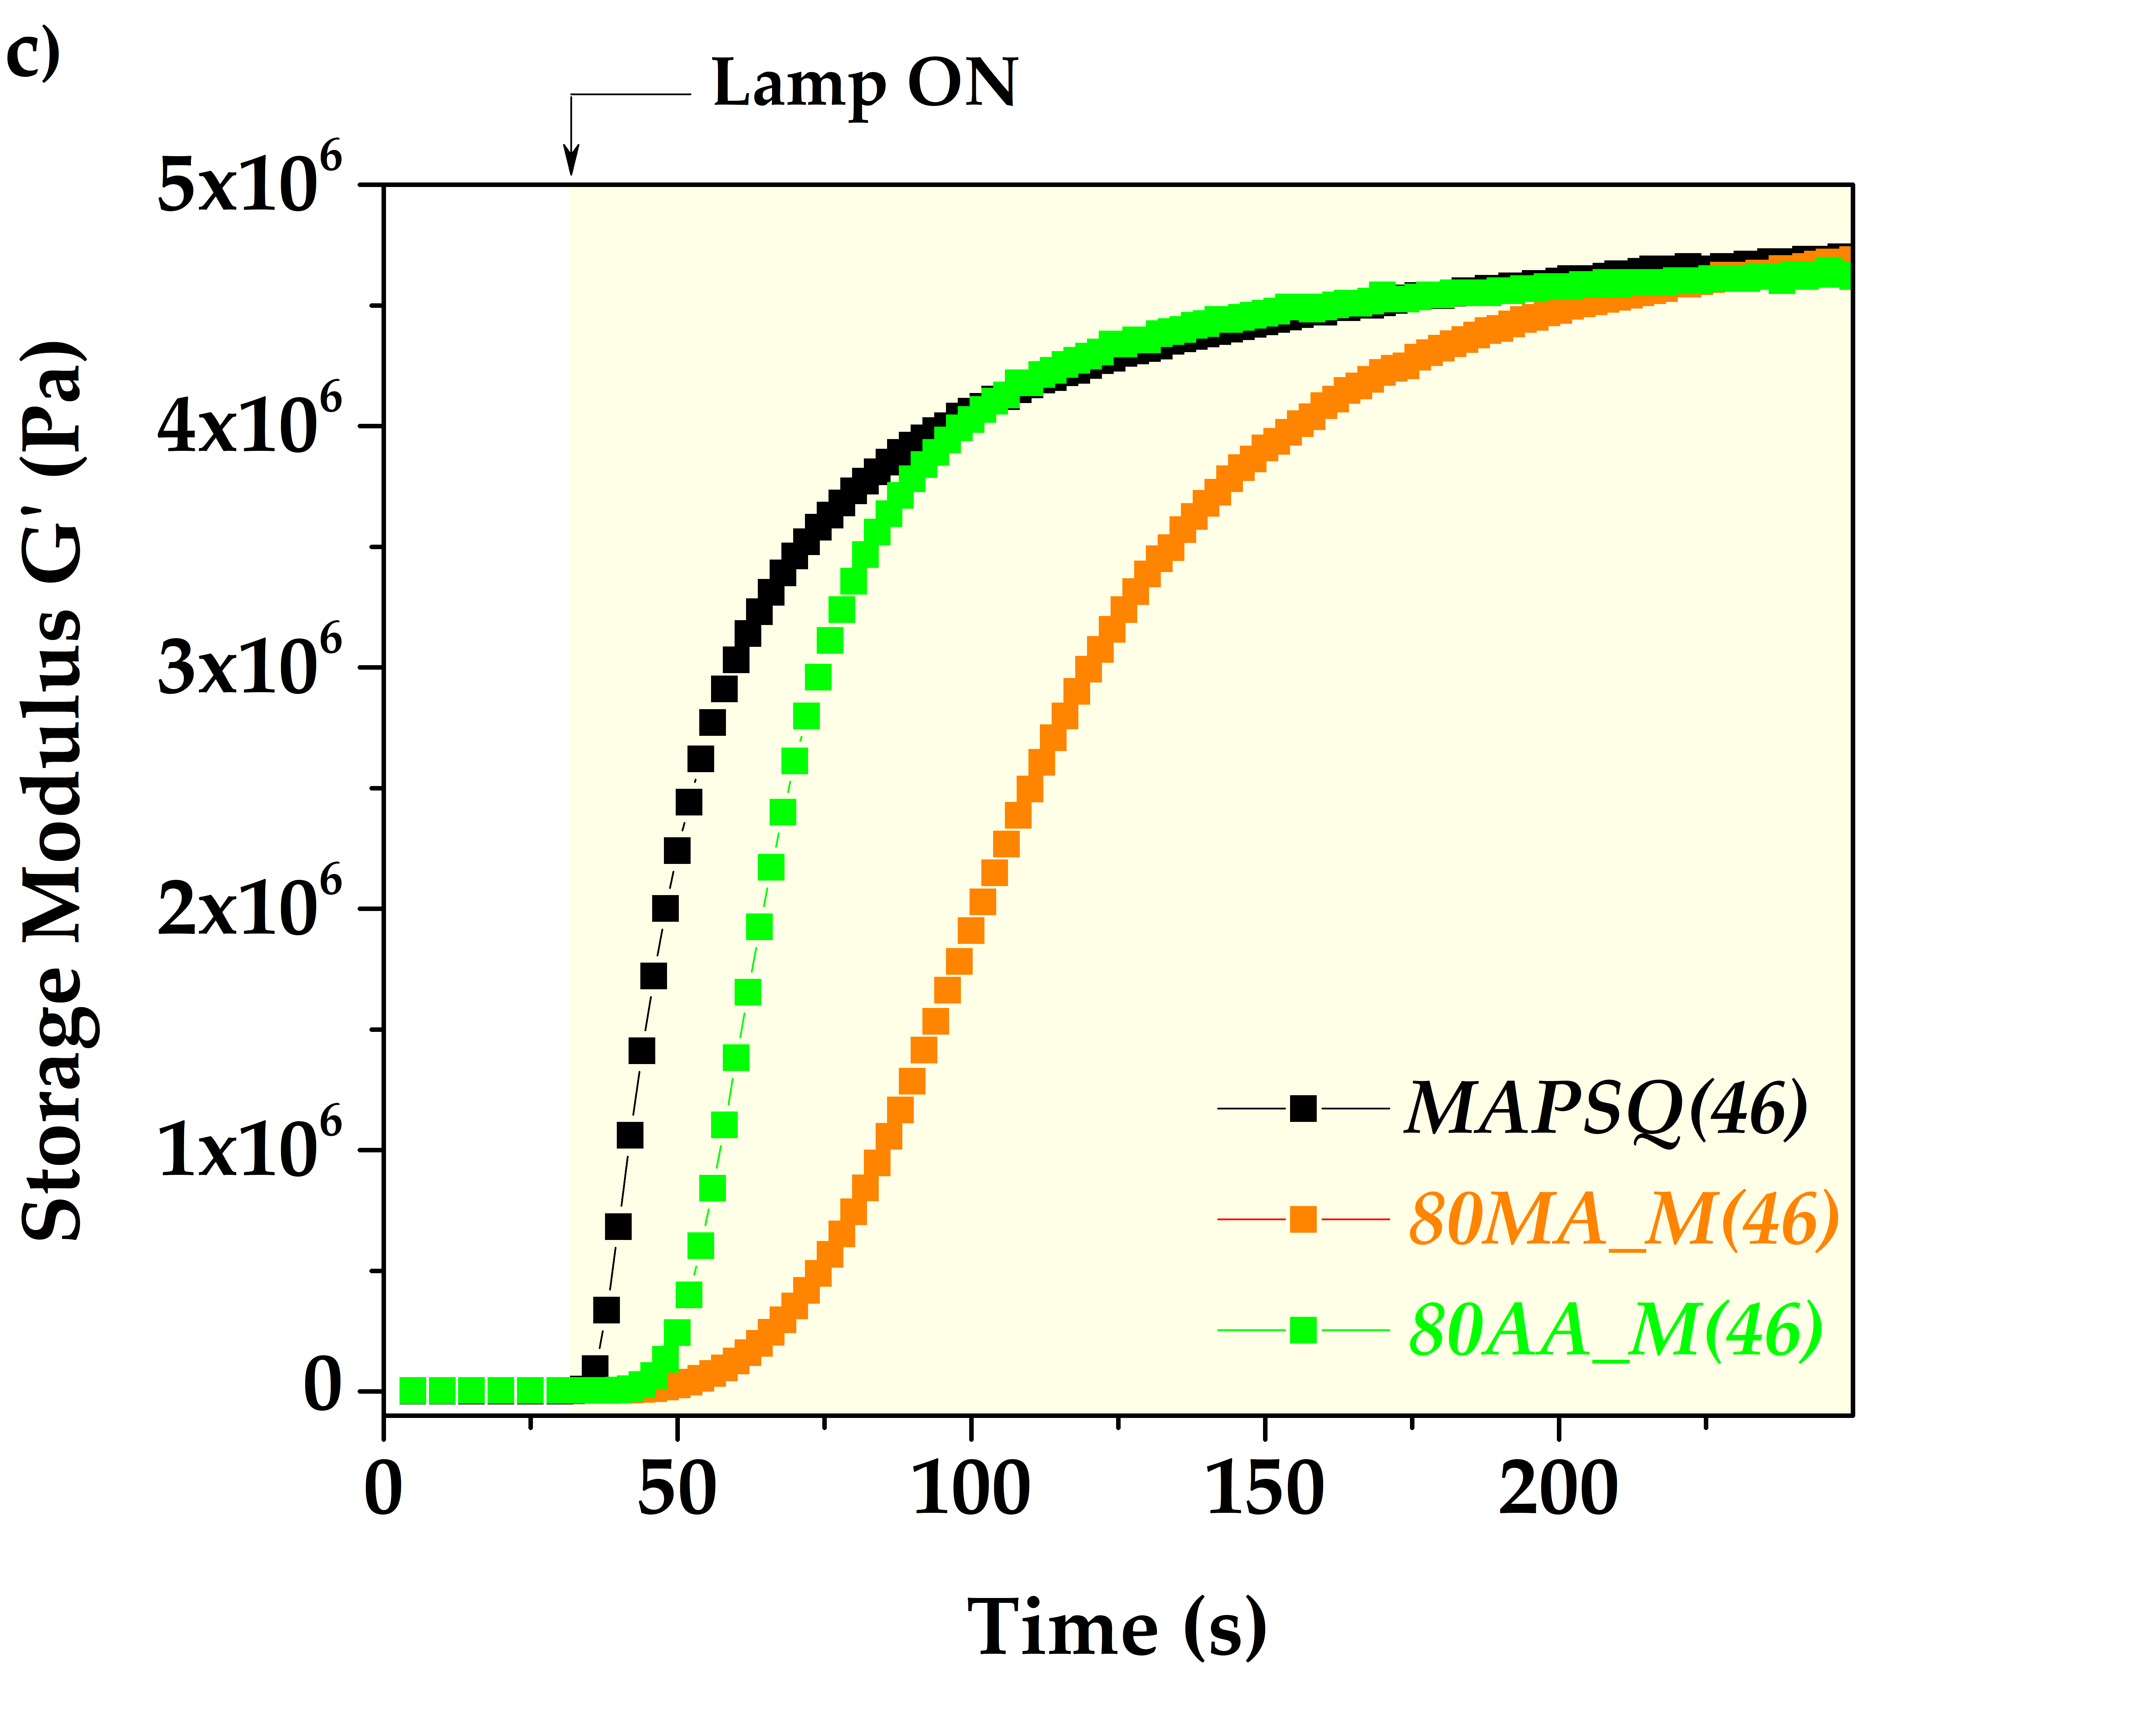
Figure S11: rt-FTIR results for MAPSQ(46)-based nanocomposites: (a) double bond conversion of methacrylate group over time, and (b) polymerization rate over time; (c) photorheology curves of MAPSQ(46)-based nanocomposites.

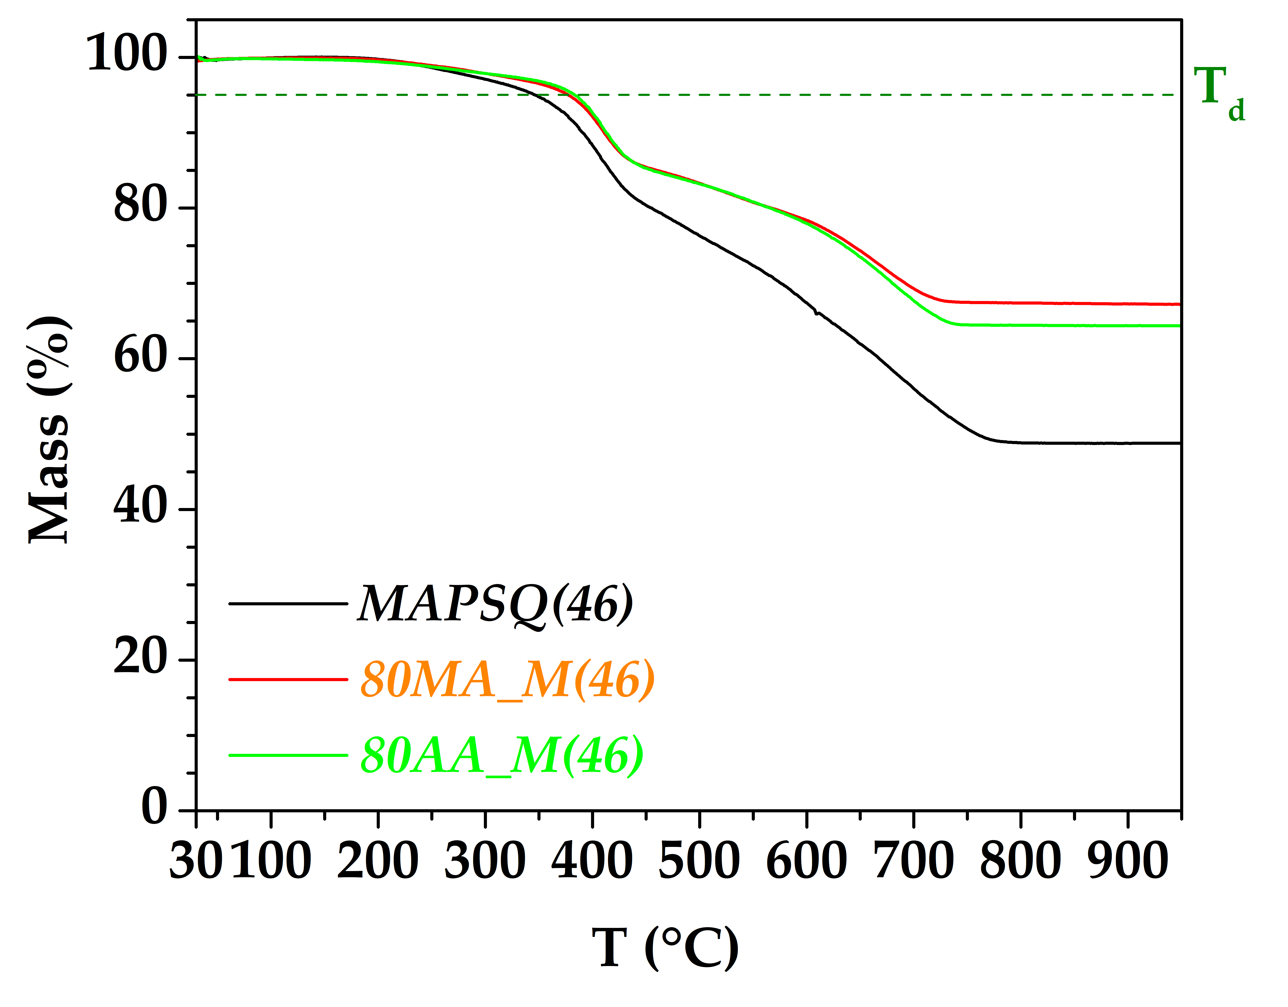
Figure S12: TG curves of MAPSQ(46)-based samples.

Table S3. Density (ρ), specific heat capacity (c_{P}), thermal diffusivity (α), and thermal conductivity (k) of MAPSQ(46)-based samples.
Sample ID | ρ (g/cm³) | c_{P} (J/g∙K) | α (mm²/s) | k (W∙m⁻¹∙K⁻¹)
MAPSQ(46) | 1.28 ± 0.01 | 1.26 ± 0.02 | 0. 1456 ± 0.0003 | 0.235 ± 0.004
80MA_M(46) | 1.74 ± 0.02 | 1.03 ± 0.05 | 0.2344 ± 0.0003 | 0.420 ± 0.021
80AA_M(46) | 1.701 ± 0.007 | 1.10 ± 0.05 | 0.226 ± 0.002 | 0.423 ± 0.020

