Supporting Information
Sintering-driven optimization of multi-ionic SDC–Na₂CO₃ nanocomposite electrolytes for low-temperature Solid Oxide Cell applications
Maria Carmenza Diaz Lacharme^{(a)}, Andrea Bartoletti^{(b)}, Katia Monzillo^{(c)}, Riccardo Ceccato^{(d)}, Francesco Parrino^{(d)}, Emanuela Callone^{(d)}, Sandra Dirè^{(d)}, Vincenzo Vaiano^{(c)}, Alessandra Sanson ^{(b)}, Angela Gondolini*^{(b)}, Alessandro Donazzi*^{(a)}
^{(a)} Department of Energy, Politecnico di Milano, via Lambruschini 4, 20156, Milan, Italy
^{(b)} National Research Council of Italy, Institute of Science, Technology and Sustainability for Ceramics (CNR-ISSMC), Via Granarolo 64, 48018, Faenza, Italy
^{(c)} Department of Industrial Engineering, University of Salerno, via Giovanni Paolo II, 132, 84084, Fisciano, Italy
^{(d)} Department of Industrial Engineering, University of Trento, via Sommarive 9, 38123 Trento, Italy
*Corresponding author: alessandro.donazzi@polimi.it; angela.gondolini@issmc.cnr.it

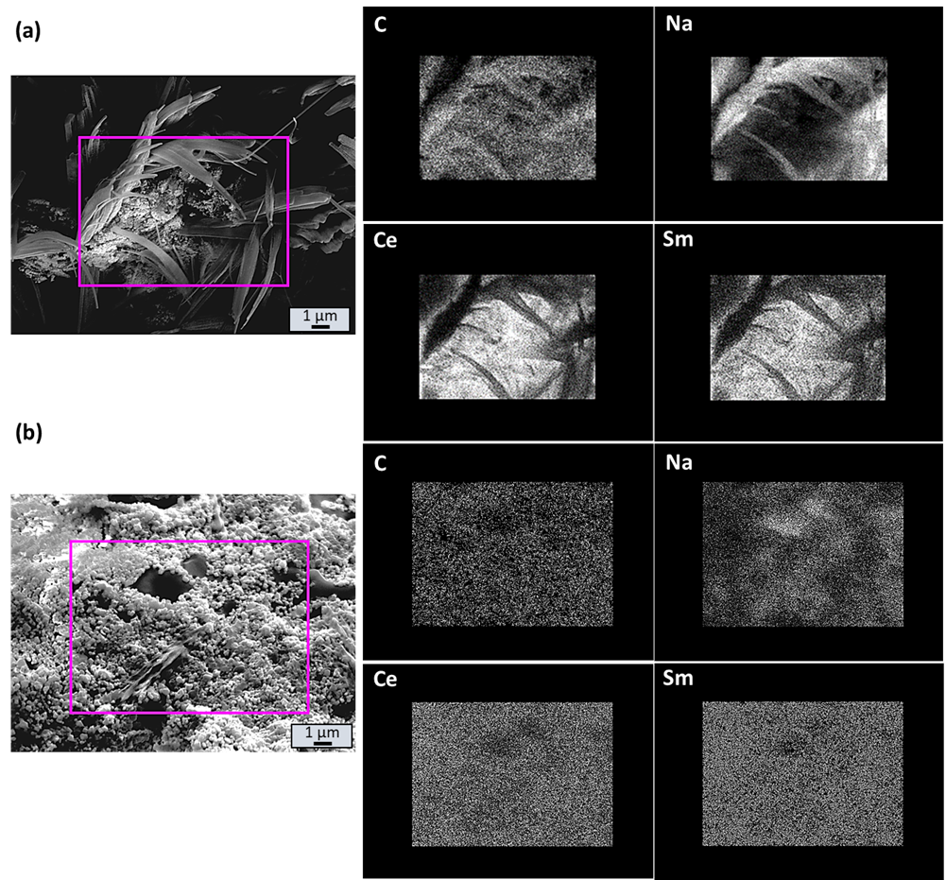
Figure S1 SEM-EDX analyses on the cross-section of SDCC samples treated at 700°C (a) and 900°C (b). On the sample treated at 700°C, the carbonate phase appears as rods, whereas in the one treated at 900°C, it appears as flakes.

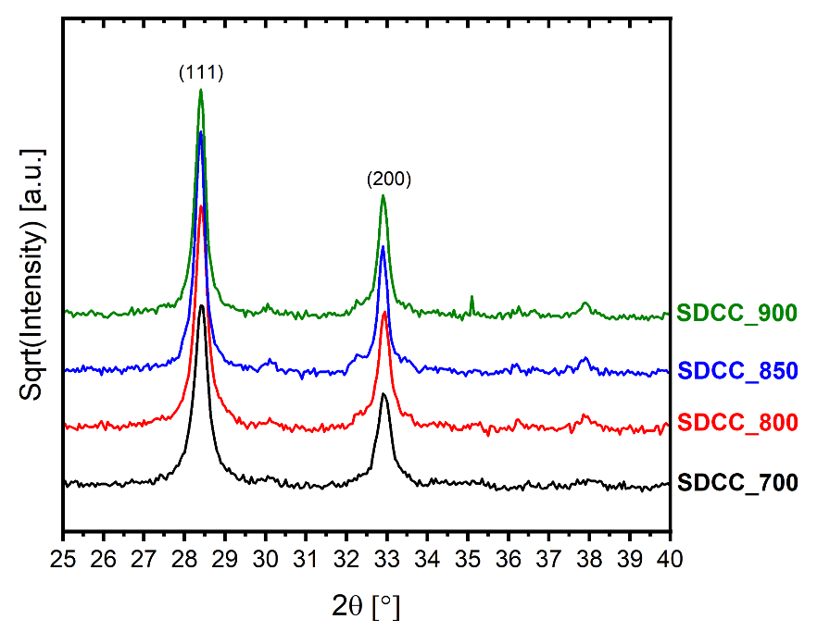
Figure S2 XRD patterns of as-synthesized SDCC pellets for different sintering temperatures in the narrow 2θ range (25 – 40°) to evidence better pattern variation due to the natrite phase. The intensity is presented on a square root scale. Reflections peaks (111) and (200) can be associated with the cerianite phase.

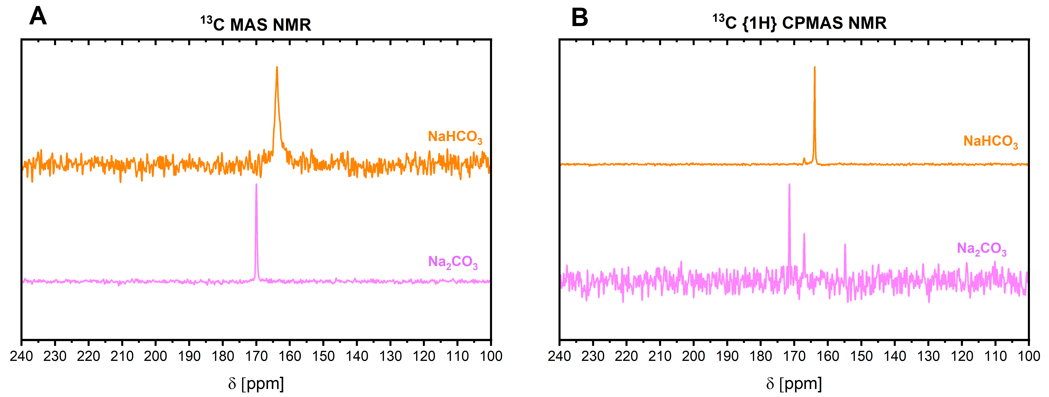
Figure S3 (A) ¹³C MAS and (B) ¹³C{1H} CPMAS NMR spectra of reference commercial Na₂CO₃ and NaHCO₃.
A | B
Figure S4 Deconvoluted peaks spectra of SDCC_700 in the carbonate range (1000-1150 cm⁻¹) (A) before and (B) after the test.

A | B
Figure S5 Deconvoluted peaks spectra of SDCC_800 in the carbonate range (1000-1150 cm⁻¹) (A) before and (B) after the test.

A | B
Figure S6 Deconvoluted peaks spectra of SDCC_850 in the carbonate range (1000-1150 cm⁻¹) (A) before and (B) after the test.

A | B
Figure S7 Deconvoluted peaks spectra of SDCC_900 in the carbonate range (1000-1150 cm⁻¹) (A) before and (B) after the test.

Specific surface area
The specific surface area of SDCC pellets before and after the test was determined by the Brunauer-Emmett-Teller (BET) theory and shown in Table S1. The SSA values of fresh SDC samples varies between 12-2 m² g⁻¹ in function of the sintering temperature. For the SDCC_850 and 900 samples there are no SSA changes. Instead, for pellets sintered at lower temperatures (700, 800°C) the decrease in SSA is more significant after the test. During the test, the samples likely undergo a sort of coalescence phenomenon, which causes a decrease in the porosity of SDC composites and therefore a lower specific surface area.

Table S1 SSA (BET method) values of the SDCC pellets for different sintering temperatures.
Sample before test | SSA*_{(modello BET)} [m² g⁻¹] | Sample after test | SSA*_{(modello BET)} [m² g⁻¹]
SDCC_700 | 12 | SDCC_700 | 8
SDCC_800 | 7 | SDCC_800 | 5
SDCC_850 | 2 | SDCC_850 | 2
SDCC_900 | 3 | SDCC_900 | 3

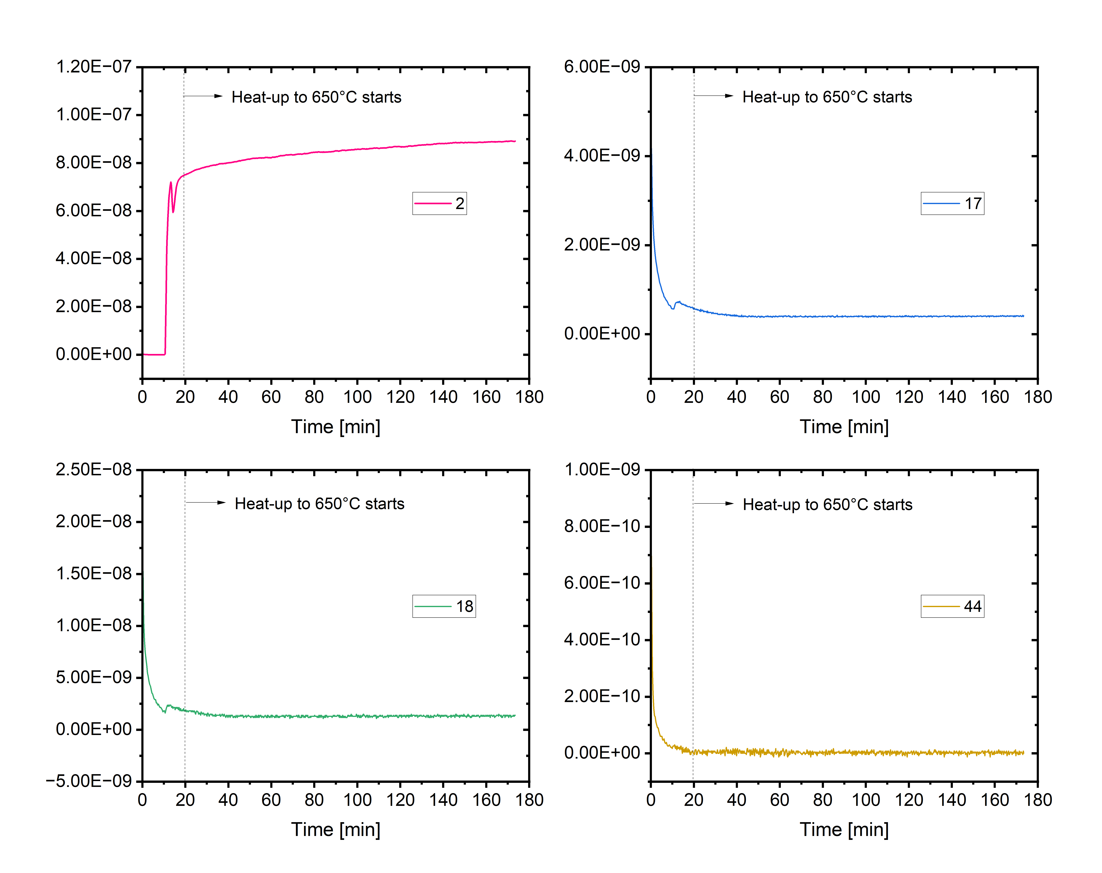
Figure S8 Mass Spectrometry Signals (m/z = 2, 17, 18, 44) during the heat-up of SDCC_850 in 4% H₂ to 650 °C in the TG experiments
The mass spectrometer signals corresponding to m/z = 2 (H₂), 17 (OH⁻), 18 (H₂O), and 44 (CO₂) were monitored during the heat-up in 4% H₂ to 650°C for the SDCC_850 sample. No significant increase was observed in the signals 18, 17, and 44, indicating the absence of water or carbon dioxide production. The stable baseline of these signals throughout the ramp confirms that no decomposition, side reactions, or desorption events involving H₂O or CO₂-related species occurred during heating. In addition, no consumption peak for the H₂ signal, suggesting that there was no ongoing reduction during the ramp-up in temperature.

