Supporting information
Sepiolite nanofibers decorated with Zn single sites: a sustainable filler for mechanically robust and self-healing ionomeric elastomer composites.
Paolo Valagussaª, Silvia Mostoni*ª, Marianella Hernandez Santana^{b}, Itziar Mas Giner^{b}, Michele Mauriª, Roberto Simonuttiª, Sandra Diré^{c}, Emanuela Callone^{c}, Barbara Di Credicoª, Roberto Scottiª, Massimiliano D’Arienzoª
ª Department of Materials Science, INSTM, University of Milano-Bicocca, Via Roberto Cozzi 55, Milano, Italy
^{b} Institute of Polymer Science and Technology (ICTP), CSIC, C/ Juan de la Cierva, 3, Madrid, Spain
^{c} “Klaus Müller” Magnetic Resonance Lab., Department of Industrial Engineering, University of Trento, Via Sommarive 9, 38123 Trento, Italy
TGA calculations
First, the moles of –OH per gram of base-treated Sep (n_{OH}) were calculated from the weight loss in the 150–1000 °C temperature range (∆W_{150-1000°C}) of Sep-OH, considering that each molecule of water released corresponds to the condensation of two hydroxyl groups:
${\text{Δ}\text{W}}_{\text{150-1000°C}}\text{ = }\frac{\text{1}}{\text{2}}\text{ · (}{\text{n}}_{\text{OH }}\text{· }{\text{w}}_{\text{Sep-OH(1000°C)}}\text{)}{\text{ · MW}}_{{\text{H}}_{\text{2}}\text{O}}$ Eq. S1

${\text{n}}_{\text{OH}}\text{ = }\frac{{\text{2ΔW}}_{\text{150-1000°C}}}{{\text{MW}}_{{\text{H}}_{\text{2}}\text{O∙}}{\text{w}}_{\text{Sep-OH(1000°C)}}}$ Eq. S2

where w_{Sep-OH(1000°C)} is the sample mass at 1000 °C and ${\text{MW}}_{{\text{H}}_{\text{2}}\text{O}}$ is the molecular weight of water (18.01 g/mol). Weight loss below 150 °C is assumed to arise from desorption of physisorbed species, such as solvent molecules. Based on this calculation, n_{OH} = 8.85 mmol/g.
The increased weight loss observed for Sep@APTES in the 150–1000 °C range is attributable to the higher organic content relative to Sep-OH. This increase is hypothesized to originate from: (i) combustion of –CH₂CH₂CH₂NH₂ functional groups from APTES; (ii) desorption of water from the remaining silanol groups, considering that two –OH groups are replaced for each silane molecule attached to the sepiolite surface; and (iii) desorption of water from –OH groups of APTES formed by hydrolysis of the residual ethoxy group.
Accordingly, the weight loss can be expressed as:

${\text{Δ}\text{W}}_{\text{150-1000°C}}\text{ = }{\text{n}}_{\text{R}}{\text{ · MW}}_{\text{R}}\text{+ }\frac{\text{(}{\text{n}}_{\text{OH }}\text{· }{\text{w}}_{\text{Sep-APTES(1000°C)}}\text{ - 2}{\text{n}}_{\text{R}}\text{)·}{\text{MW}}_{{\text{H}}_{\text{2}}\text{O}}}{\text{2}}\text{+}\frac{{\text{(}{\text{n}}_{\text{OH-A}}\text{ · MW}}_{{\text{H}}_{\text{2}}\text{O}}\text{)}}{\text{2}}$ Eq. S3

where MW_{R} is the molecular weight of –CH₂CH₂CH₂NH₂, n_{OH-A} is the number of hydroxyl groups bound to each APTES unit (equal to $n_{R}$), and the factor 1/2 accounts for the condensation of two –OH groups into one water molecule.
From the moles of –CH₂CH₂CH₂NH₂, (n_{R}), the weight percentage of aminopropyl groups (W_{AP}%) is calculated as:

${\text{w}}_{\text{AP}}\text{\%}\text{ = }\frac{{\text{n}}_{\text{R}}{\text{ · MW}}_{\text{R}}}{ {\text{m}}_{\text{Sep-APTES(1000°C)}}}\text{· 100}$ Eq. S4

DSC with stearic acid
DSC tests were carried out using a three-steps temperature program:
- from 25 to 200 °C, heating rate of 5 °C/min, adding an isotherm of 2 min at 200 °C;
- temperature was brought back to 25 °C (heating rate -10 °C/min), adding an isotherm of 2 min at 30 °C;
- second heating step from 25 to 200 °C (heating rate 5 °C/min), followed by an isotherm of 2 min at 200 °C;
- final cooling treatment to 25 °C (heating rate -10 °C/min).
All the experiments were carried out under nitrogen flow of 80 mL/min.

Preparation of Sep@ZnO filler
Sep-OH filler was decorated with ZnO nanoparticles by preparing a 0.10 M NaOH solution in 70 mL of EtOH at 65°C. After complete NaOH dissolution, 0.33 g of zinc acetate dihydrate (Zn(CH₃COO)₂·2H₂O) was added and stirred for 20 min. Subsequently, 1.0 g of Sep-OH was added, and the suspension was left under stirring for additional 20 min at 65 °C. After cooling, the product was isolated trough centrifugation (9000 rpm, 20 min) and washed twice with EtOH. The resulting solid was dried at 80 °C overnight.

XRD
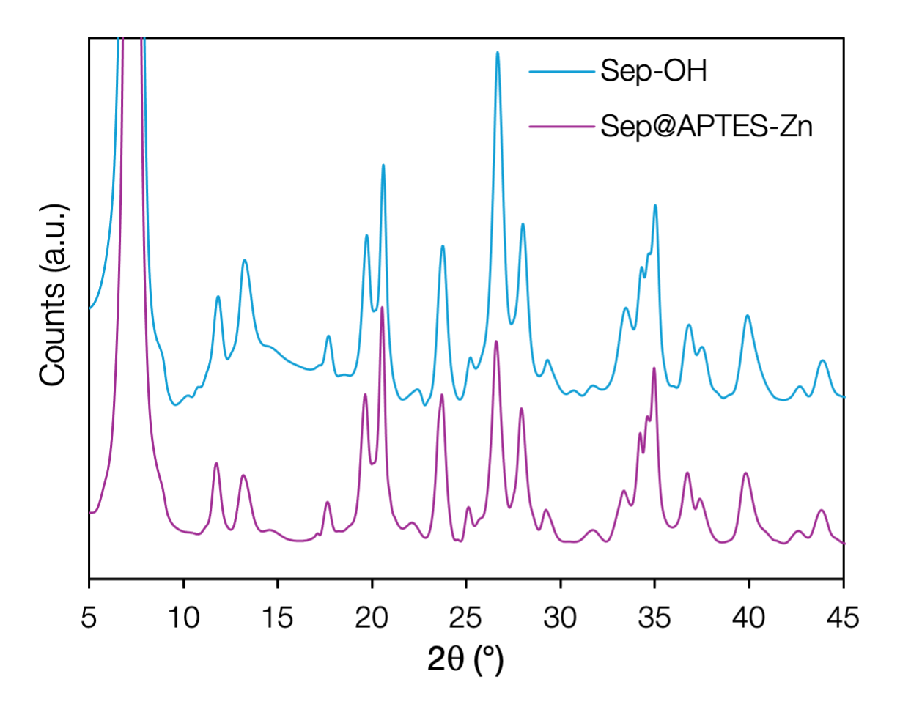
Figure S1. XRD patterns of Sep@APTES-Zn compared to bare Sep-OH.

N₂ physisorption
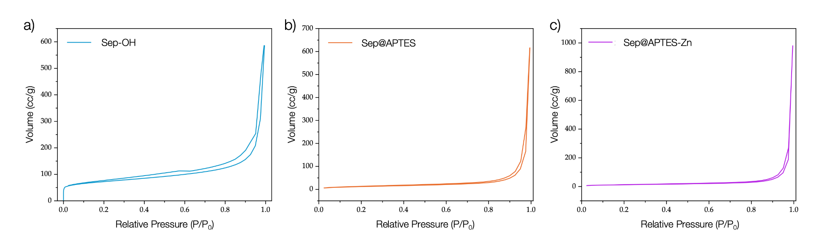
Figure S2. Nitrogen physisorption isotherms at 77K for a) Sep-OH, b) Sep@APTES and c) Sep@APTES-Zn.

FTIR
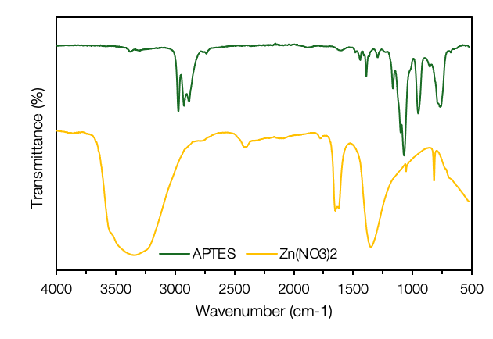
Figure S3. ATR/FTIR spectra of APTES and Zn(NO₃)₂ precursors.
Solid State NMR
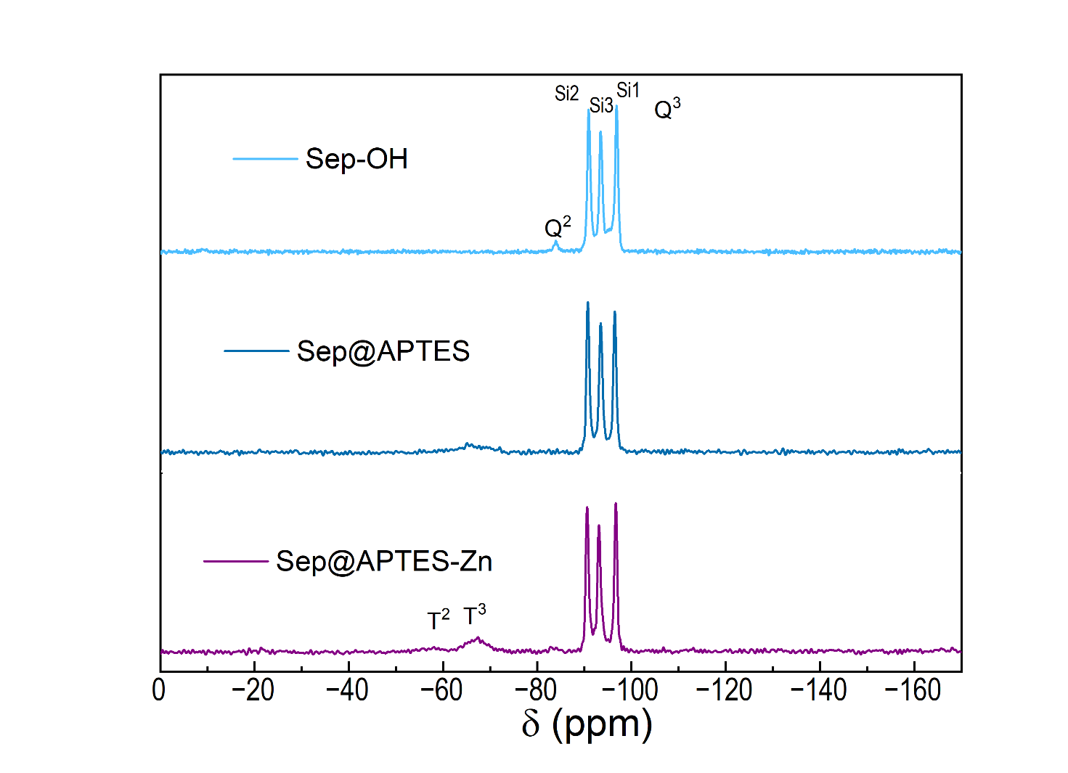
Figure S4. ²⁹Si CPMAS NMR spectra of Sep-OH and functionalized Sep samples.
SEM
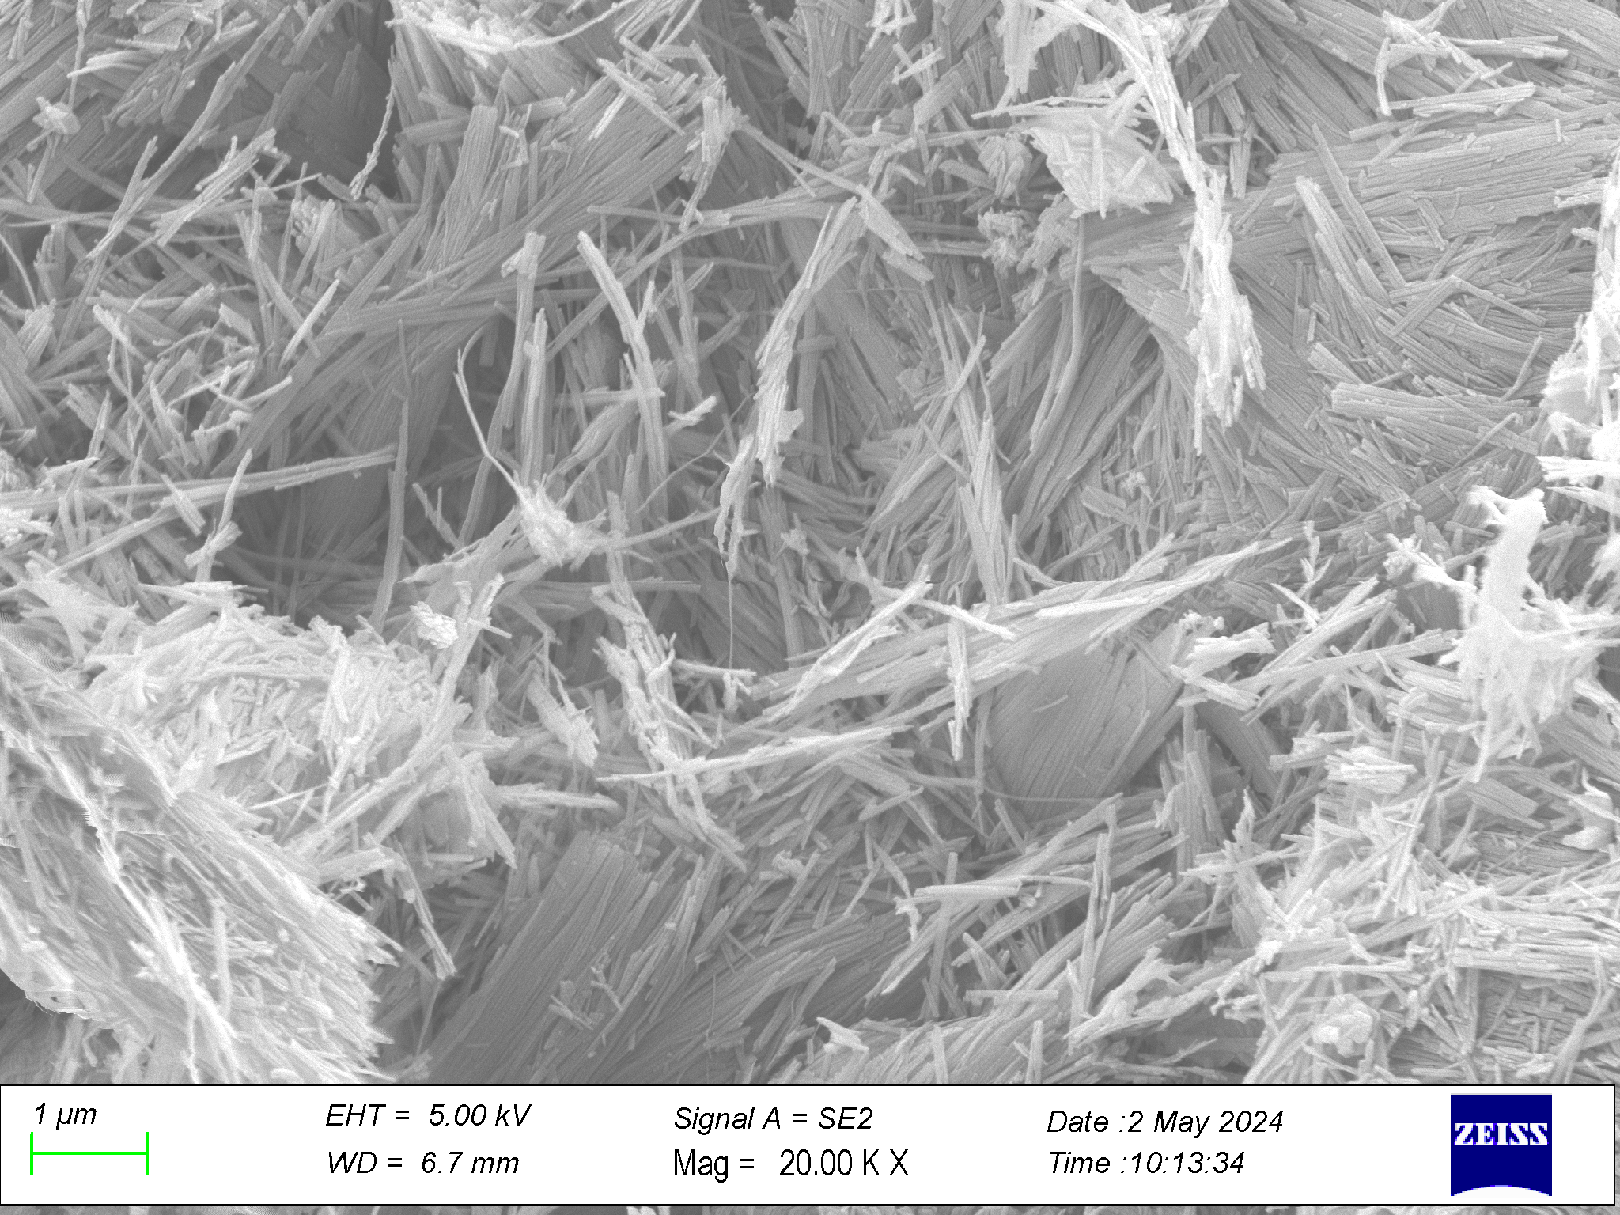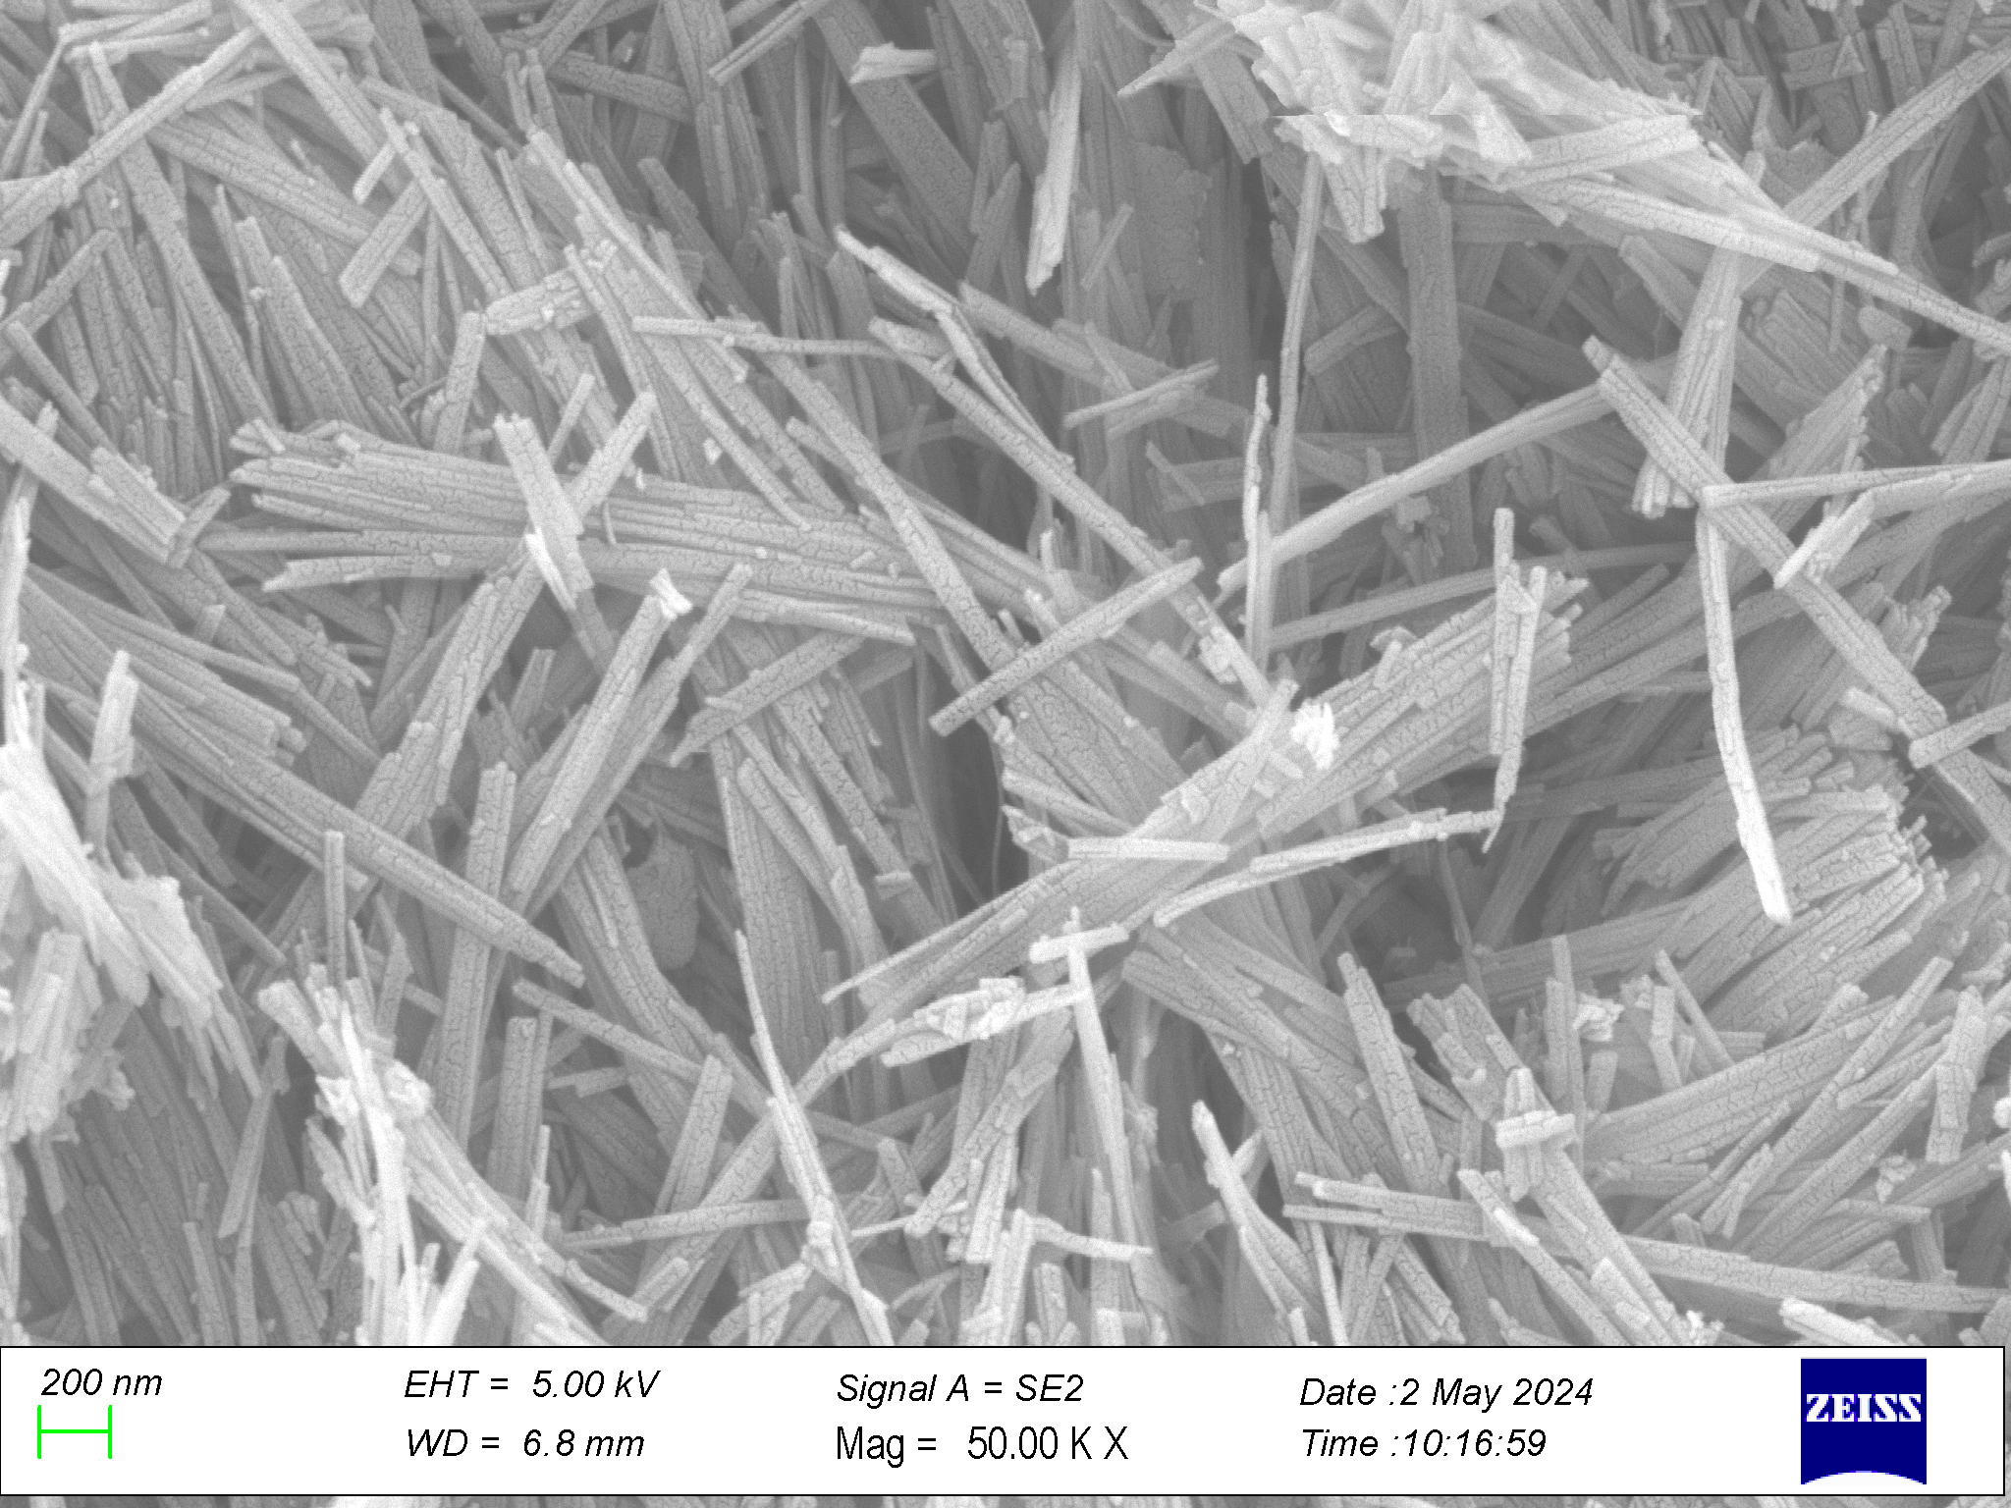

Figure S5. SEM micrographs of Sep@APTES-Zn at different magnifications.

Electron Paramagnetic Resonance (EPR) spectroscopy
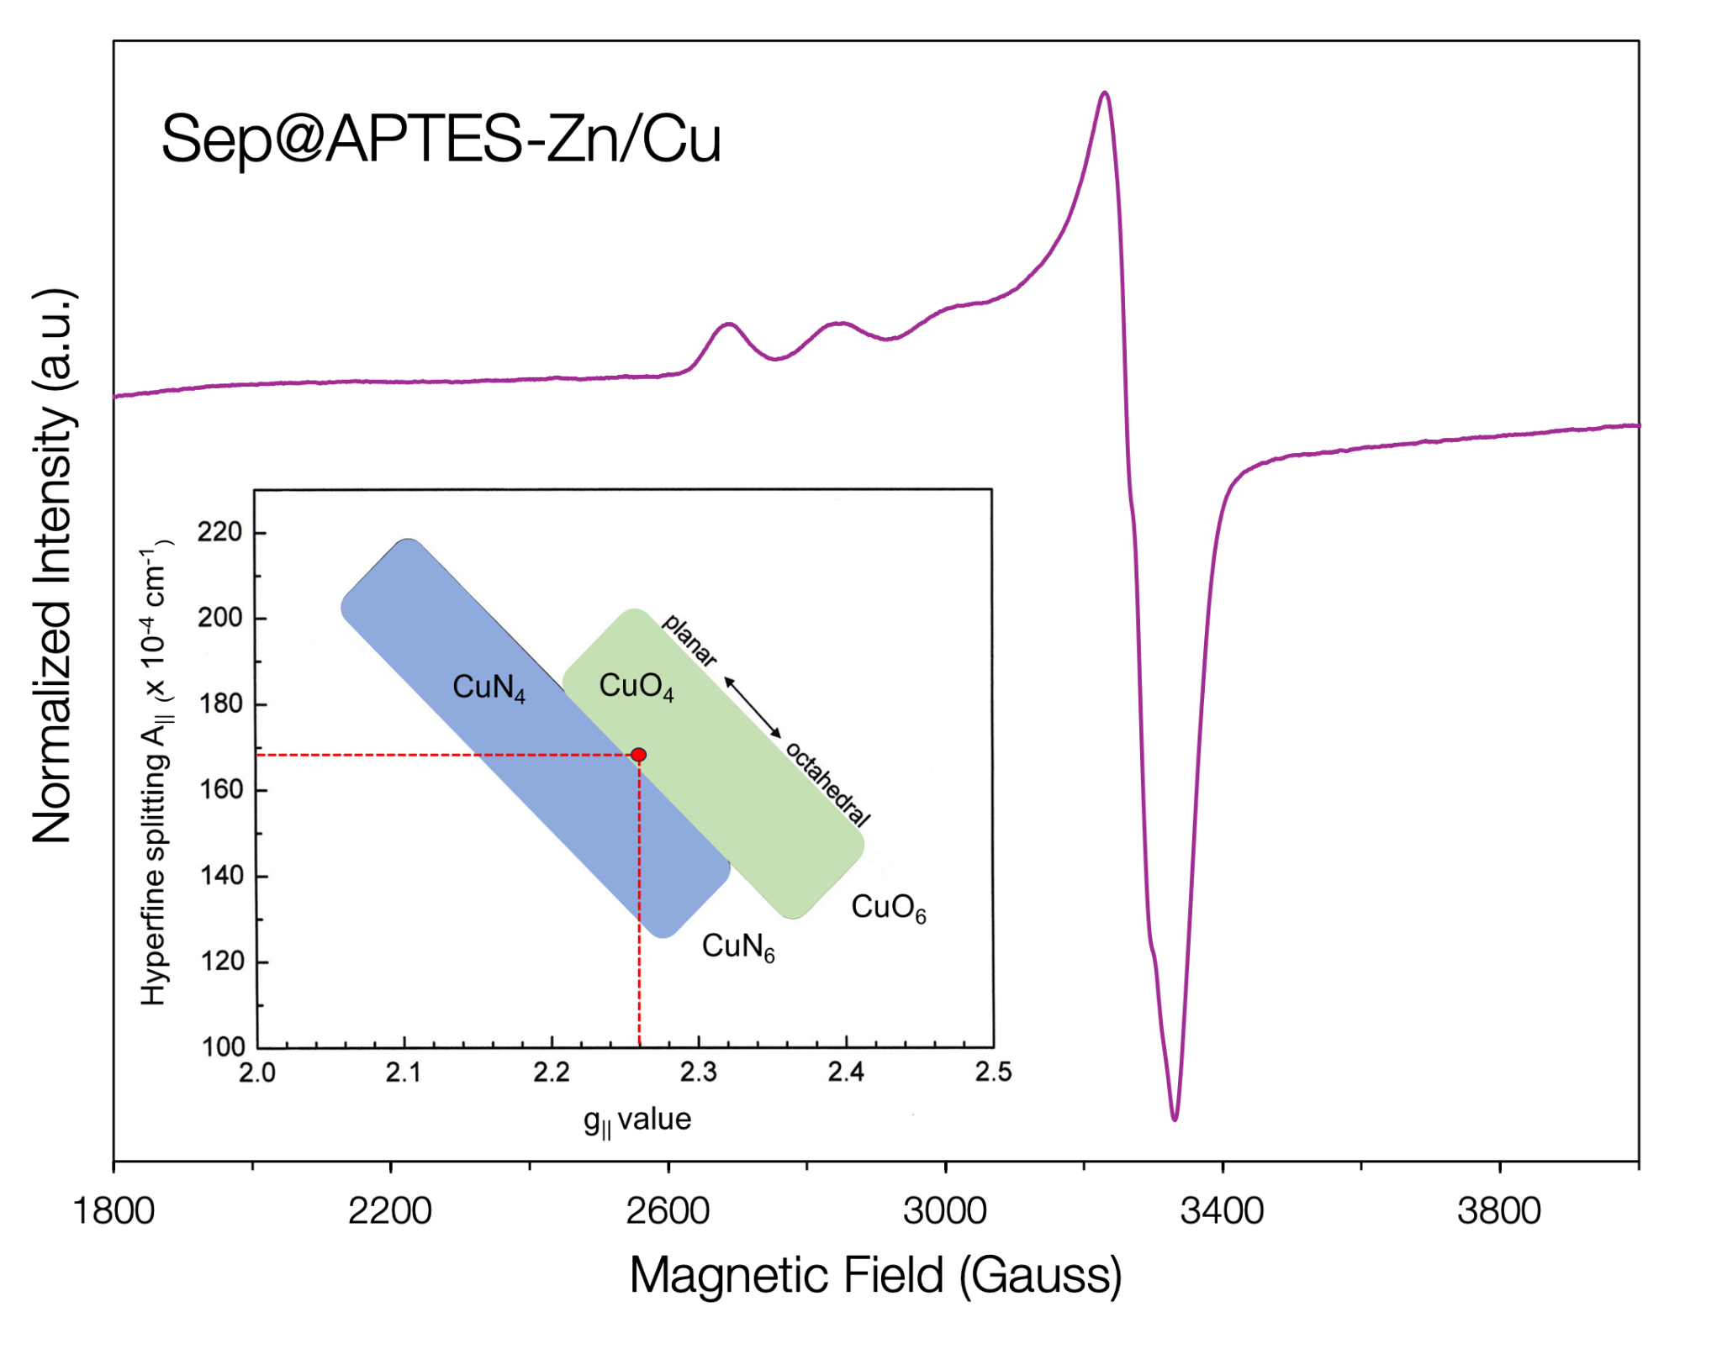
Figure S6. EPR spectrum of Sep@APTES-Zn/Cu prepared by substituting Zn(II) with Cu(II) (0.01%); the inset shows the Peisach–Blumberg correlation diagram for oxygen and nitrogen coordinating Cu(II) ions.

TGA of XNBR NCs
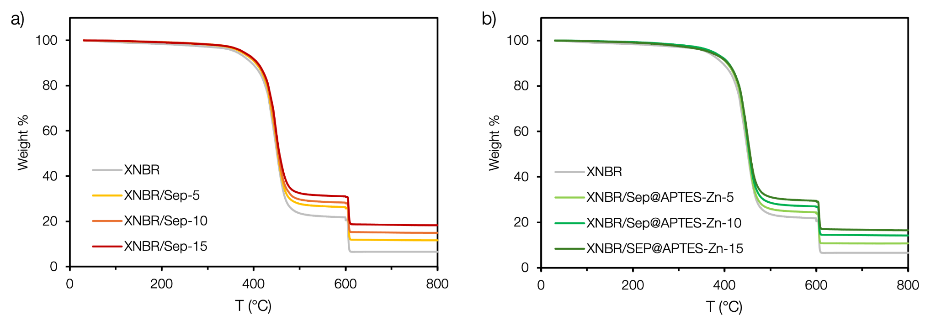
Figure S7. TGA curves of a) XNBR/Sep-X and b) XNBR/Sep@APTES-Zn-X NCs. In both graphs the grey curve is the reference XNBR NC prepared by using ZnO as reported in Table 1 of the main text.

Mechanical properties
Table S1. Parameters of the curing curves registered for XNBR/Sep-X, XNBR/Sep@APTES-ZnX and XNBR NCs. In the first three colums the kinetic parameters are reported: t_{S1}, t_{S2} and t_{S90} represent the time required to achieve 1 %, 2% or 90 % of the maximum torque. In the latter three columns the torque increase (ΔM), calculated as the difference between the maximum (M_{H}) and the minimum torque (M_{L}) are also shown.

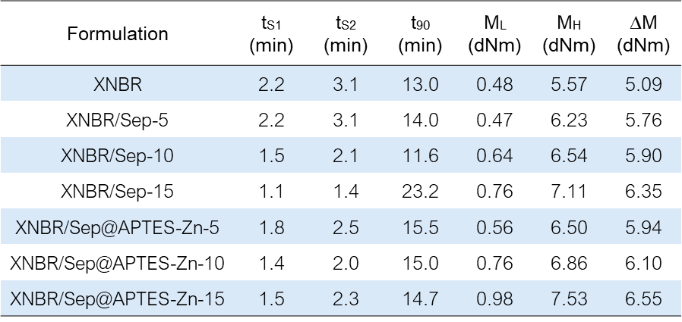
Table S2. Parameter of the tensile tests performed on XNBR/Sep-X, XNBR/Sep@APTES-Zn-X compared to XNBR and XNBR/Sep@ZnO-10. In the Table the values of the measured stress at 100 % (M100), 300 % (M300) and 500 % (M500) strain, along with the values of tensile strength (TS) and elongation at break (EB) are reported.

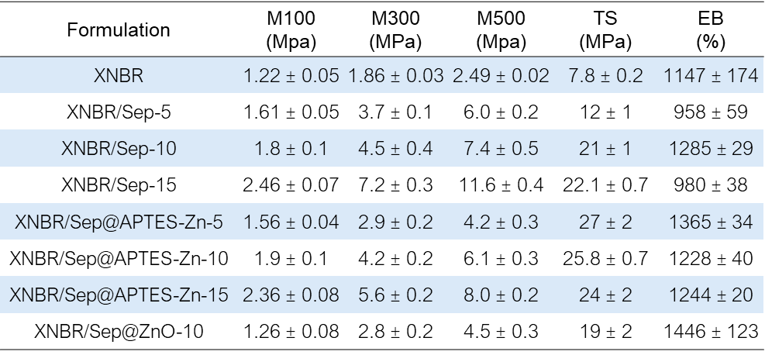

Self-Healing properties
Table S3. Healing efficiency (η, %) calculated from TS values of the healed and pristine NCs, according to Eq. 1 of the main text.
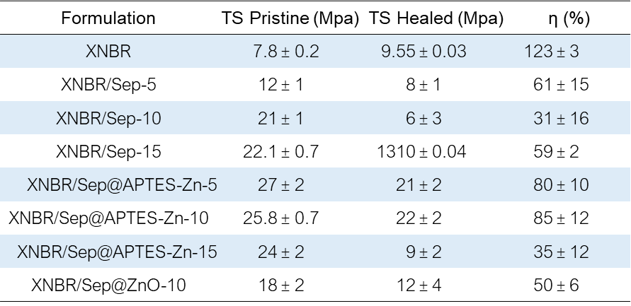
Table S4. Healing efficiency (η, %) calculated from EB values of the healed and pristine NCs, according to Eq. 1 of the main text.
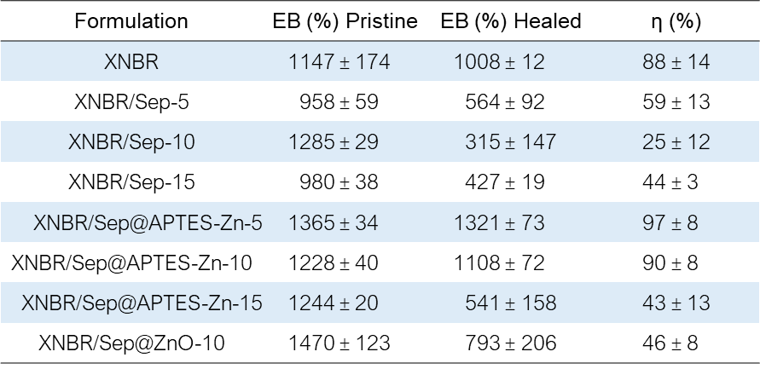

Time Domain NMR

Three-component decay function used for fitting Hahn Echo experiments at 30 °C:

$y=A \exp^{- \frac{x^{2}}{D}}+B \exp^{- \frac{x}{T_{2}b}}+C \exp^{- \frac{x}{T_{2}c}}$ Eq. S5

Where A, B and C represent three distinct proton populations, corresponding to microstructural domains within the composite. These can be described as a highly constrained fraction (A), a slightly constrained fraction (B) and a mobile fraction (C). The parameter D represents the gaussian relaxation constant of the rigid cross-linked domains and ionic clusters. The parameter T₂b and T₂c denote the relaxation time constants associated with the semi-mobile entangled segments and the highly mobile free chains within the XNBR matrix, respectively.
Table S5. Exponential function parameters of XNBR/Sep@APTES_N, XNBR/Sep@APTES-Zn-10_N and XNBR/Sep@ZnO-10_N NCs, according to Eq.S5.
